Keywords

Angola, Marginal da Corimba, Luanda, flushing, water quality, Delft3D-FLOW, Delft3D-WAQ

Summary

Urbinveste SA and Van Oord are developing the Marginal da Corimba project along the coast of Luanda (Angola), as commissioned by the Project Owner, Gabinete Futungo. As part of the development a land reclamation will be constructed.

Royal HaskoningDHV is carrying out design services for this project and has commissioned Deltares to update the flushing and water quality assessments of the Deltares (2014a) and Deltares (2014b) studies for the latest layout of the Marginal da Corimba scheme using Delft3D-FLOW and Delft3D-WAQ.

For the bathymetry it had been assumed that the shoal at the bay entrance will lower with 0.5 m due to flow contraction in the first years after construction of the scheme (‘base case’).

In this memo the results for the updated flushing and water quality assessments for the latest layout are presented for the dry season, wet season and 1/100 yr storm conditions (rainfall event).

The results indicate that under average conditions, the improvements offered by introducing wastewater treatment are expected to be substantial. The only remaining impacts from pollution loadings are a limited reduction of the water transparency (as compared to undisturbed background conditions) within the Corimba channel in the wet season, as a result of the presumed overflows of the wastewater collection and treatment systems in the valas during rain events. Exceedance of *E. coli*'s suitability criterion for swimming water could still be expected, but over much smaller areas than in the baseline.

The remediation of these problems in the selected Marginal de Corimba layout would require an improvement of the wastewater collection and treatment systems in the valas, either by increasing the capacity, or by separating the wastewater from the storm water.

|  |  |  |  |  |  |  |  |
| --- | --- | --- | --- | --- | --- | --- | --- |
| Version | Date | Author | Initials | Review | Initials | Approval | Initials |
| 1 | Apr. 2017 | Pieter Visser  Rudy Schueder  Robin Morelissen |  | Jos van Gils |  | Hans de Vroeg |  |
|  |  |  |  |  |  |  |  |
|  |  |  |  |  |  |  |  |

|  |
| --- |
| State  draft  This is a draft report, intended for discussion purposes only. No part of this report may be relied upon by either principals or third parties. |

Contents

1 Introduction 1

2 Flushing and water quality 3

2.1 Introduction 3

2.2 Model set-up 3

2.2.1 General 3

2.2.2 Spatial model schematisations 4

2.2.3 Simulation periods and initialisation strategy 10

2.2.4 Physical forcing 11

2.2.5 Discharges to the coastal waters 11

2.2.6 Set up of the flushing assessment 15

2.3 Results and discussion 16

2.3.1 Flushing 16

2.3.2 Water quality 20

2.3.3 Baseline scenario – seasonal water quality patterns 20

2.3.4 Baseline scenario – 1-in-100-year storm event 30

2.3.5 Marginal de Corimba development scenario – seasonal water quality patterns 41

2.3.6 Marginal de Corimba development scenario – 1-in-100-year storm event 60

2.4 Sumarizing conclusions 78

References 79

Appendices

No table of contents entries found.

# Introduction

Urbinveste SA and Van Oord are developing the Marginal da Corimba project along the coast of Luanda (Angola), as commissioned by the Project Owner, Gabinete Futungo. As part of the development a land reclamation will be constructed. The contours of the reclamation are indicated in red in Figure 1.1.

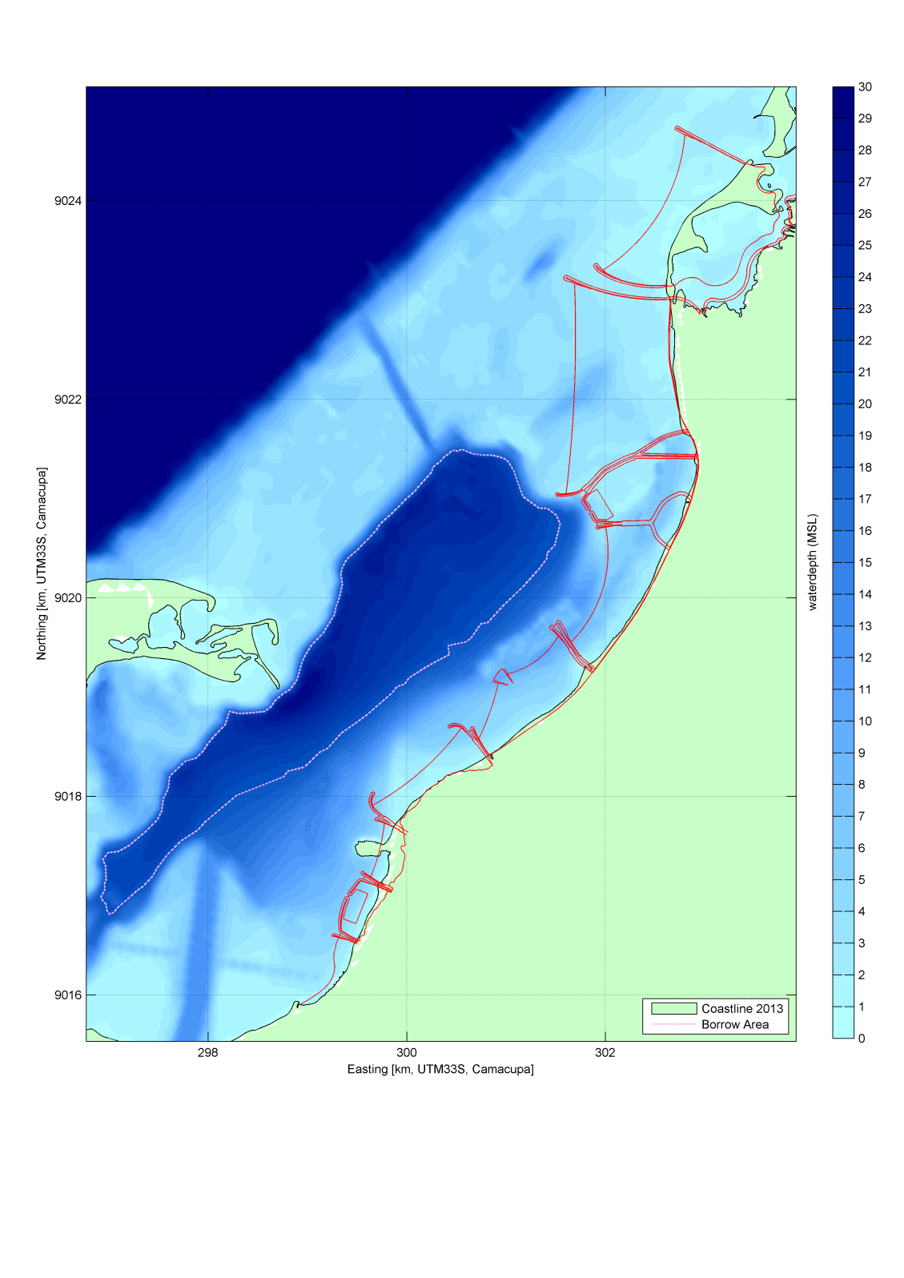

Figure 1.1 Marginal da Corimba land reclamation contours (red lines) projected on the present coast (green surface). The bathymetry is given with a blue colour scale. The dashed white line encloses the borrow area inside the lagoon.

The Marginal da Corimba development aims at a high standard of living and recreation. Therefore, good water quality is a precondition for the success of the project. Water quality in the area is determined by substance loadings (for example input of nutrients or contaminants) on one hand, and the transport (flushing, residence time) on the other hand. Also physical–chemical and biochemical processes (for example the natural decay of some substances) play a role in the quality of the water.

Royal HaskoningDHV is carrying out design services for this project and has commissioned Deltares to evaluate the flushing and water quality for the planned new development.

Storm drainage and waste water modelling has been carried out by Royal HaskoningDHV in order to quantify storm drainage and waste water discharges for typical seasonal conditions as well as storm events.

Chapter 2 of this report describes the results of the flushing and the water quality assessments. Map plots of the modelling results are presented for both the flushing study (indicative residence time plots) and the water quality assessment (footprints of various substances).

The basis for the modelling has been verified (and confirmed by the Consortium) via an input verification document dd. 12/4/2017. The output of the modelling study will be input to the Basis of Design for Detail Design which is being developed.

# Flushing and water quality

## Introduction

In this chapter we discuss the flushing and water quality of the latest layout of the Marginal de Corimba development. In particular, we consider (a) seasonal water-quality patterns within a larger area of 50-100 km around the project location, and (b) event-driven water-quality patterns within the direct vicinity of the project location.

The seasonal assessments take into account the typical differences in precipitation and run-off and wastewater flows between the dry season and the wet season. They rely on a previously developed baseline computation (Deltares, 2014a). The assessments produce results that are representative of average conditions during each season.

The event-related assessments focus on the response of the water-quality indicators to a heavy rain event. These assessments use the simulated wet season water-quality conditions as a starting point. The present analysis includes both the baseline and the Marginal de Corimba development.

The discharge information related to the rain and wastewater discharges through the valas for the different scenarios have been based on Technical Note PD-TNO-4000-001-RevA, dated 11 April 2017 by RHDHV, which in turn is based on the Water Management Report (BC7050-109-R002 Rev 0-final Design report Water management_2017-02-27).

It is noted that the modeling approach in the present assessment for both the hydrodynamic and water quality modeling is based on the modeling assessment of Deltares (2014b) and kept as consistent with that study as possible.

## Model set-up

### General

The Delft3D FLOW and WAQ model setup has been discussed in the previous modelling reports (Deltares, 2014a and Deltares, 2014b). The key elements of the model setup will be repeated here for the sake of readability. For the remaining aspects, such as the selection of the modelled substances and processes, a summary of the model parameters, the open sea water quality boundary conditions and the estimation of the quality of the discharges to the coastal waters, we refer to the large scale modelling report (Deltares, 2014a).

For the present assessment, nine simulations have been performed with the flow and water quality models, see Table 2.1.

Table 2.1 Overview of simulations

|  |  |
| --- | --- |
| Configuration | Season / event |
| Baseline | Dry season – without wastewater treatment |
| Baseline | Wet season – without wastewater treatment |
| Baseline | 1 in 100 year storm – without wastewater treatment |
| Marginal da Corimba | Dry season – without wastewater treatment |
| Marginal da Corimba | Dry season – with wastewater treatment |
| Marginal da Corimba | Wet season – without wastewater treatment |
| Marginal da Corimba | Wet season – with wastewater treatment |
| Marginal da Corimba | 1 in 100 year storm – without wastewater treatment |
| Marginal da Corimba | 1 in 100 year storm – with wastewater treatment |

Out of the three alternative 1 in 100 year storm events discussed in the large-scale modelling report, the event with the 24 hours duration is considered the most realistic. This event is used for the present simulations. The previous assessments showed that the response of the water quality to the event-related discharges was not very much dependent on the actual weather conditions. For this reason, we selected the “normal” land-sea-breeze as the basis for the present event simulations.

### Spatial model schematisations

The simulations are based on the Luanda flow model, see Figure 2.1. In the present study, the model grid has been slightly adapted to efficiently include the present Marginal de Corimba development layout. Two versions of this grid are used, one representing the baseline and one representing the Marginal de Corimba development.

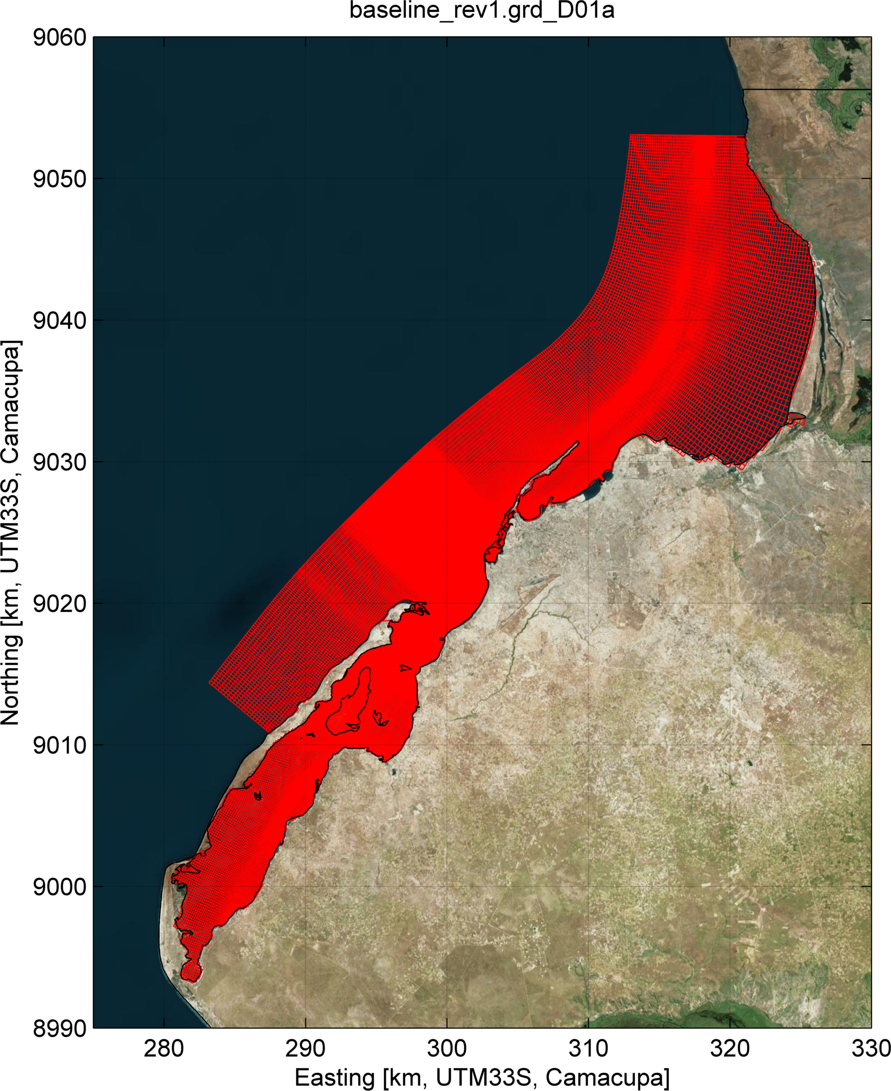

Figure 2.1 Overview of the Luanda model grid

Large-scale morphological features in the project area are the Island of Mussulo and the Bay of Mussulo. The most important morphological features and geographical features are presented in **Error! Reference source not found.**. .

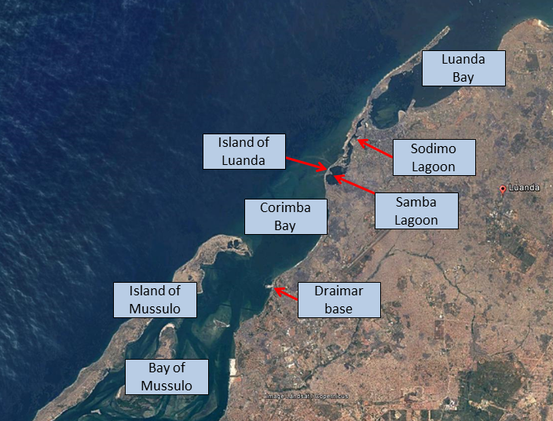

Figure 2.2 Overview of the most important morphological and geographical features

The applied bathymetry in the area of interest is presented in Figure 2.3. The basis for this bathymetry is the survey carried out in 2014 (Deep, 2014). Locally a modification has been made to the bathymetry to account for a planned borrow area of which the deepening (to MSL -35 m) is presented in Figure 2.3 (based on Urbinveste/Van Oord, 2017). In the applied bathymetry the “Draimar base” (see Figure 2.2 ) has been removed and the depth contours in that area have been smoothened (depths equal to surrounding depths).

The reclamation plan (modified shoreline) is also shown in Figure 2.3 (right panel). This shoreline, representing the MSL-line, has been derived from Royal HaskoningDHV extract of drawing ‘Phases 1a-4e-3.0-line.dwg’.

In Deltares (2017a) considerations on possible future changes of the shoal have been discussed. On the basis of these considerations it was concluded that due to flow contraction caused by the land reclamation some scour of the shoal is expected to occur. This was conservatively estimated to lead to a uniform deepening of the shoal of 0.5 m. In addition it was discussed that on the longer term some further lowering of the shoal is possible due to other causes, such as natural dynamics and non-project related dredging activities. The bathymetry with the present shoal level and with a 0.5 m lowered shoal is presented in Figure 2.3.

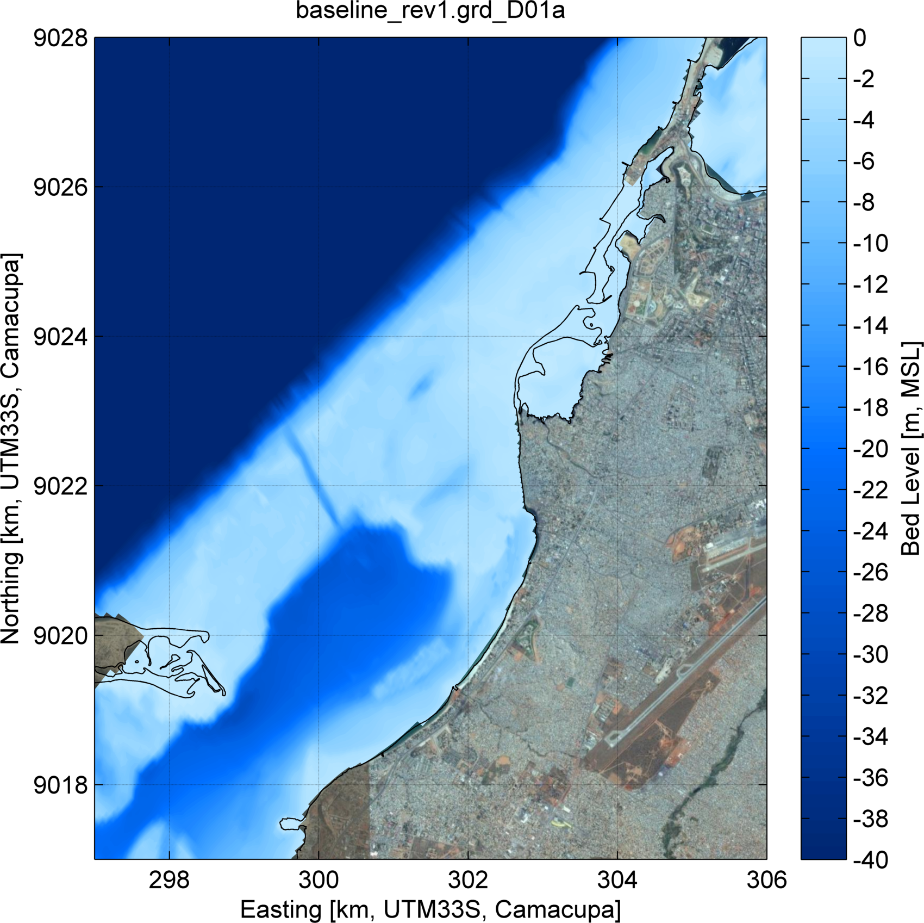 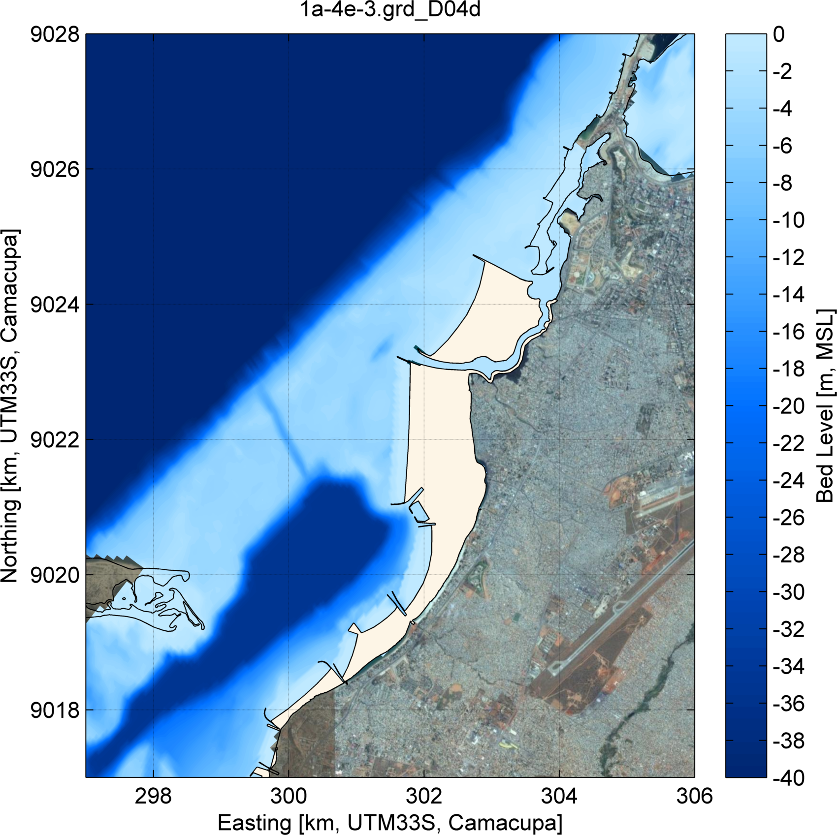

Figure 2.3 Present bathymetry (left) and bathymetry with modified shoreline, deepened borrow area and the deepened shoal (right)

In the present assessment, a schematisation of two expected bridges in the Corimba channel is included in the Delft3D-FLOW model. These bridges are schematised as a sub-grid size hydraulic structure of a porous plate that imposes an energy loss on the flow at the anticipated locations of the bridges. The energy loss is calculated as a quadratic loss term ( 0.04 [-]), based on the spacing and dimensions of the bridge pillars. The basis for the bridge pillar spacing and dimensions is based on the currently present bridges (i.e. based on drawings ‘Dimensions Bridge West of Vala 2.pdf’ and ‘Dimensions Bridge North of Vala 1.pdf’ provided by RHDHV). The locations of the bridges are shown in Figure 2.4.

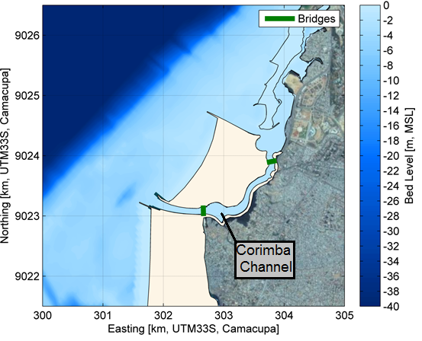

Figure 2.4 Locations of the two bridges (dark green) in the Corimba channel in the Delft3D-FLOW model

The water quality model grid is based on the flow model grid. While covering the entire area at high resolution is important for the transport modeling, the resolution in areas away from the area of interest, where strong gradients are not expected, can be reduced for water quality studies. Specifically, a 2x2 horizontal aggregation is applied in the direct vicinity of the project area, while a 4x4 aggregation is used further away (Figure 2.5 and Figure 2.6). The vertical flow model grid is maintained with 10 layers.

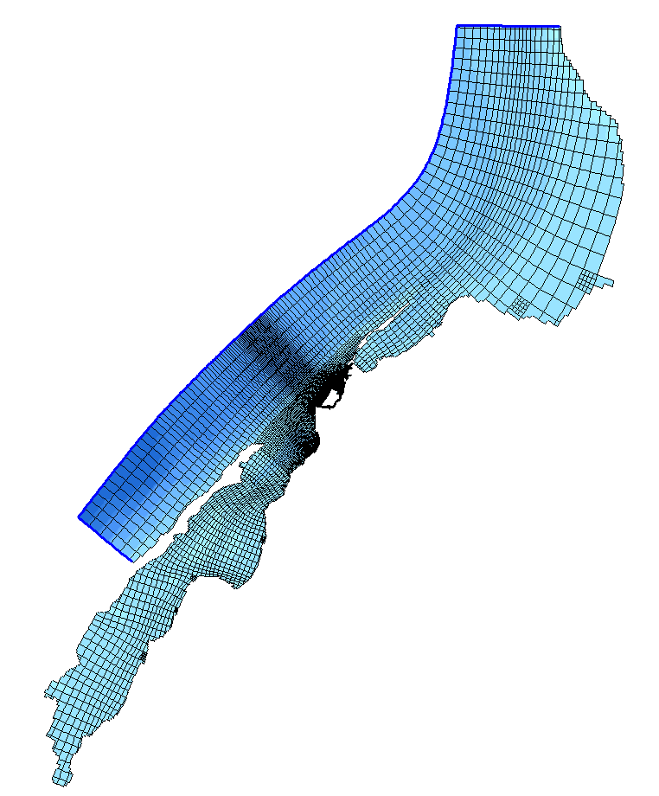

**West**

**North**

**South**

Figure 2.5 Grid schematization for the WAQ model.

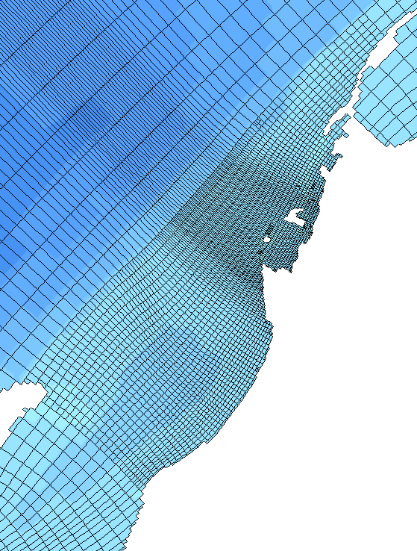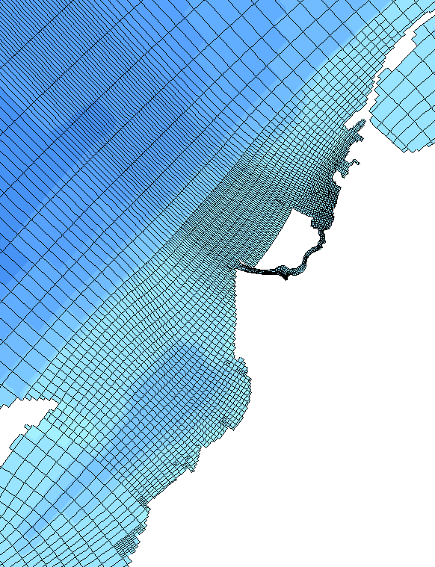

Figure 2.6 Zoom on the grid schematization in the project for the baseline scenario (left) and the Marginal Phase 4 Development scenario (right).

### Simulation periods and initialisation strategy

The existing baseline simulations for the dry and wet seasons reveal that the modelled area needs about a year to spin up. With this in mind, we chose to carry out a 2 year simulation to cover both typical dry season and typical wet season conditions, see Table 2.2. The wet season includes the months of November to April, while the dry season includes May to October (<http://www.luanda.climatemps.com/luanda-climate-graph.gif> ).

|  |  |  |  |
| --- | --- | --- | --- |
| Year | Initialisation | Forcing | Output |
| 1 (spin-up):  Nov – October | Equal to boundary conditions | Wet (Nov-Apr)  Dry (May-Oct) | n.a. |
| 2 (production):  Nov – October | From year 1 | Wet (Nov-Apr)  Dry (May-Oct) | Wet month (February)  Dry month (August) |

Table 2.2 Simulation periods, typical dry season and wet season conditions

Typically, March and April are the wettest months in Luanda. For the event simulations, we therefore consider the wet season situation from year 2, end of March, as an appropriate initial situation, see Table 2.3.

|  |  |  |  |
| --- | --- | --- | --- |
| Event | Initialisation | Forcing | Output |
| 1 / 100 year storm, duration 24 hours | 31 March (year 2) | Event (day 1)  Typical wet season (day 2-7) | Whole simulation |

Table 2.3 Simulation period, event-related simulations

### Physical forcing

The water quality model derives spatially and temporally varying input data from the hydrodynamic model. This concerns the water volumes, the currents and the vertical dispersion coefficients, together with temperature and salinity. The hydrodynamics model is run for one spring-neap cycle in the dry season and one spring-neap cycle in the wet season. The water quality simulations use alternate repeated spring-neap cycles for the dry months and the wet months of the year respectively (Table 2.2). The horizontal dispersion is specified equal to zero.

The water quality model also uses wind speed and solar radiation input data. For the wind speed, an observed typical daily pattern is repeated, in all seasons (Deltares, 2014a). For the solar radiation, daily averages of 280 and 270 W.m-2 have been estimated for the wet and dry seasons respectively (Deltares, 2014a).

A typical net evaporation rate of 1 m.y-1 has been included in the hydrodynamic modelling for the dry season. Evaporation is relevant to water quality since it can result in residual currents caused by density differences, and since it tends to cause increased concentrations in areas with low flushing. In the hydrodynamic modelling for the wet season, neither evaporation nor precipitation have been included, under the assumption that precipitation and evaporation balance each other.

### Discharges to the coastal waters

For a detailed description of the discharges to the coastal waters, we refer to the large-scale modelling report (Deltares, 2014a). This section presents a summary of the relevant input data. In the modelling we consider different types of discharges:

* Wastewater flows
* Storm water flows
* Bengo River

Wastewater and storm water are discharged via valas and drains (see Figure 2.7 and Figure 2.8).

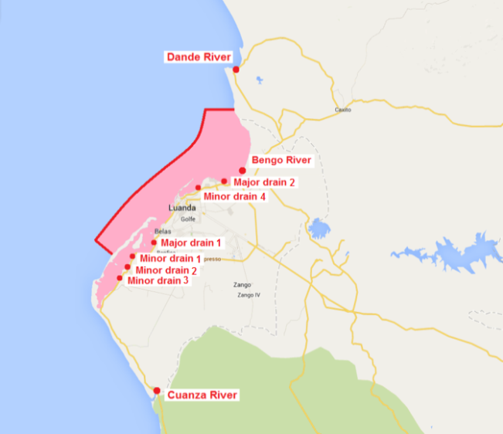

Figure 2.7 Point sources for substances loadings in the vicinity of the project area

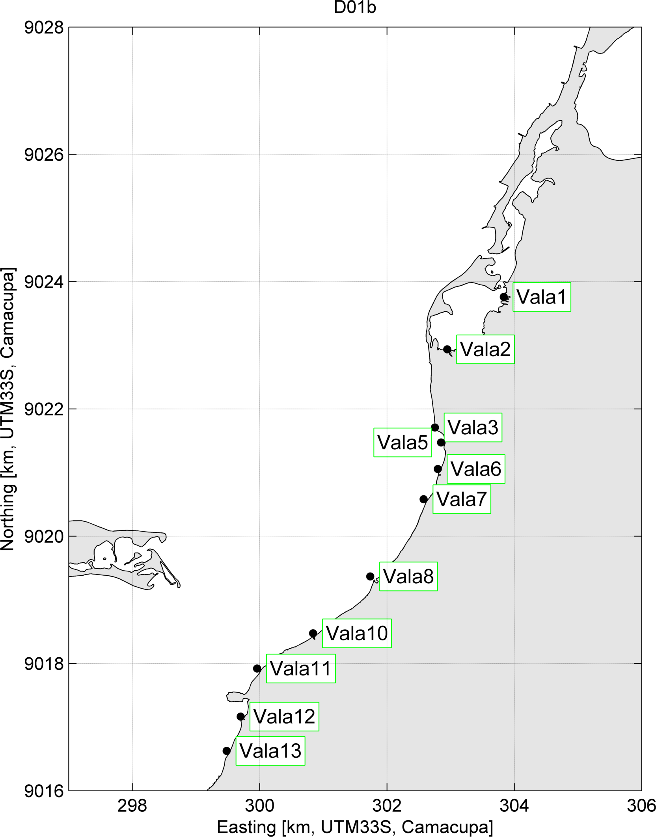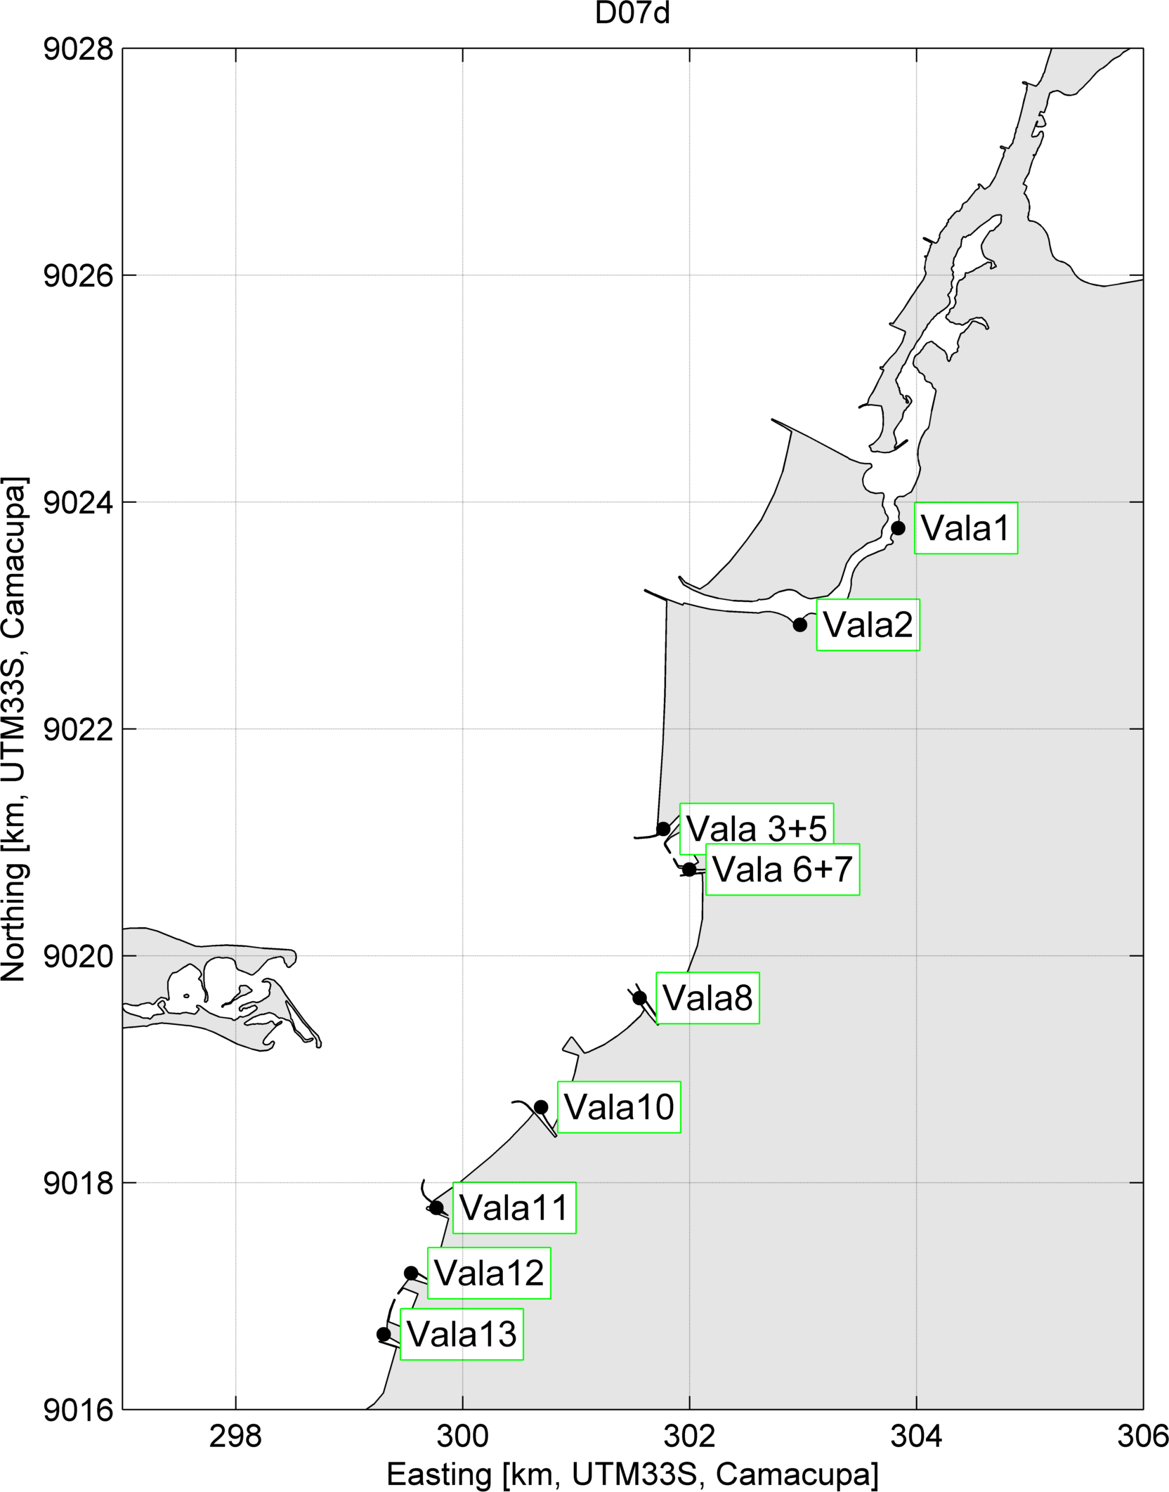

Figure 2.8 Zoom on point sources of the valas in Luanda for (a) the existing situation, and (b) the Marginal de Corimba development.

The discharges via the valas and drains are calculated by RHDHV and provided to Deltares in their Technical Note PD-TNO-4000-001-RevA, dated 11 April 2017, which in turn is based on the Water Management Report (BC7050-109-R002 Rev 0-final Design report Water management_2017-02-27). RHDHV also provided the discharge data in the form of Excel sheets, which were used as input for the discharges in the model. Note that valas 10-13 were not identified yet during the previous study (Deltares, 2014a).

The storm event conditions were updated by RHDHV, based on information available after the previous studies, resulting in a 1/100 year rainfall event of 170mm/day instead of 213mm/day in the previous studies. This has been accounted for in the vala discharge information provided by RHDHV. It is noted that for the major and minor drains in the model domain, as well as for the Bengo River, the discharges from the previous study are adopted, but scaled back proportionally to the new 1/100 year rainfall conditions.

The resulting discharges per vala are summarised in Table 2.4.

|  |  |  |  |  |  |  |
| --- | --- | --- | --- | --- | --- | --- |
| Name | Storm water (average over wet season, m3/s)  [Existing situation] | Storm water (average over wet season, m3/s)  [Marginal de Corimba development] | Wastewater (m3/s)  [Existing situation] | Wastewater (m3/s)  Marginal de Corimba development] | Storm water (during event, m3/s)  [Existing situation] | Storm water (during event, m3/s)  [Marginal de Corimba development] |
| Vala1 | 0.07 | 0.07 | 0.101 | 0.107 | 7.22 | 7.22 |
| Vala2 | 0.06 | 0.07 | 0.088 | 0.102 | 6.32 | 7.33 |
| Vala3 | 0.02 | 0.03 | 0.028 | n/a | 2.04 | n/a |
| Vala5 | 0.04 | 0.05 | 0.06 | n/a | 4.28 | n/a |
| Vala 3+5 | n/a | 0.08 | n/a | 0.115 | n/a | 8.28 |
| Vala6 | 0.01 | n/a | 0.014 | n/a | 1.01 | n/a |
| Vala7 | 0.01 | n/a | 0.016 | n/a | 1.13 | n/a |
| Vala 6+7 | n/a | 0.03 | n/a | 0.045 | n/a | 3.23 |
| Vala8 | 0.06 | 0.07 | 0.084 | 0.099 | 6.00 | 7.11 |
| Vala10 | 0.02 | 0.02 | 0.034 | 0.034 | 2.41 | 2.41 |
| Vala11 | 0.01 | 0.01 | 0.013 | 0.013 | 0.97 | 0.97 |
| Vala12 | 0.06 | 0.06 | 0.091 | 0.091 | 6.55 | 6.55 |
| Vala13 | 0.08 | 0.08 | 0.112 | 0.112 | 8.00 | 8.00 |
| Major drain1 | 0.18 | 0.18 | 0.125 | 0.125 | 8.97 | 8.97 |
| Major drain2 | 0.09 | 0.09 | 0.067 | 0.067 | 4.80 | 4.80 |
| Minor drain1 | 0.01 | 0.01 | 0.007 | 0.007 | 0.47 | 0.47 |
| Minor drain2 | 0.02 | 0.02 | 0.013 | 0.013 | 0.94 | 0.94 |
| Minor drain3 | 0.01 | 0.01 | 0.007 | 0.007 | 0.47 | 0.47 |
| Minor drain4 | 0.02 | 0.02 | 0.013 | 0.013 | 0.94 | 0.94 |

Table 2.4 Overview of discharges

Note that for the baseline scenario, vala 3, vala 5, vala 6 and vala 7 are defined separately, while for the Marginal de Corimba development some of the valas flow to the same location (valas 3+5 and valas 6+7). The existing discharges within the study are modified in the Marginal de Corimba development scenario. The wastewater discharges in the project area, which are discharged via the valas in the baseline simulations, are expected to be intercepted and treated in the Marginal da Corimba development in future. Nevertheless, also simulations for the Marginal de Corimba development without the assumption of wastewater treatment are carried out. In the simulations with wastewater treatment, it is assumed that this happens during dry weather conditions only. During rain events, the total discharge via the valas is too large to be intercepted and treated due to the added storm water. Therefore, we assume that the wastewater will still be discharged to the coastal water via the valas during rain events. This implies for the Marginal da Corimba development scenario:

* there are no wastewater discharges during the dry season simulation;
* during the event simulation, there are wastewater discharges during the 24 hour rain period only;
* during the average wet season simulation, only a fraction *Φ* of the wastewater discharges is discharged to the coastal waters. This fraction *Φ* represents the wastewater discharges taking place during rain events. We estimate fraction *Φ* by taking the number of days with rain and dividing it by the total number of days in the wet season. The reported number of days with rain in November-April equals 27 (http://www.luanda.climatemps.com/luanda-climate-graph.gif). Therefore, factor *Φ* is estimated as 27/183 = 0.15.

These are conservative estimates, since we assume that during rain the intercepted wastewater flow is zero. Also our assumption that during the wet season all storm water is discharged to the coastal waters is a conservative assumption.

Outside the development area, the discharges (e.g. the minor and major drains) remain unchanged in the Marginal de Corimba development scenario and will also not be connected to wastewater treatment.

The concentrations assumed representative for wastewater and storm water discharges in the model are collected in Table 2.5.

|  |  |
| --- | --- |
| Wastewater |  |
| Suspended solids | 350 mg/L |
| Biological oxygen demand | 300 mg/L |
| Total nitrogen | 85 mg/L |
| Total phosphorous | 20 mg/L |
| E. Coli Bacteria | 6*10^7 CFU/100 mL |
| **Storm water** |  |
| Suspended solids | 35 mg/L |
| Total organic carbon | 12.7 mg/L |
| Total nitrogen | 2 mg/L |
| Total phosphorous | 0.3 mg/L |
| E. Coli Bacteria | 1450 CFU/100 mL |

Table 2.5 Substance concentrations in all wastewater and storm water loads in the water quality model

### Set up of the flushing assessment

The large-scale flushing assessment (Deltares 2014a) helped in identifying small-scale areas which could be sensitive to develop poor water-quality. The assessment was performed by studying the residence time of a non-decayable tracer discharged in the project area. The area of interest was initially filled with a non-decayable tracer. The residence time was defined as the time required for the non-decayable tracer to be diluted by ambient water to a pre-defined level (37% of initial tracer concentration).

The objective of the flushing assessment is to identify areas which could be sensitive to develop poor water quality. Flushing in the existing and future situation has been assessed.

The land-sea breeze behaviour occurs frequently in the project area (Deltares 2014a) and can be seen as a normal condition (which usually occurs for a longer period). In the existing situation a north-westerly wind was found to be unfavourable from a viewpoint of residence times in Corimba channel. Based on the assessment in Deltares (2014b) it is expected that in the future configuration, both a westerly and north-westerly wind will result in relatively unfavourable flushing behaviour. Therefore these conditions were selected (see Table 2.6).

During neap tide, the current velocities are relatively low, resulting in a limited tidal flushing capacity. Therefore, the flushing simulations have been started with an initial tracer field during neap tide.

Overview of simulations for flushing assessment the following ambient conditions were selected for the flushing assessment (Table 2.5).

|  |  |  |
| --- | --- | --- |
|  | Wind condition | Tidal phase during start of  flushing simulation |
| Baseline (existing) | Land-sea breeze | High water, neap |
| West 3 m/s | High water, neap |
| North-west 2 m/s | High water, neap |
| Marginal de Corimba development | Land-sea breeze | High water, neap |
| West 3 m/s | High water, neap |
| North-west 2 m/s | High water, neap |

Table 2.6 Overview of simulations for flushing assessment

## Results and discussion

### Flushing

In the existing situation (i.e. the baseline scenario), for all wind conditions, the Sodimo lagoon was the area showing the slowest flushing (Figure 2.9). Notably after 15 days, the entirety of the lagoon was not fully flushed. It was further demonstrated that the Samba lagoon exhibits relatively high flushing times too, ranging from 5 to 7 days. Note that slight differences in residence times can be observed from the model results from the previous study in the Samba Lagoon for the baseline scenario which is caused by a slightly improved grid alignment in this assessment, however, the residence times are in the same order of magnitude.

In the situation including the Marginal da Corimba developments, the Sodimo lagoon showed the same poor flushing characteristics as those observed in the baseline scenario (Figure 2.10). The various wind conditions did not reduce significantly the residence times. In Corimba channel, however, the north-westerly wind conditions increased the residence time to more than 10 days (Figure 2.11). Under land-sea breeze wind conditions, which are predominant in the project area, the residence times in Corimba channel are 4-7 days.

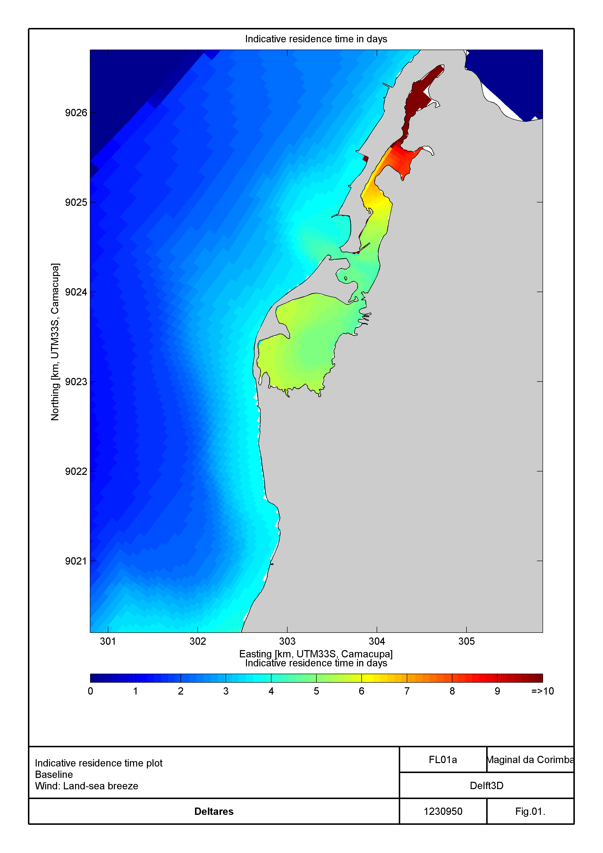

Figure 2.9 Indicative residence times, existing situation, wind: land-sea breeze

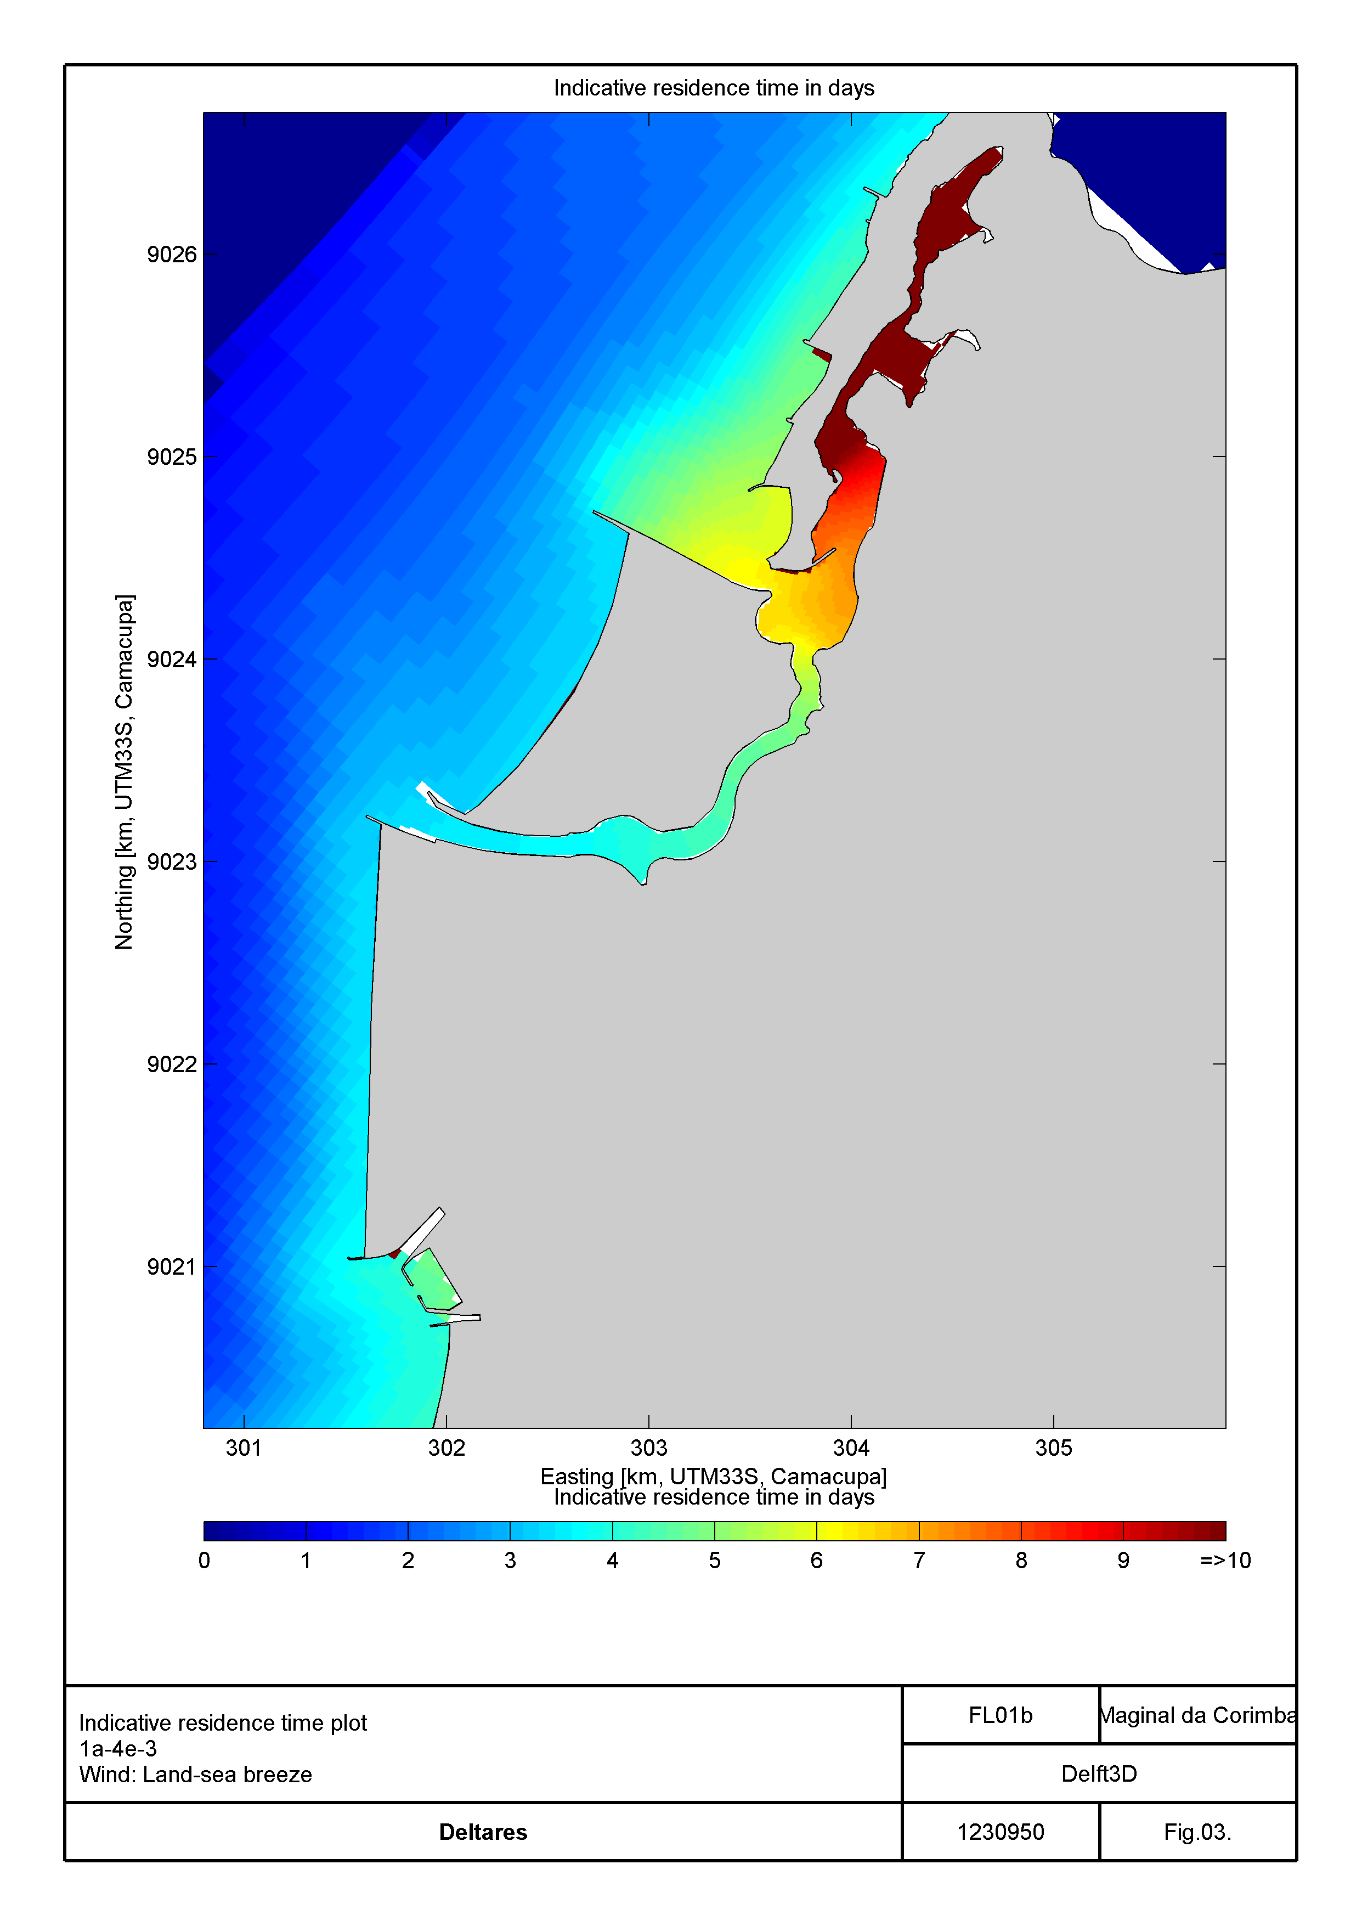

Figure 2.10 Indicative residence time, Phase 4 development, wind: land-sea breeze.

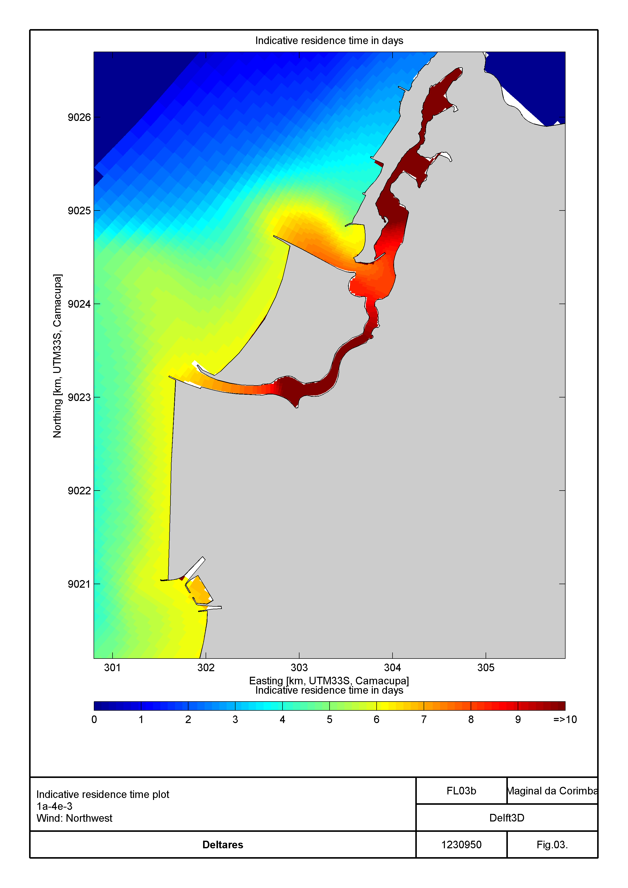

Figure 2.11 Indicative residence time, Phase 4 development, wind: northwest.

### Water quality

The water-quality assessment focuses on the dispersion characteristics of water constituents discharged from the rivers, drains and valas. In general, the dominant direction for residual transport of the discharged constituents is oriented towards the north (Deltares 2014a). This follows from simulations of tracers discharged from each vala, drain, channel, and river located in the vicinity of the project area Figure 2.9 to Figure 2.11). Except for the Bay of Mussolo, Luanda Bay, Samba Bay and Sodimo Bay the residence time in most of the model domain is very short (less than a few days). Sea water coming from offshore mixes rapidly with the water in the coastal area. The rapid mixing can play a relevant role in regards to the water quality of the coastal waters, especially if the area is experiencing high loadings.

Because of its elongated shape and its narrow and very shallow opening at the northern end, the Bay of Mussolo has a distinct behaviour. Residence times at the extreme South of the Bay are long and reach nearly 10 to 11 months. There, self-purification of the water column and burial into the sediment bed are the main processes that can efficiently remove pollutants from the water column. In addition, and especially during the dry season, evaporation in the Bay (assumed as 1 m/year in the model) negatively affects the water quality. More precisely, the substance concentrations in the south part of the bay can be expected to increase by about 10% under the effect of evaporation only. Fortunately, the direct discharges to the Bay are limited.

In the following, the results from 9 different loading configurations (wet season, dry season, and 1-in-100-year storm event) are described and discussed for the baseline scenario and the Marginal de Corimba development considering a scheme both with and without wastewater treatment.

### Baseline scenario – seasonal water quality patterns

Results for wet and dry seasons' conditions were described previously in Deltares (2014a). Overall, all substances originating from the drains and Bengo River displayed rapid mixing with open-sea waters outside of the project area. At these major loading sources, plumes were smaller in the dry season than in the wet season as a result of lower flow discharges. Additionally, there was a vertical gradient over the water column, caused by a salinity stratification induced by the larger freshwater inflows.

Loads occurring in the Samba lagoon (from valas in the project area), however, were not rapidly mixed with open-sea water (Figure 2.12 to Figure 2.19). High values of total nitrogen (TotN) and total phosphorus (TotP) were reached in the Samba Lagoon, where both storm water and wastewater were discharged. This led to high chlorophyll-*a* concentrations in the project area, especially in the dry season. In addition, vertical gradients were less marked than for the drains outside the project area. The high concentrations of chlorophyll-a and of suspended solids lead to a strongly reduced water transparency in the lagoon. The Samba Lagoon shows lower levels of dissolved oxygen than the waters outside the lagoon, but the simulated average values are all high enough to avoid damage to marine life (taken as concentrations > 2 mg/L). The simulated concentrations of *E. coli* exceed the suitability criterion for swimming water (in the order of several hundreds of cfu/100ml) over the whole of Samba Lagoon including the adjacent open sea waters.

Finally, in the Bay of Mussolo, an increase of TotN and TotP concentrations was also reported (Deltares, 2014a) and attributed mainly to the effect of evaporation. Its magnitude was therefore larger during the dry season than during the wet season, and caused approx. 10% increase in the concentration of TotP.

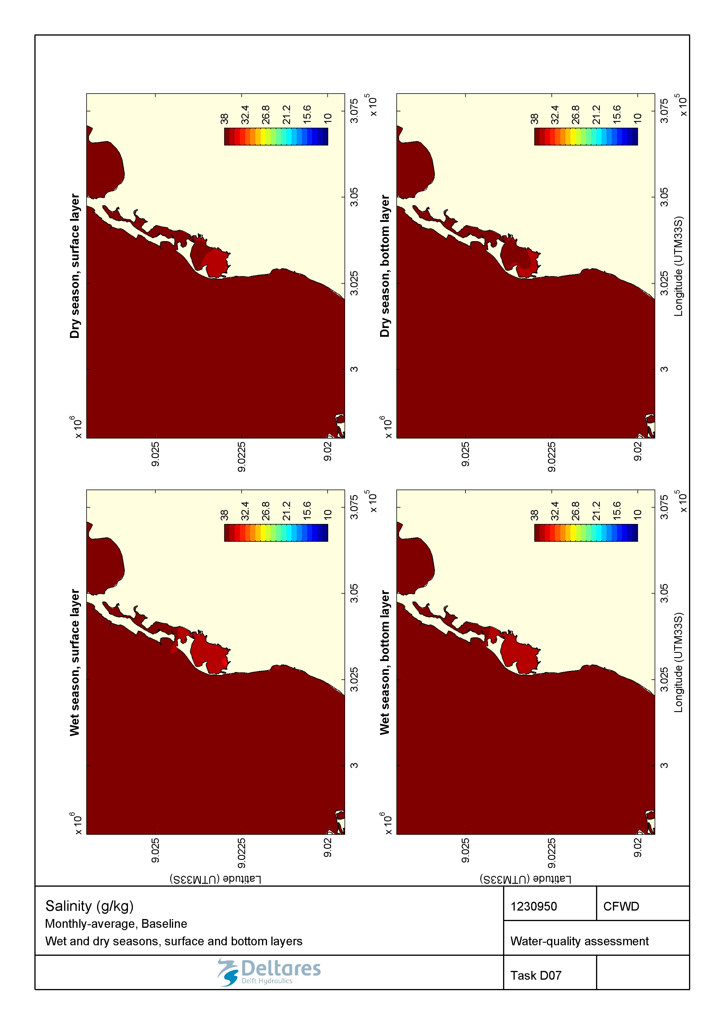

Figure 2.12 Monthly-averaged salinity (g/kg) during wet and dry seasons in the surface and bottom layers for the baseline scenario.

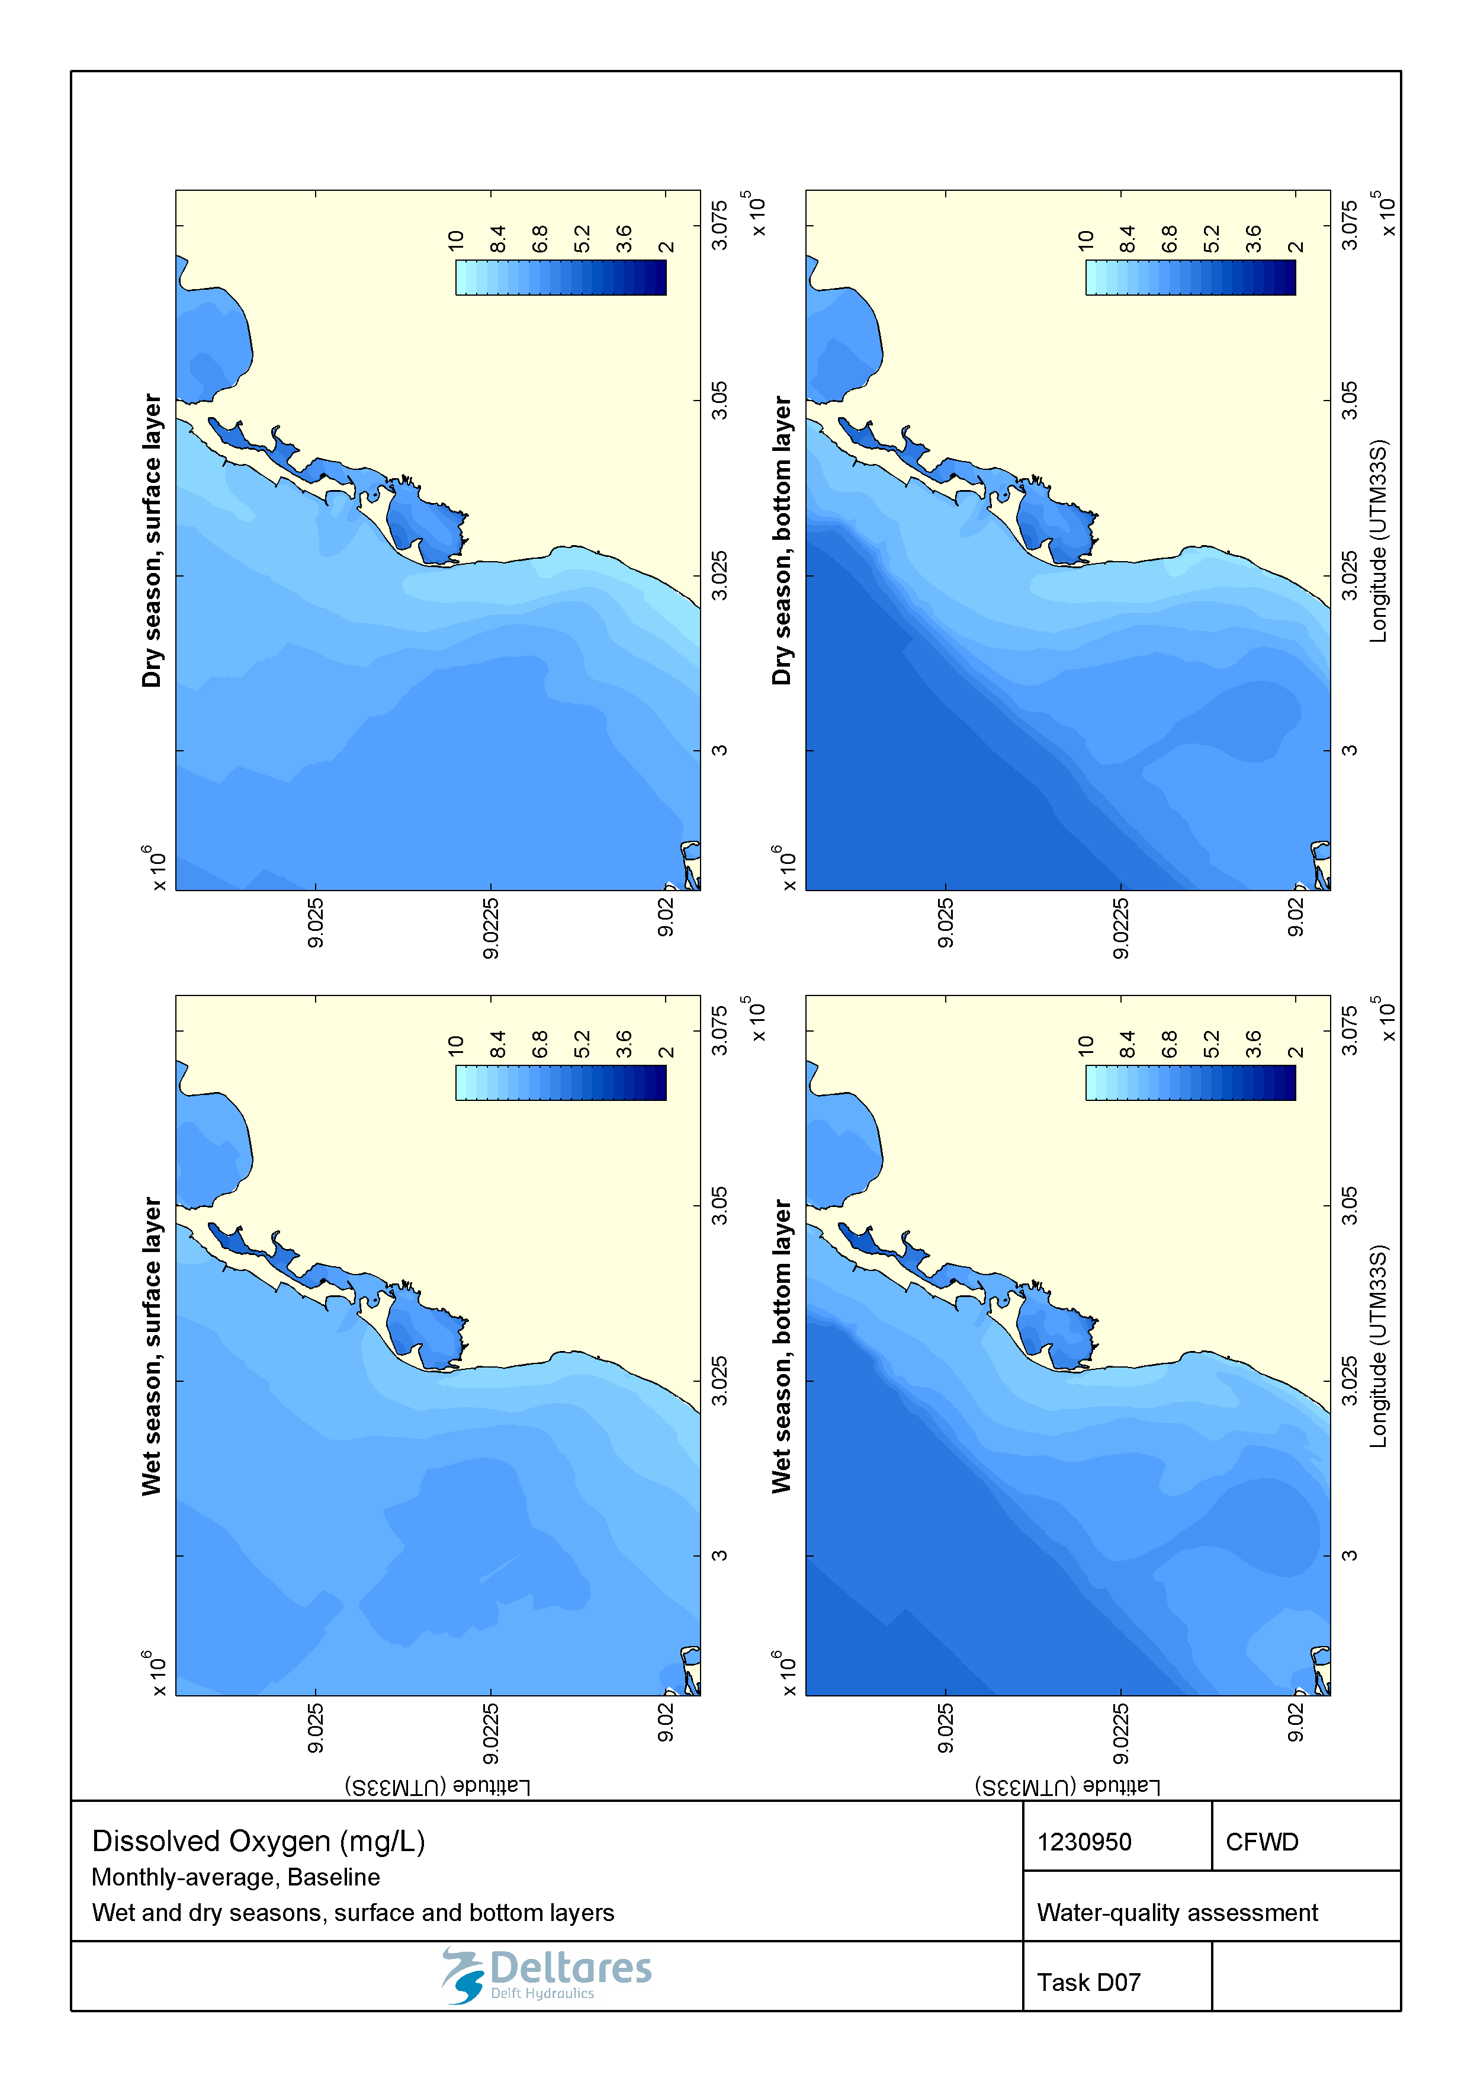

Figure 2.13 Monthly-averaged concentration of dissolved oxygen (mg/L) during wet and dry seasons in the surface and bottom layers for the baseline scenario.

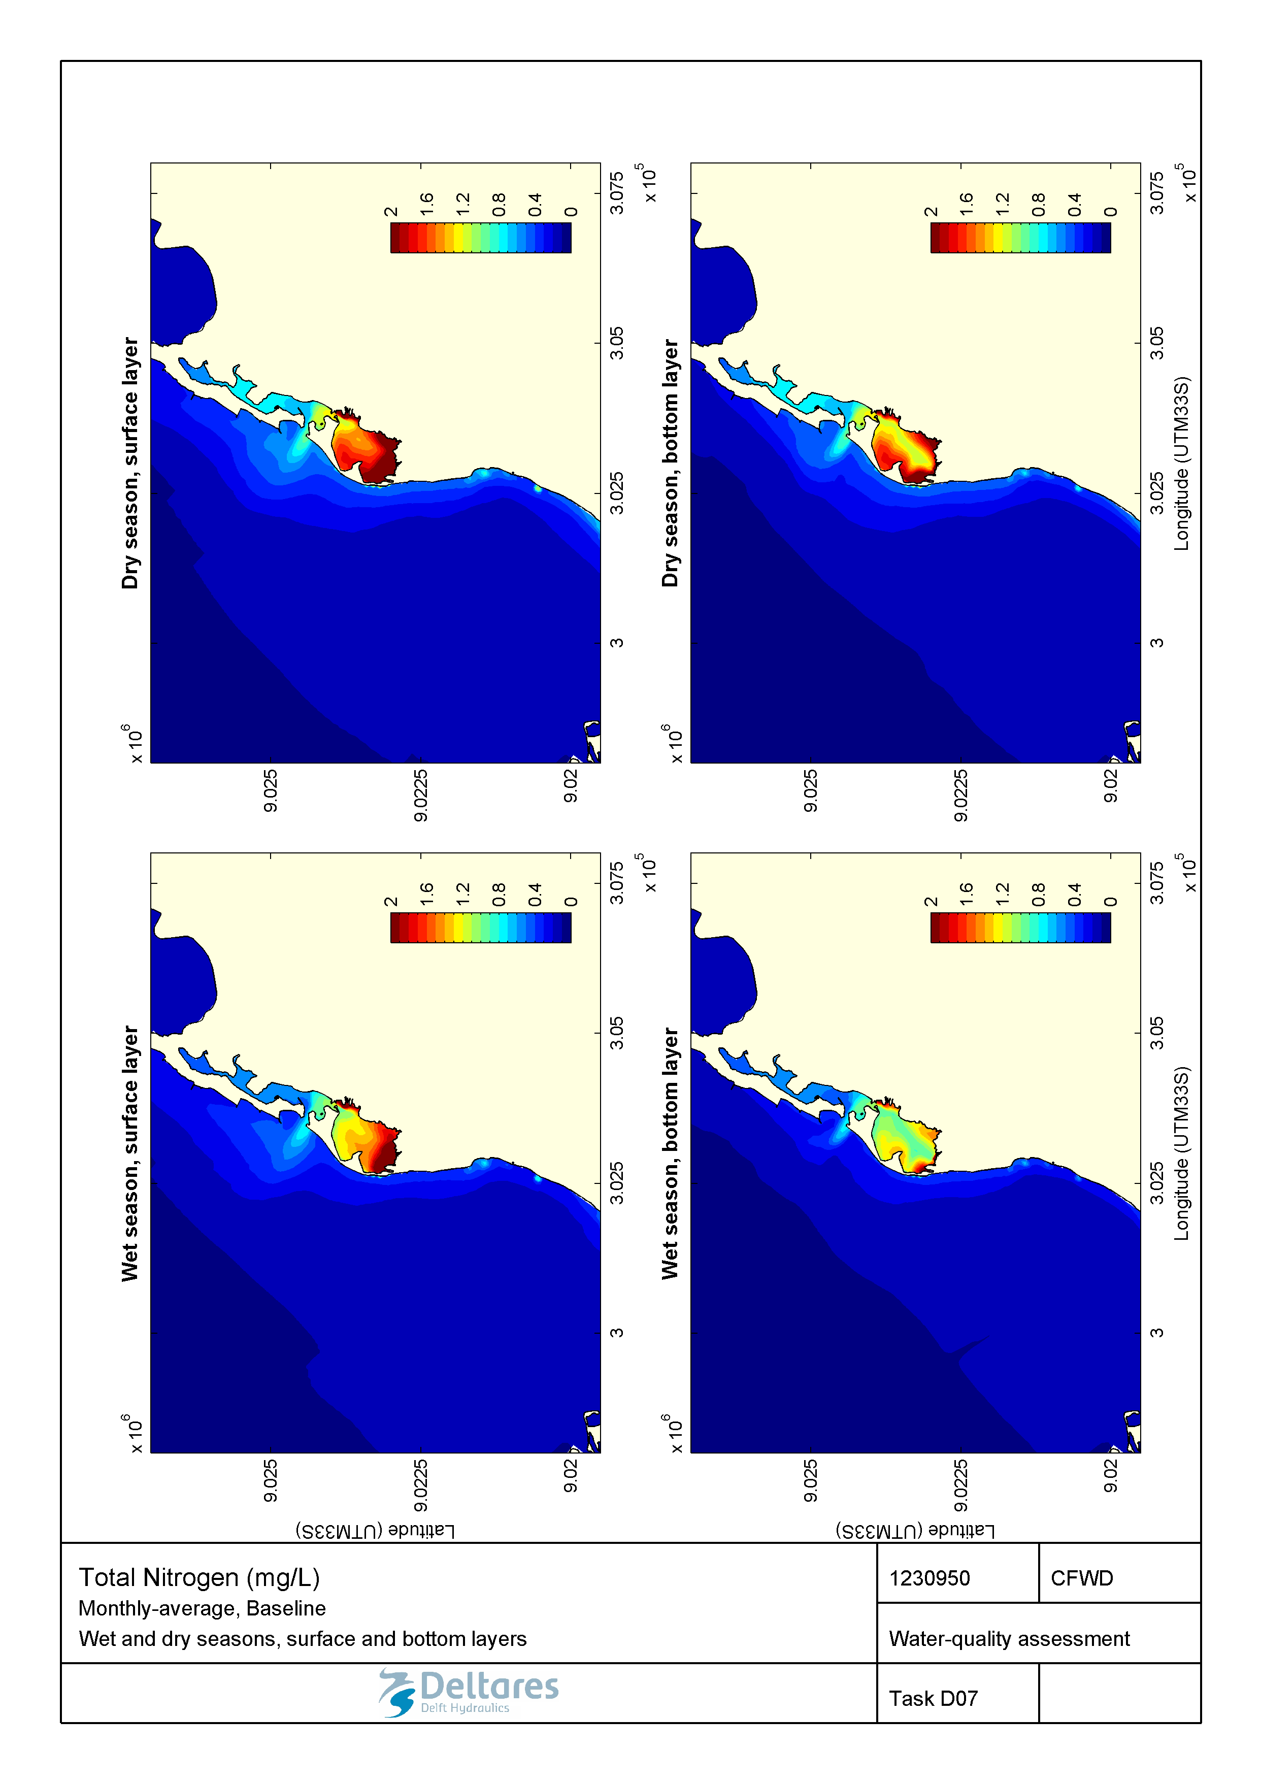

Figure 2.14 Monthly-averaged concentration of total nitrogen (mg/L) during wet and dry seasons in the surface and bottom layers for the baseline scenario.

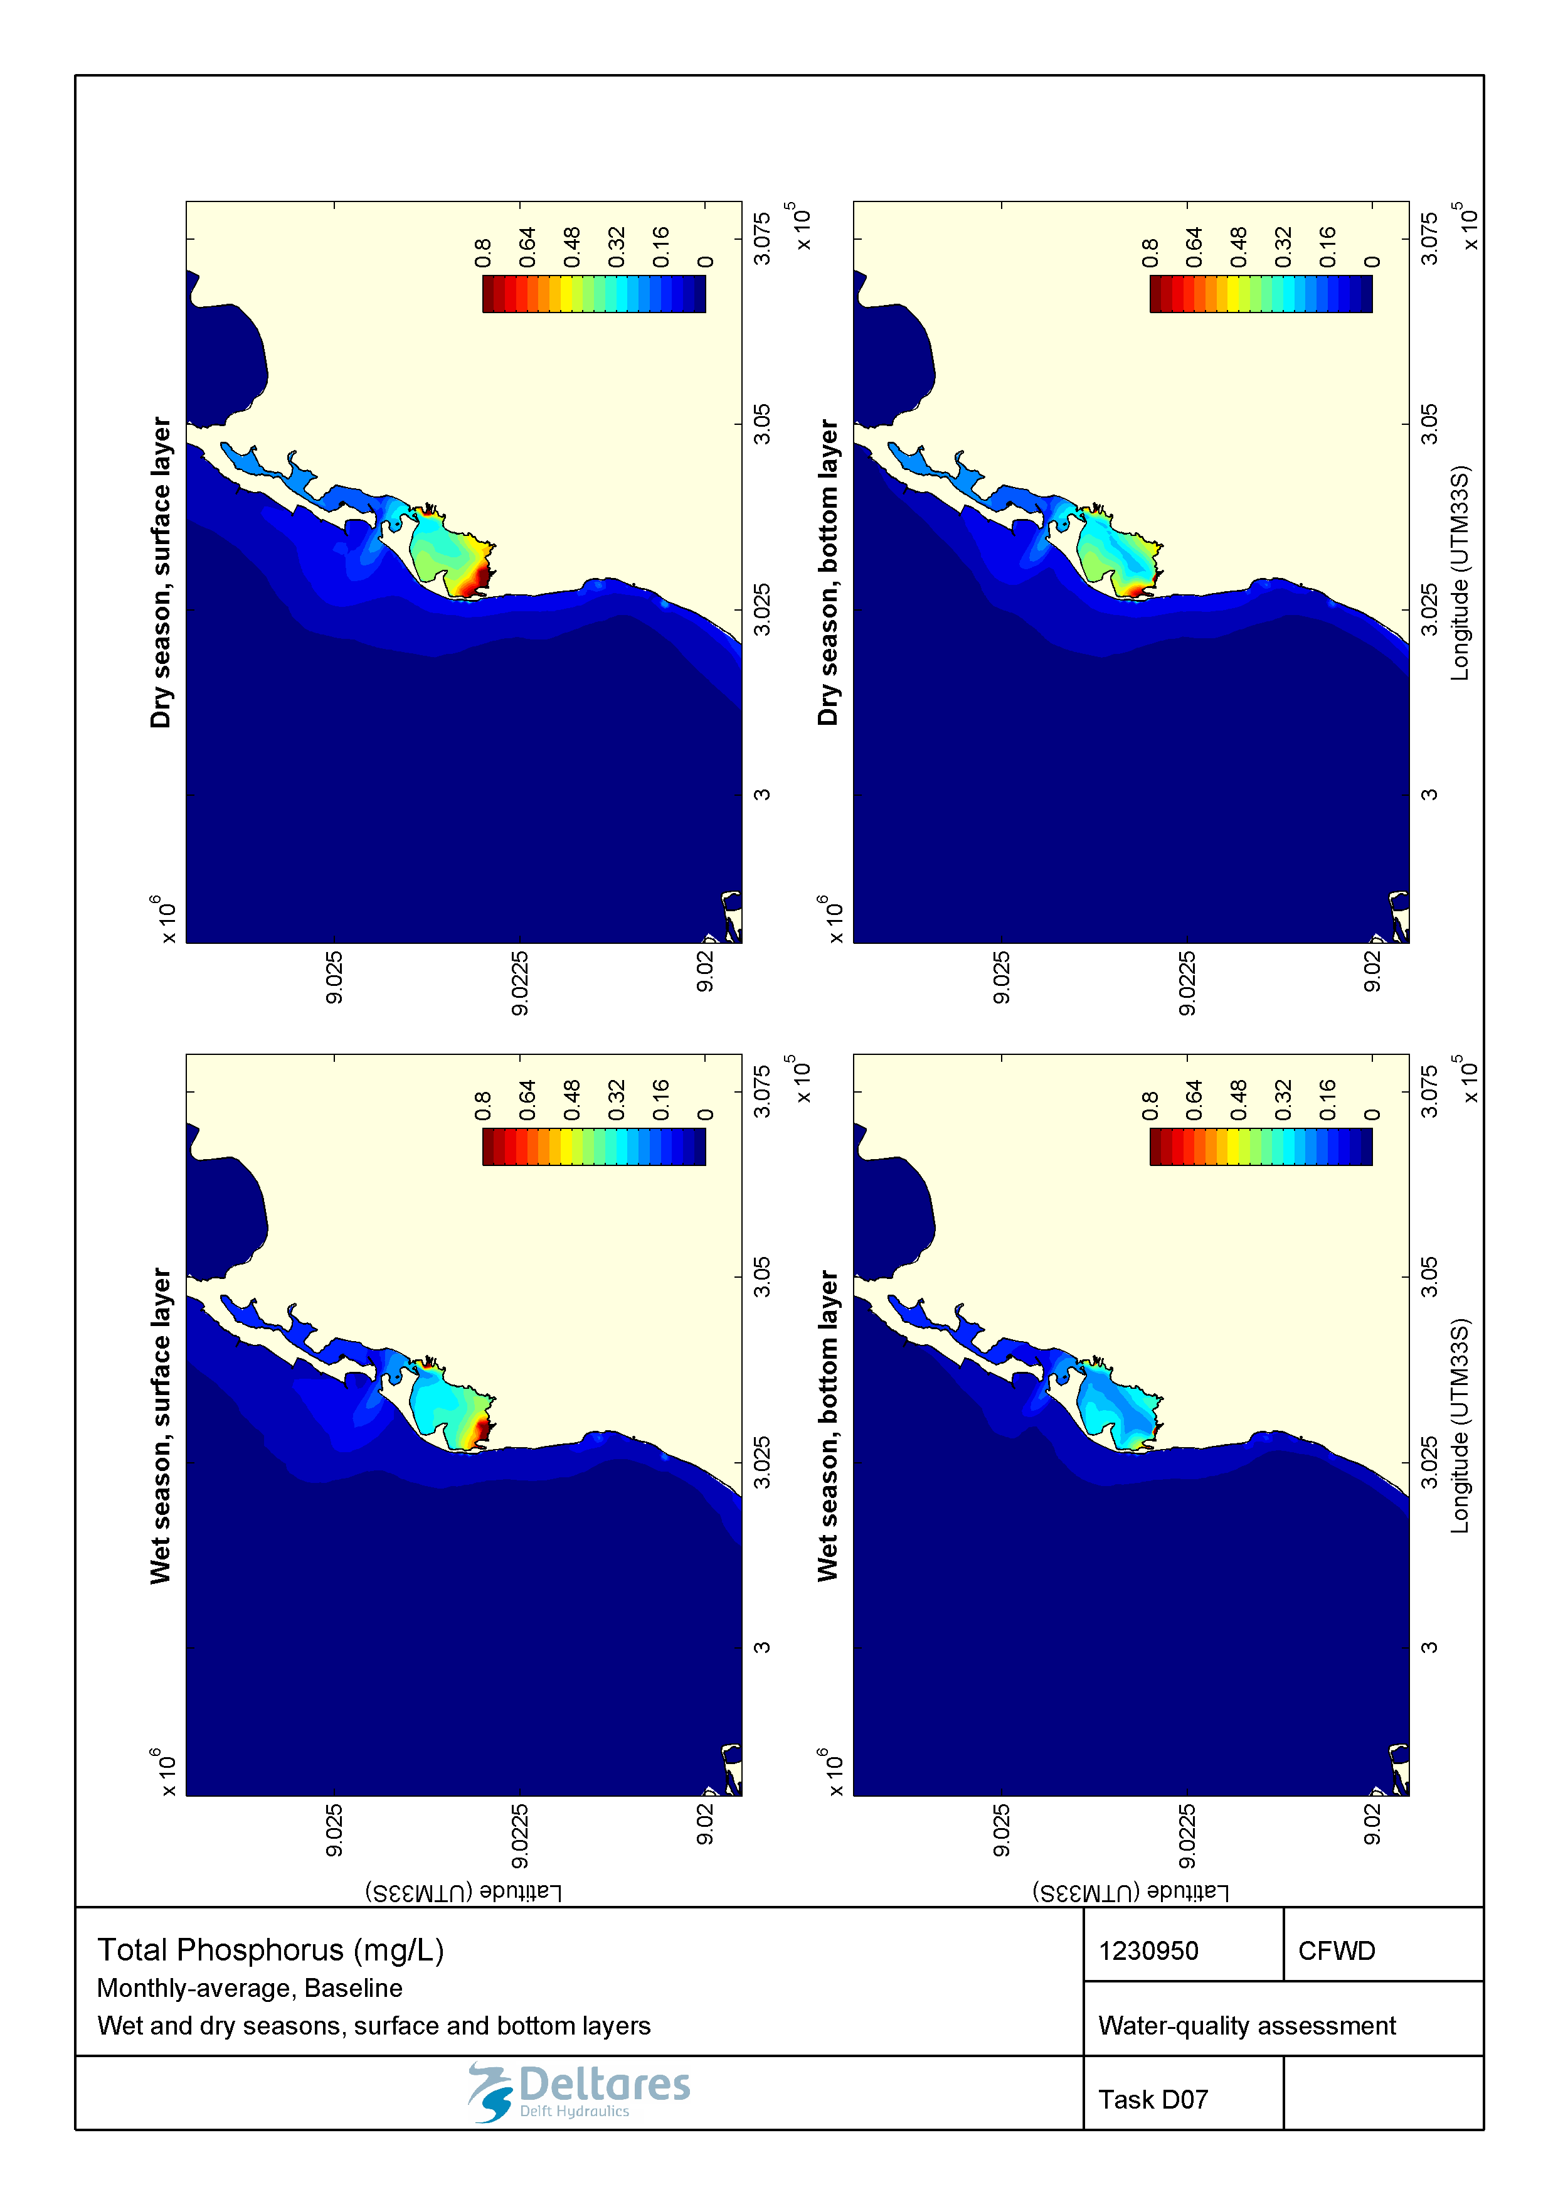

Figure 2.15 Monthly-averaged concentration of total phosphorus (mg/L) during wet and dry seasons in the surface and bottom layers for the baseline scenario.

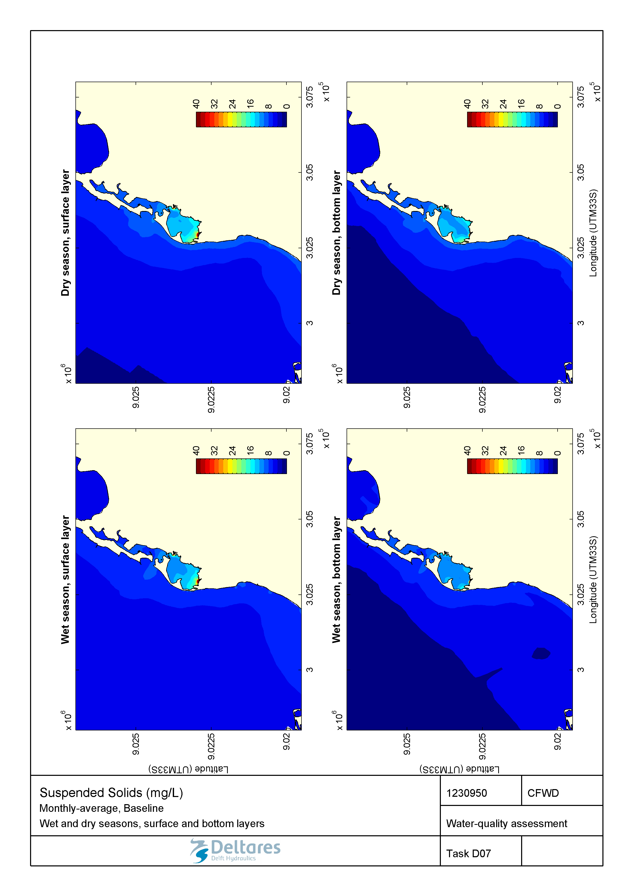

Figure 2.16 Monthly-averaged concentration of suspended solids (mg/L) during wet and dry seasons in the surface and bottom layers for the baseline scenario.

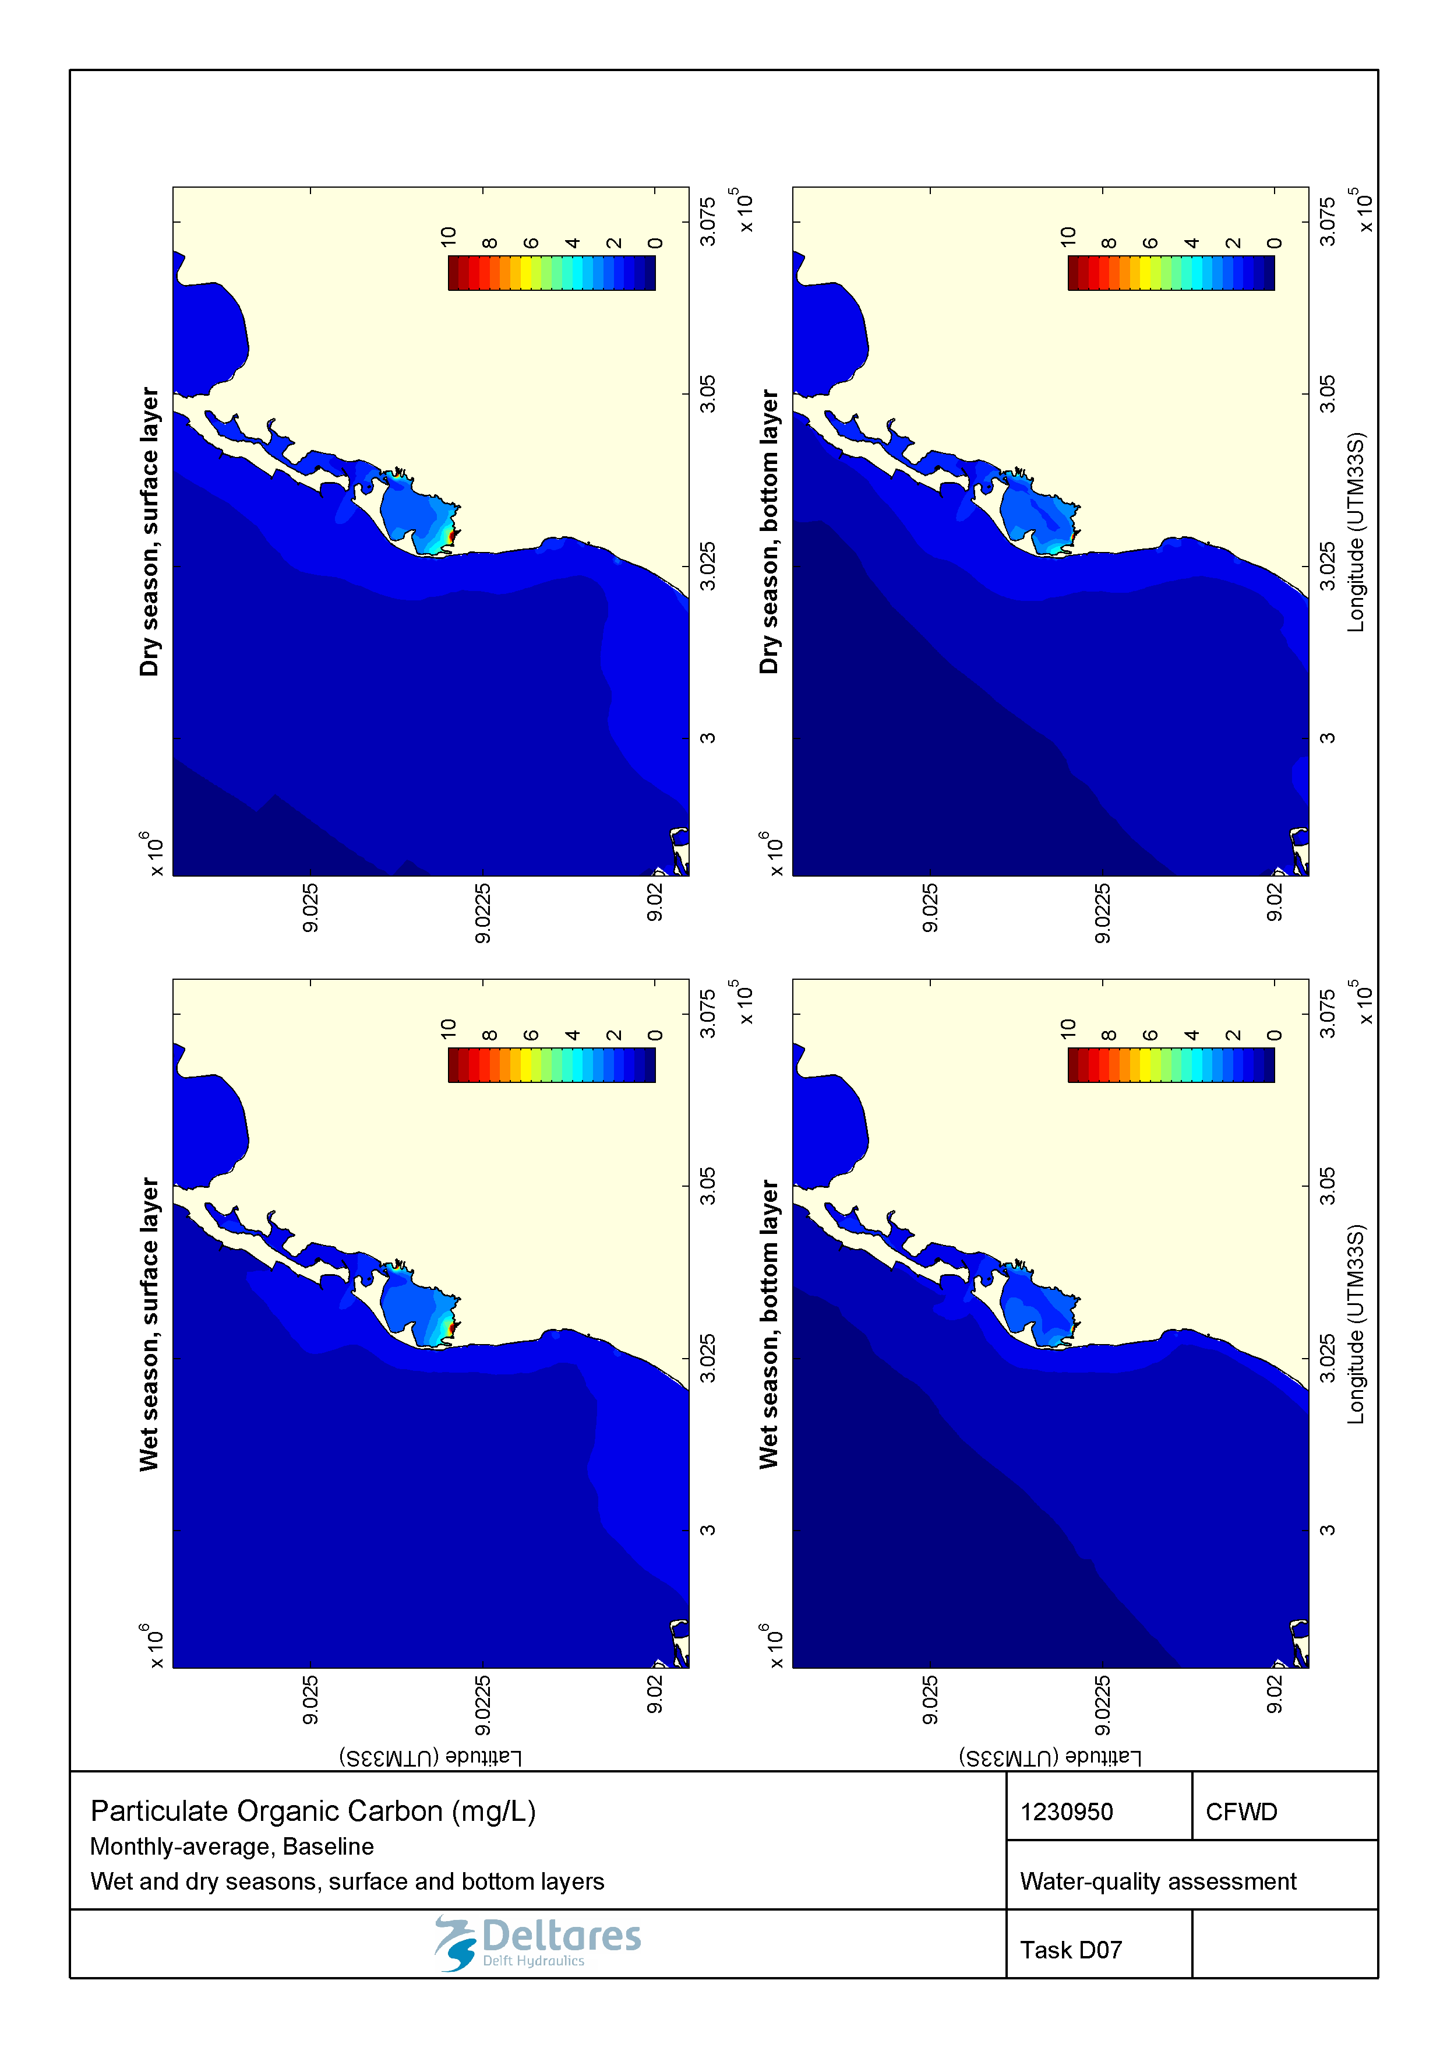

Figure 2.17 Monthly-averaged concentration of particulate organic carbon (mg/L) during wet and dry seasons in the surface and bottom layers for the baseline scenario.

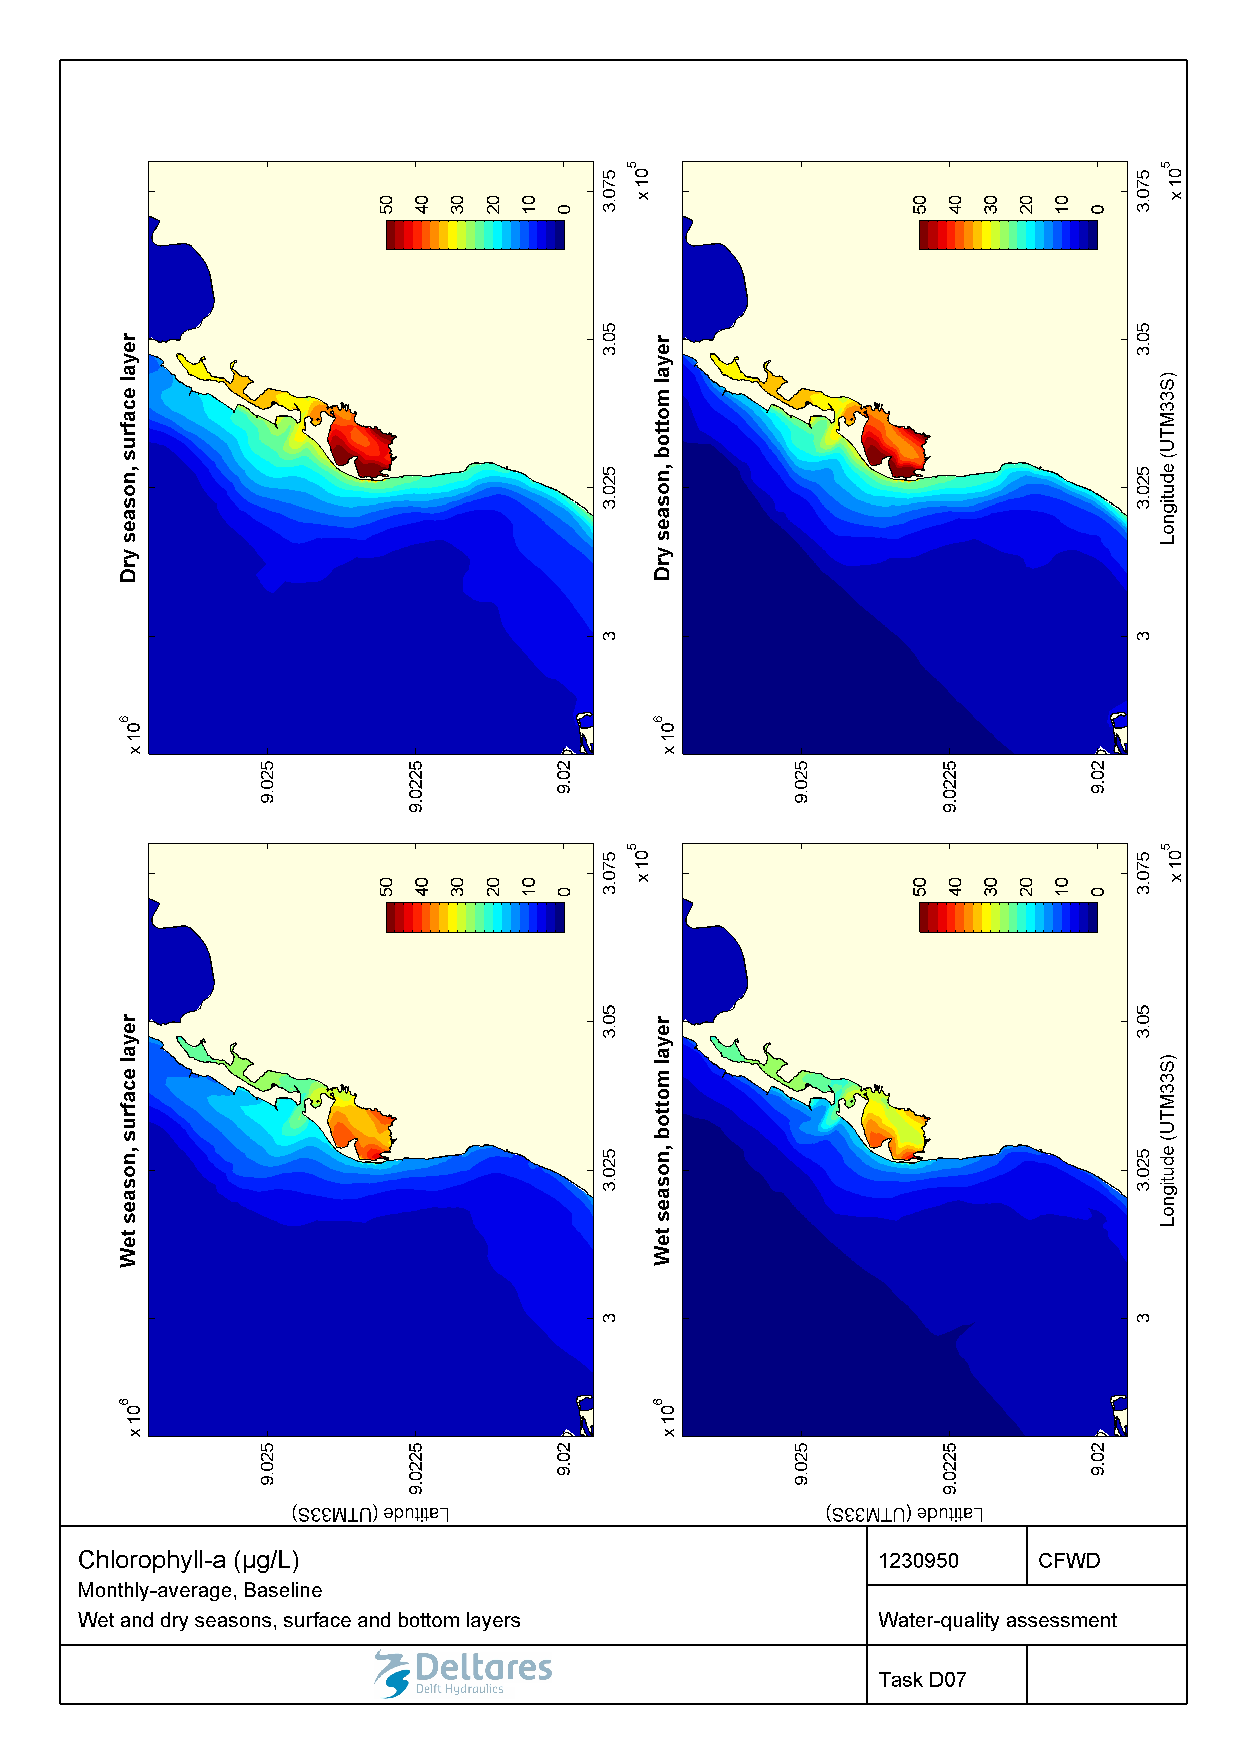

Figure 2.18 Monthly-averaged concentration of chlorophyll a (µg/L) during wet and dry seasons in the surface and bottom layers for the baseline scenario.

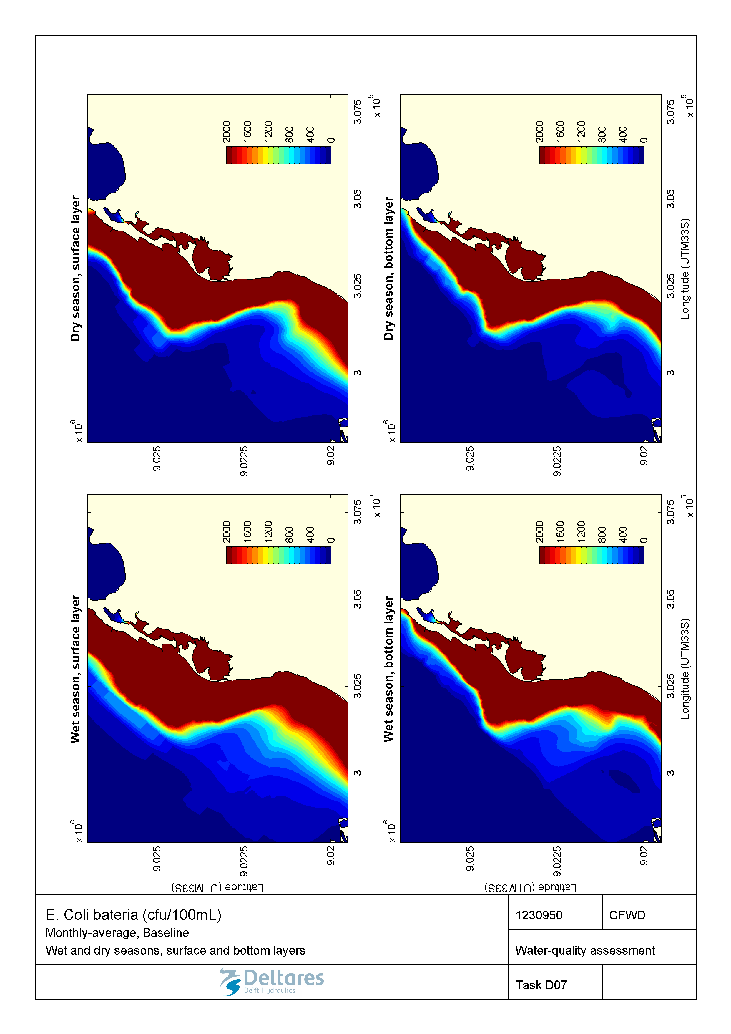

Figure 2.19 Monthly-averaged concentration of E. coli (cfu/100mL) during wet and dry seasons in the surface and bottom layers for the baseline scenario.

### Baseline scenario – 1-in-100-year storm event

The introduction of high loadings in a 24-hour period as in our 1-in-100-year storm event simulation, results in a very poor water-quality status as compared to average wet season conditions. The flushing and self-purification processes are not able to assimilate the loadings as under average conditions, which is resulting in stronger effects upon the marine environment.

During a 1-in-100-year storm event, the simulated salinity drops to minimum values of ca. 10 ppt in the project area, with a noticeable plume extending along the coast (Figure 2.20).

Strong vertical gradients are also observed, especially within the Samba lagoon. For dissolved oxygen, minimum concentrations below 2 mg/L are calculated in the Samba lagoon (Figure 2.21). Values below 2 mg/L occur for a few hours only. We note that low oxygen concentrations can cause significant damage to the existing marine life. Elevated total nitrogen and total phosphorus concentrations are also calculated for the project area (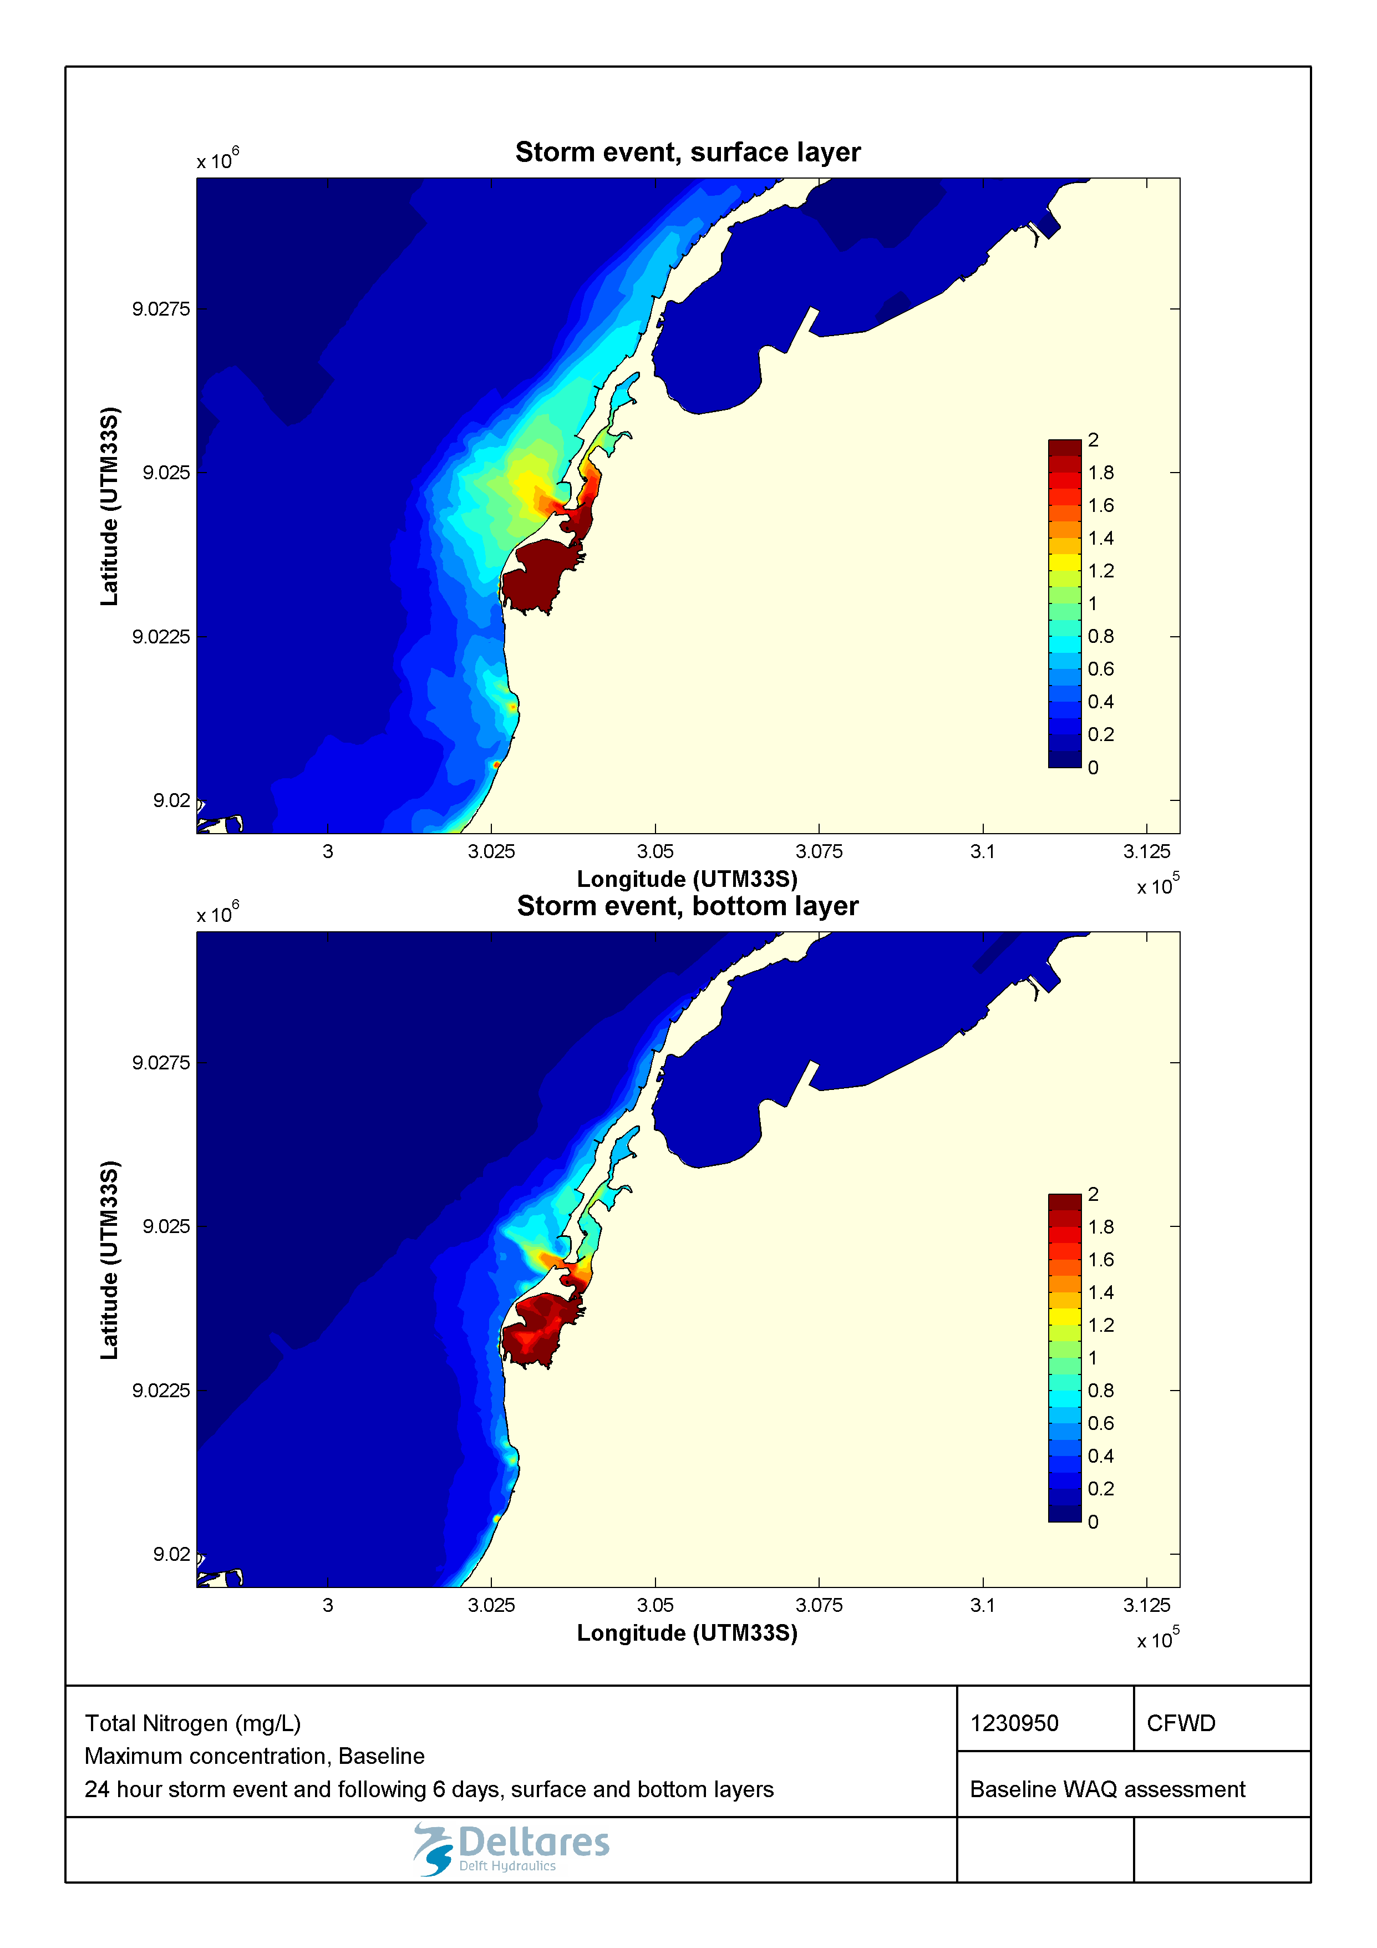

Figure 2.22 and Figure 2.23). This is explained by the high loads that occur during a storm event over a short period of time.

Outside of the Samba lagoon, the simulated maximum concentrations of total nitrogen and total phosphorus drop below 1 mgN/L and 0.4 mgP/L, respectively. Similar observations can be made for suspended solids and particulate organic carbon (Figure 2.24 and Figure 2.25), which are also supplied in large quantities by the valas to the Samba lagoon during a 1-in-100-year storm event. As a result, high concentrations of chlorophyll-a (up to 50 μg/l, Figure 2.26) are simulated within the Samba lagoon, and directly in the vicinity of its mouth to the Atlantic Ocean. Similarly, since large quantities of wastewater are discharged during a storm event, high concentrations of *E. coli* are simulated in the vicinity of the valas outfalls (Figure 2.27). These values exceed the suitability criterion for swimming water (in the order of several hundreds of cfu/100ml) by several orders of magnitude over large areas.

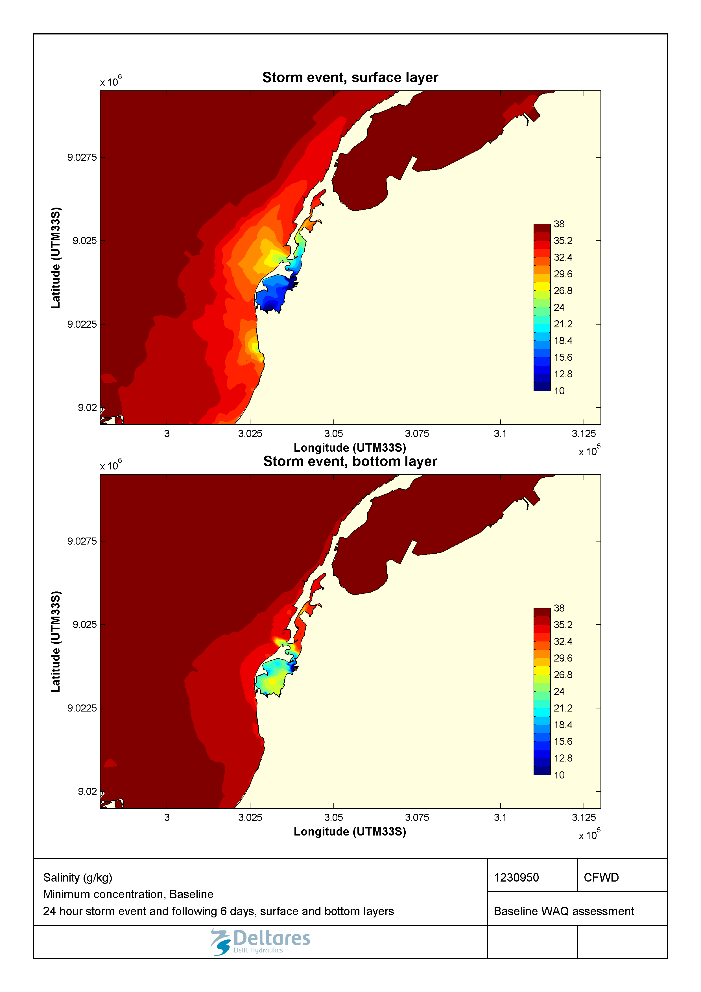

Figure 2.20 Minimum salinity (g/kg) during a 1-in-100-year storm event in the surface and bottom layers for the baseline scenario.

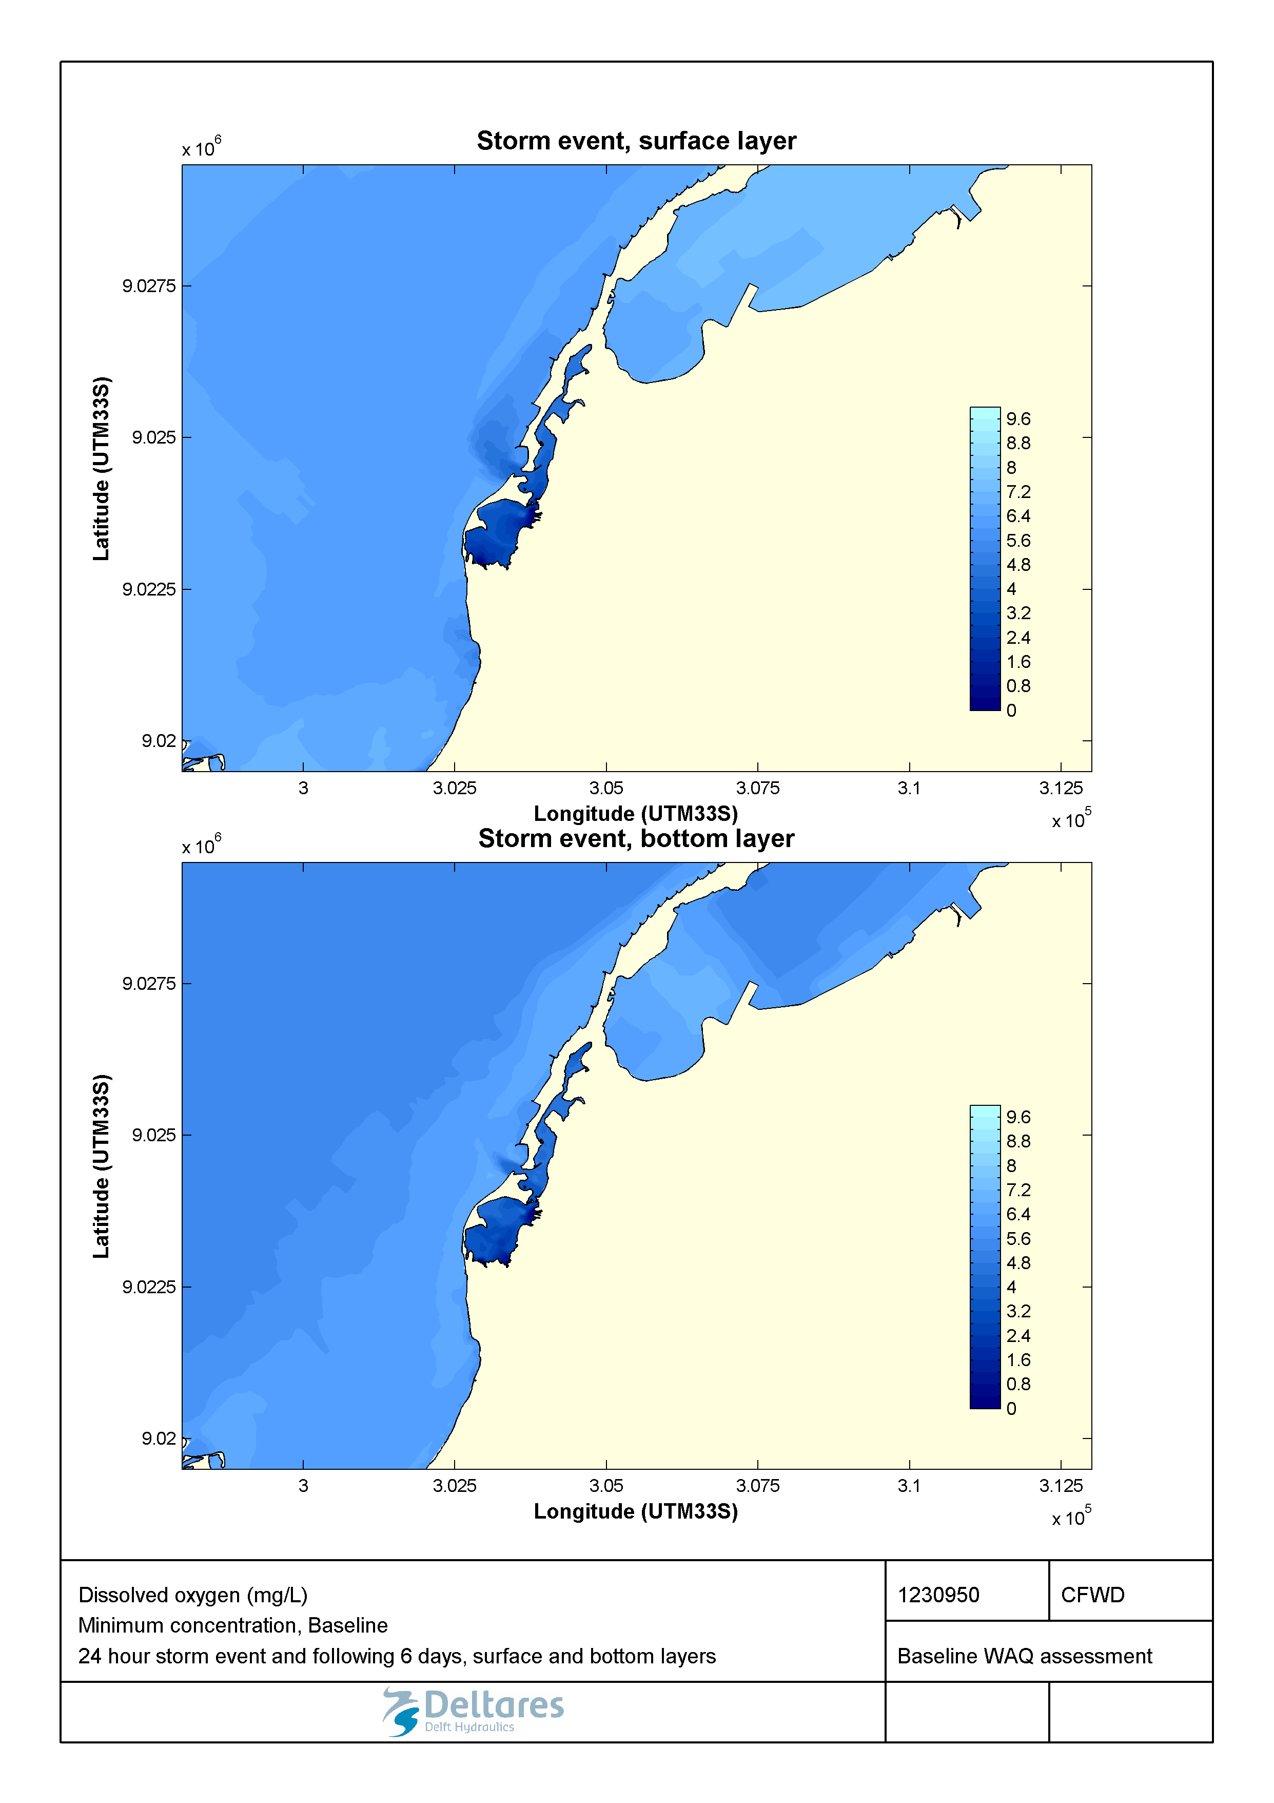

Figure 2.21 Minimum concentration of dissolved oxygen (mg/L) during a 1-in-100-year storm event in the surface and bottom layers for the baseline scenario.



Figure 2.22 Maximum concentration of total nitrogen (mg/L) during a 1-in-100-year storm event in the surface and bottom layers for the baseline scenario.

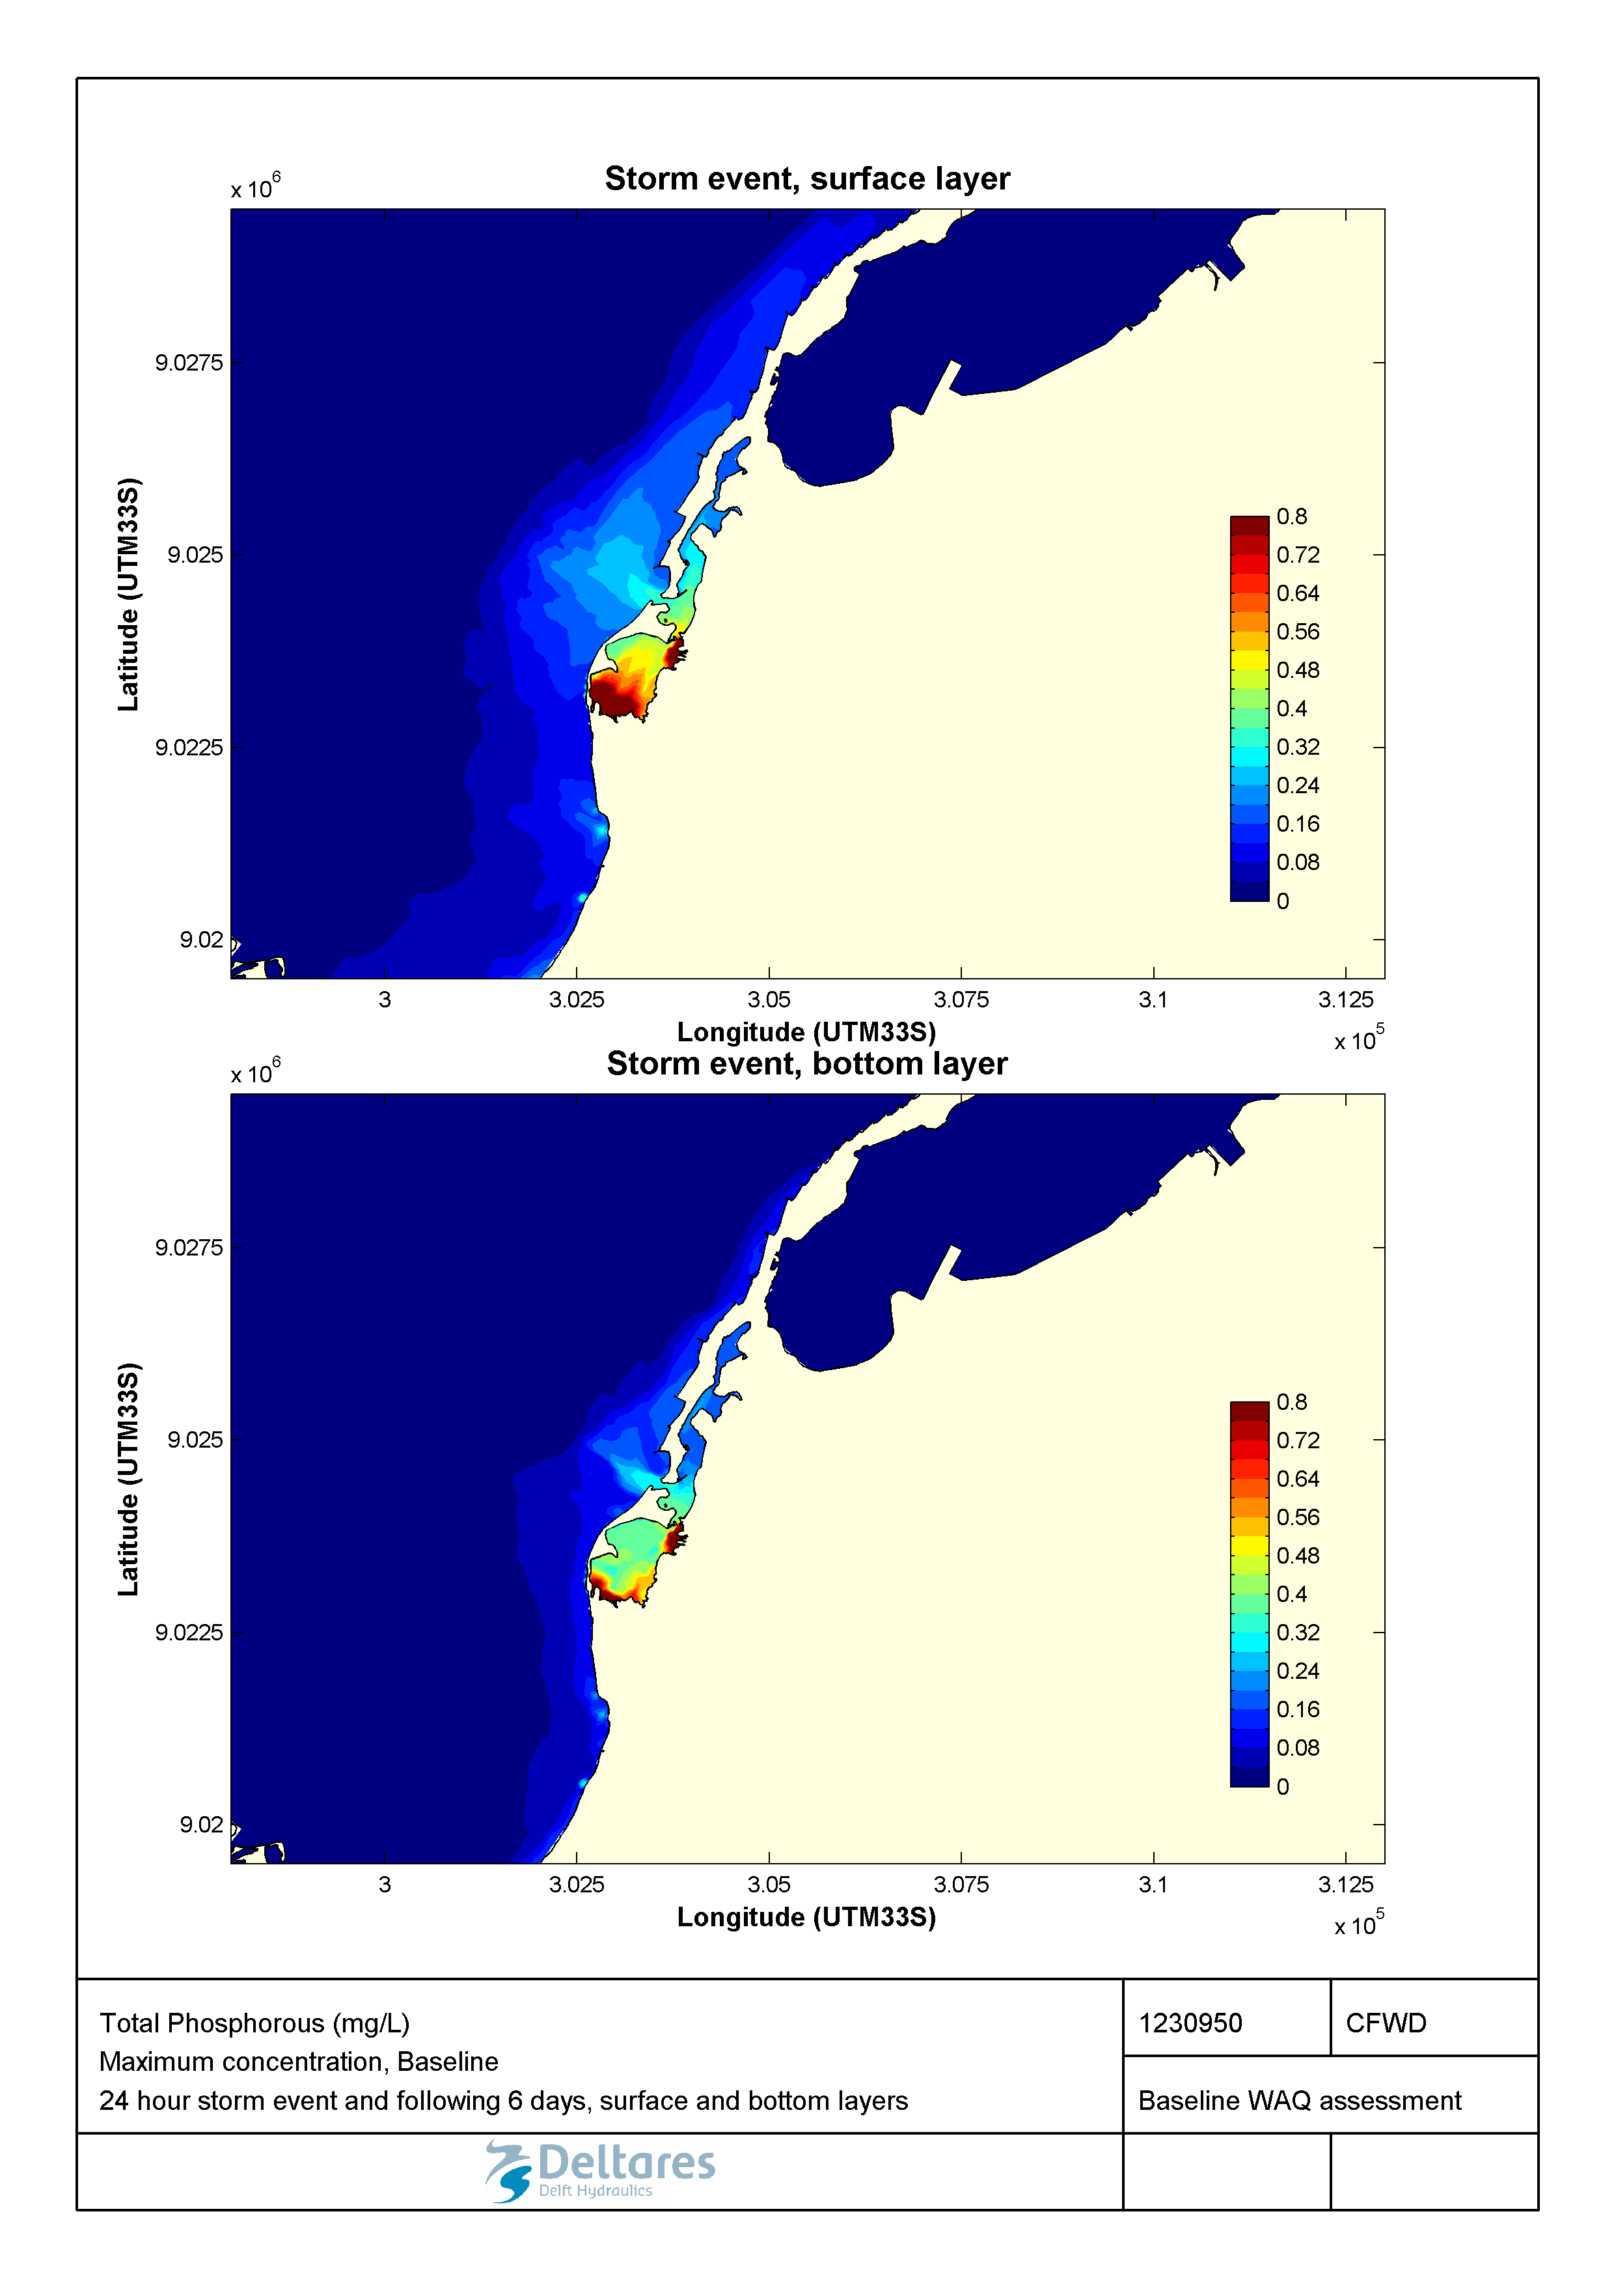

Figure 2.23 Maximum concentration of total phosphorus (mg/L) during a 1-in-100-year storm event in the surface and bottom layers for the baseline scenario.

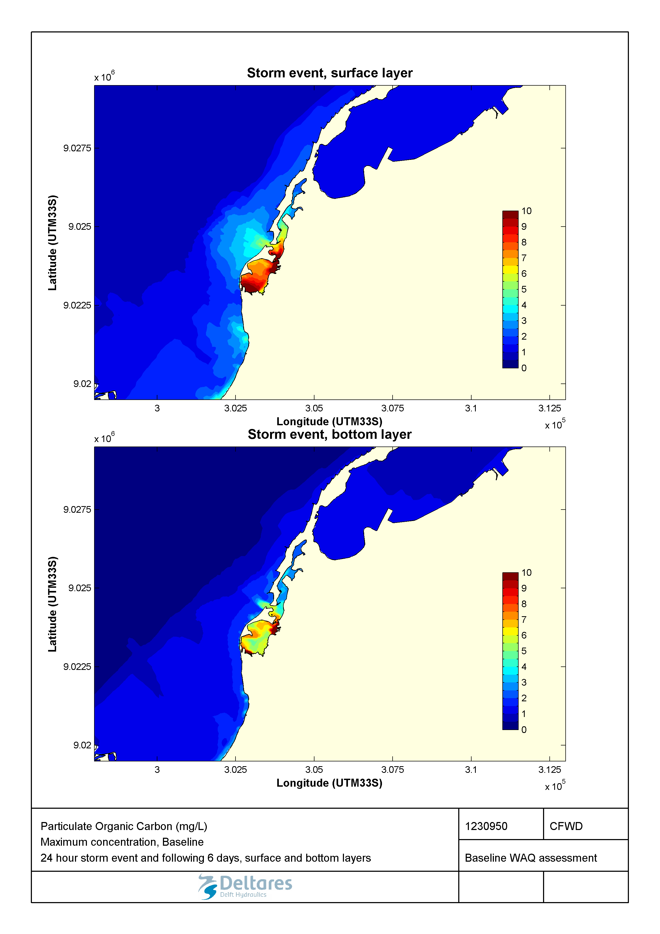

Figure 2.24 Maximum concentration of particulate organic carbon (mg/L) during a 1-in-100-year storm event in the surface and bottom layers for the baseline scenario.

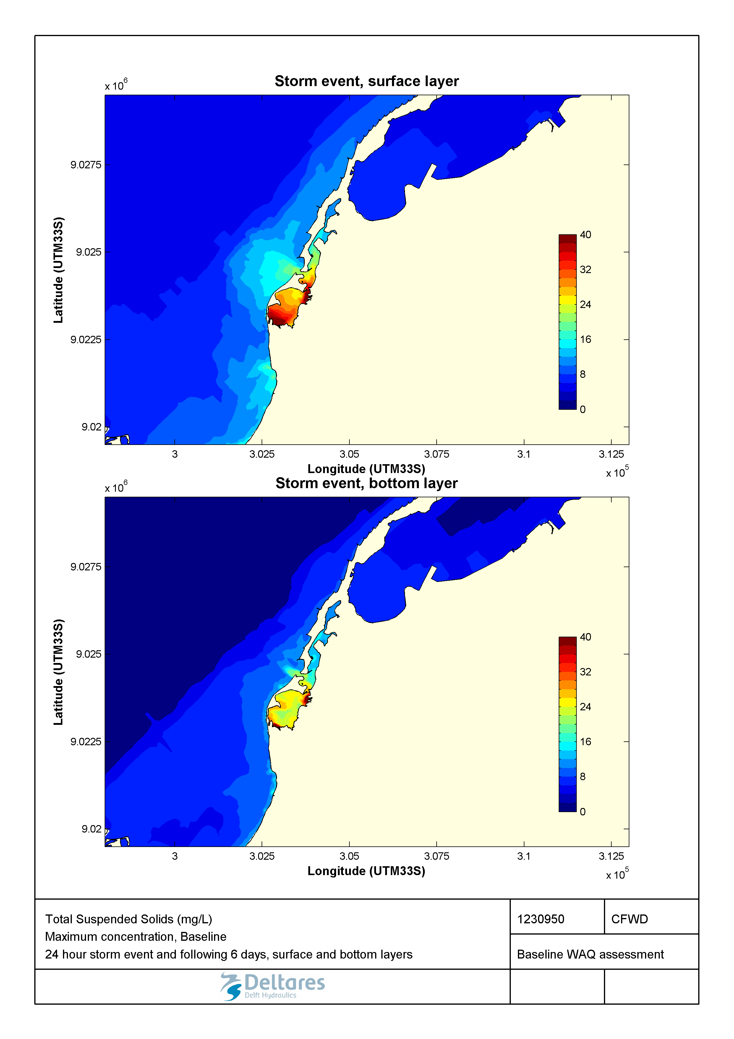

Figure 2.25 Maximum concentration of suspended solids (mg/L) during a 1-in-100-year storm event in the surface and bottom layers for the baseline scenario.

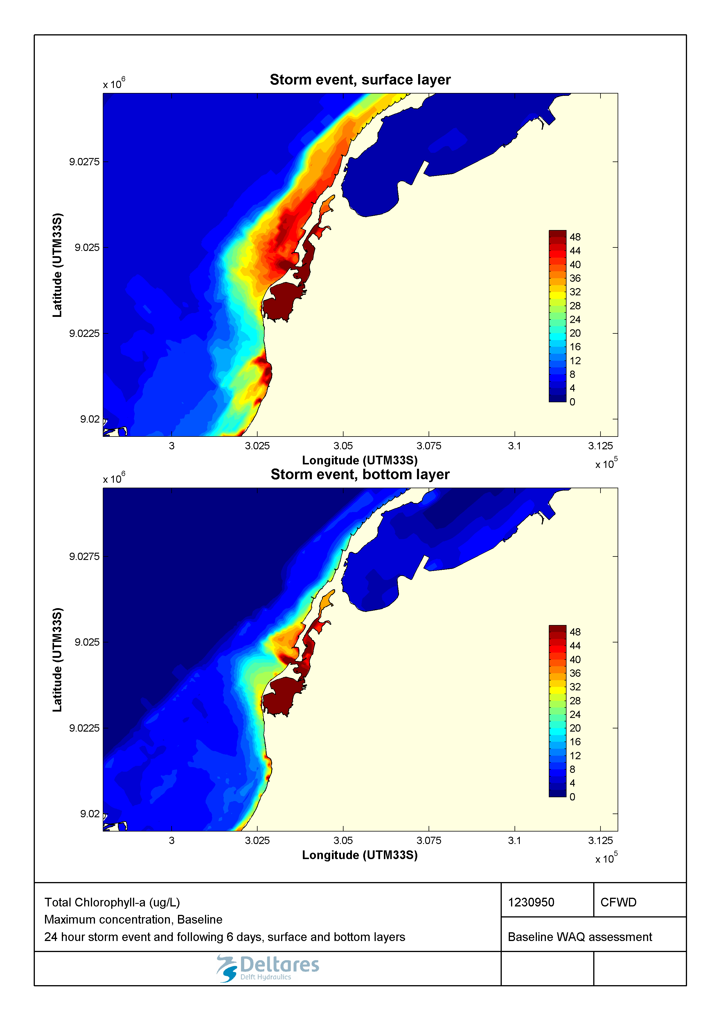

Figure 2.26 Maximum concentration of chlorophyll a (µg/L) during a 1-in-100-year storm event in the surface and bottom layers for the baseline scenario.

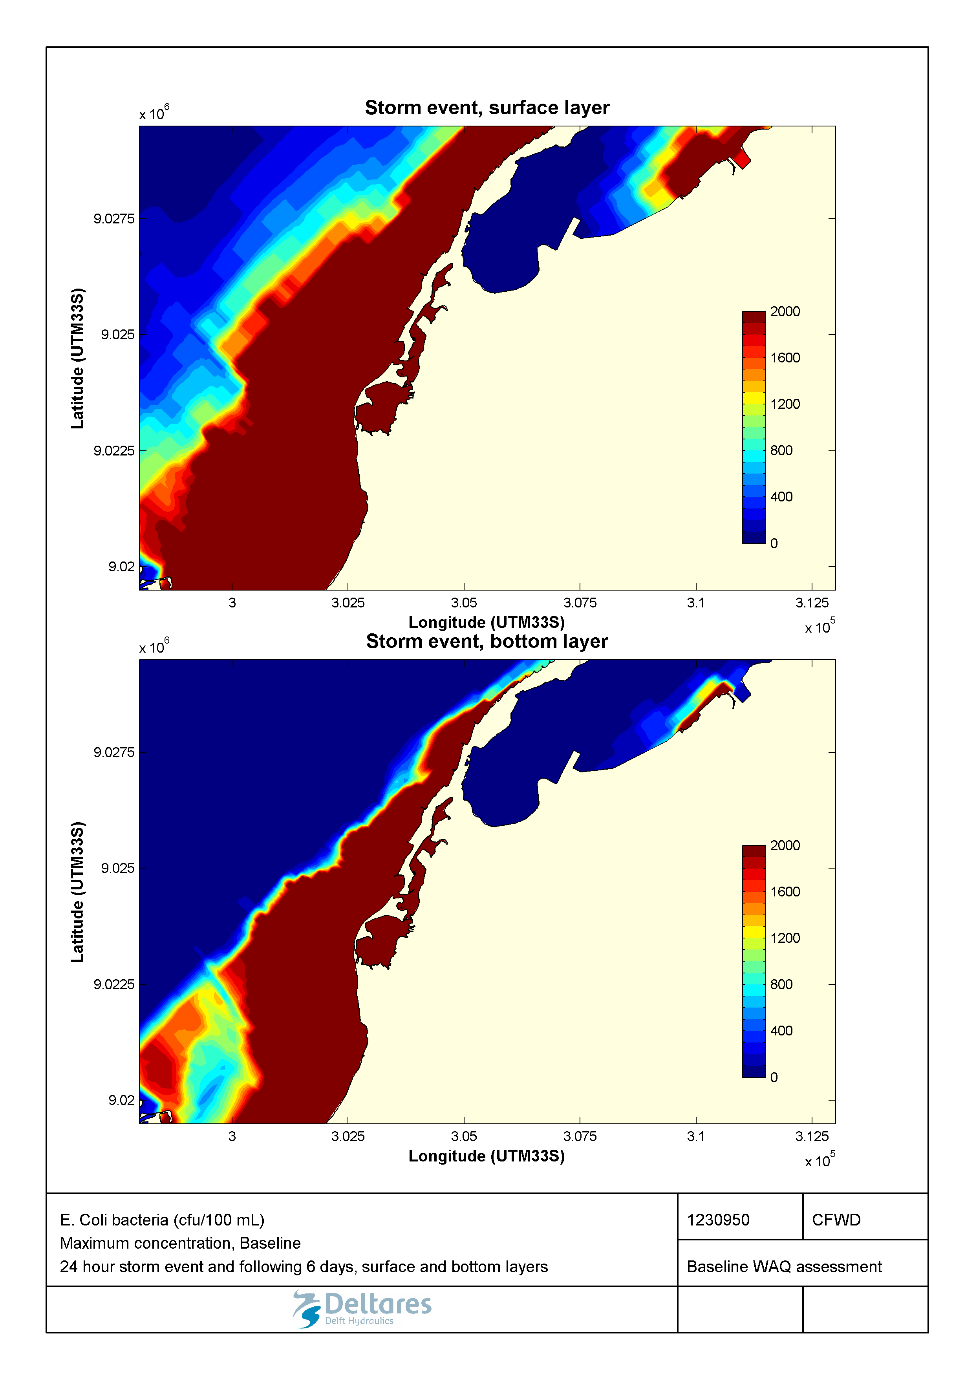

Figure 2.27 Maximum concentration of E. coli (cfu/100mL) during a 1-in-100-year storm event in the surface and bottom layers for the baseline scenario.

### Marginal de Corimba development scenario – seasonal water quality patterns

Apart from the obvious changes in the coastline, the Marginal de Corimba development differs from the baseline with respect to the pollution loadings. The main difference is that wastewater from the valas will be collected and treated, which leads to reduced loadings to Corimba channel.

In order to evaluate the impact of the change in coastline resulting from the Marginal de Corimba development in isolation from the wastewater treatment, two Marginal de Corimba development schemes are analysed. The first consists of changes to the coastline and the resulting drainage basin sizes with respect to the baseline. The second is equivalent to the former in all respects except that a 100% wastewater treatment is applied in the dry season and an 85% wastewater treatment is applied in the wet season. During rain events however, the collection and treatment capacity is expected to be exceeded, and we assume no loading reduction resulting from wastewater treatment. This is a conservative assumption.

#### No wastewater treatment applied

The effect of the change in coastline and drainage basin size in the Marginal Phase 4 development is a generally small change to water quality compared to baseline conditions. For both salinity and oxygen (Figure 2.28 and Figure 2.29), there is little difference between baseline and phase 4 developments without wastewater treatment. However, the removal of the previously enclosed Samba Lagoon now allows for greater flushing and thus higher dissolved oxygen concentrations in the Corimba Channel region.

The average concentrations of total N and P (Figure 2.30 and Figure 2.31) are comparable between both scenarios in the wet season. We see that the phase 4 development scenario exhibits only slightly higher concentrations due to a greater overall loading. For example, this effect is exhibited by the higher concentrations near valas 3, 5, 6 and 7 where more nutrients are observed in the surface layer under the new drainage conditions. As the Samba Lagoon has been removed in phase 4, there is less potential for evaporation induced concentration of N and P within the area that is now the Corimba Channel due to increased flushing, and as a result dry season N and P concentrations in the bottom layer are slightly reduced under the phase 4 development scenario.

Whereas in the baseline, suspended solids concentrations were quite low in areas not directly adjacent to an outfall, the new configuration in phase 4 causes there to be slightly higher average concentrations in the area just south of Sodimo Lagoon (Figure 2.33). The same can be said for particulate organic carbon (Figure 2.32), which is a constituent of total suspended solids. This is thought to be a result of increased residence times in the area and consequently more algae growth.

Aside from some slightly higher concentrations near the south Sodimo Lagoon, chlorophyll-a is still observed at comparable concentrations under the new scenario (Figure 2.34), but the spatial patterns of its extent are changed by the new coastline configuration. Whereas previously the single straight between the inner Samba and Sodimo Lagoon area caused the algae to enter the Atlantic Ocean at a single point and spread along the coast, the new configuration of the Corimba Channel causes the algae to spread in a more diffuse manner via two straights, resulting in lower concentrations along the north and south coasts of the development in the dry season.

The new phase 4 development does not cause any considerable changes in the average *E.* coli concentrations, and *E. coli* is still in exceedanceof the suitability criterion for swimming water (in the order of several hundreds of cfu/100ml, Figure 2.35) over the whole of Samba Lagoon including the adjacent open sea waters.

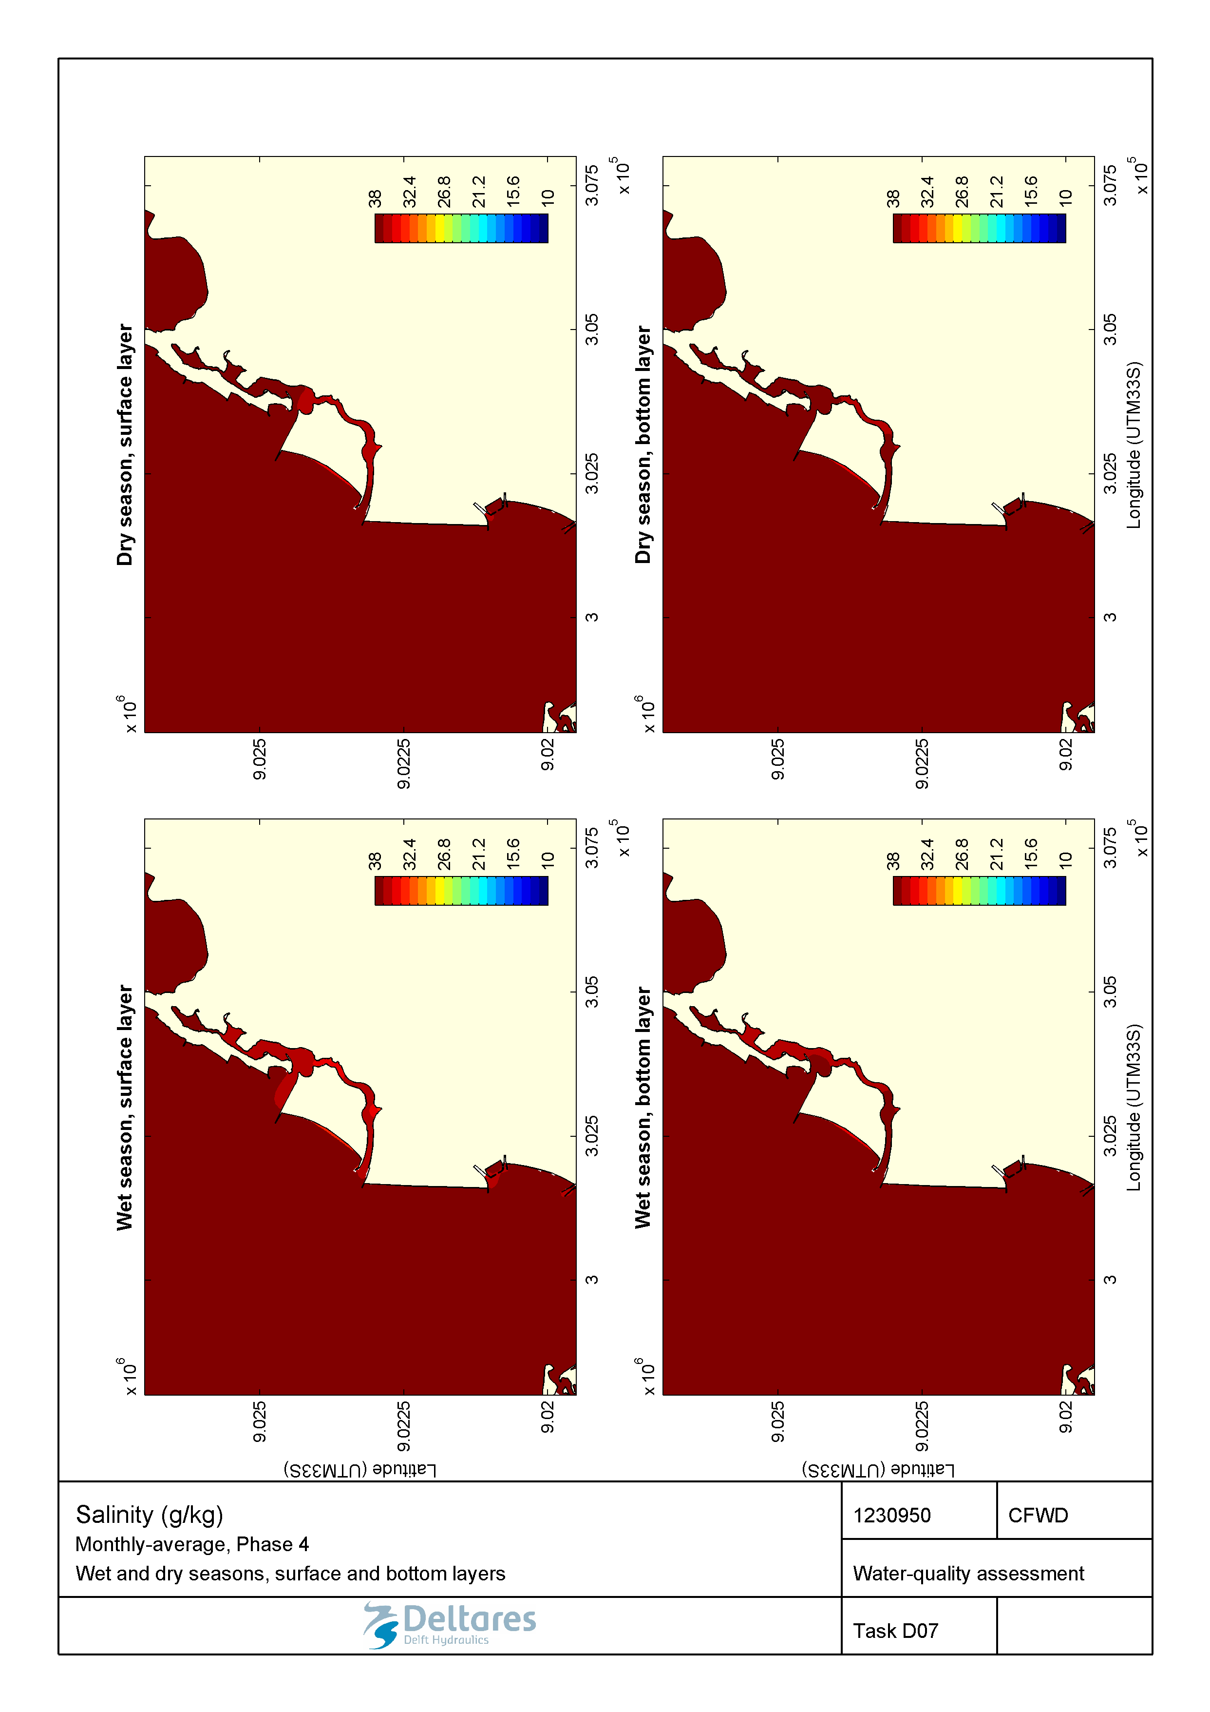

Figure 2.28 Monthly-averaged salinity (g/kg) during wet and dry seasons in the surface and bottom layers for the Marginal Phase4 developments.

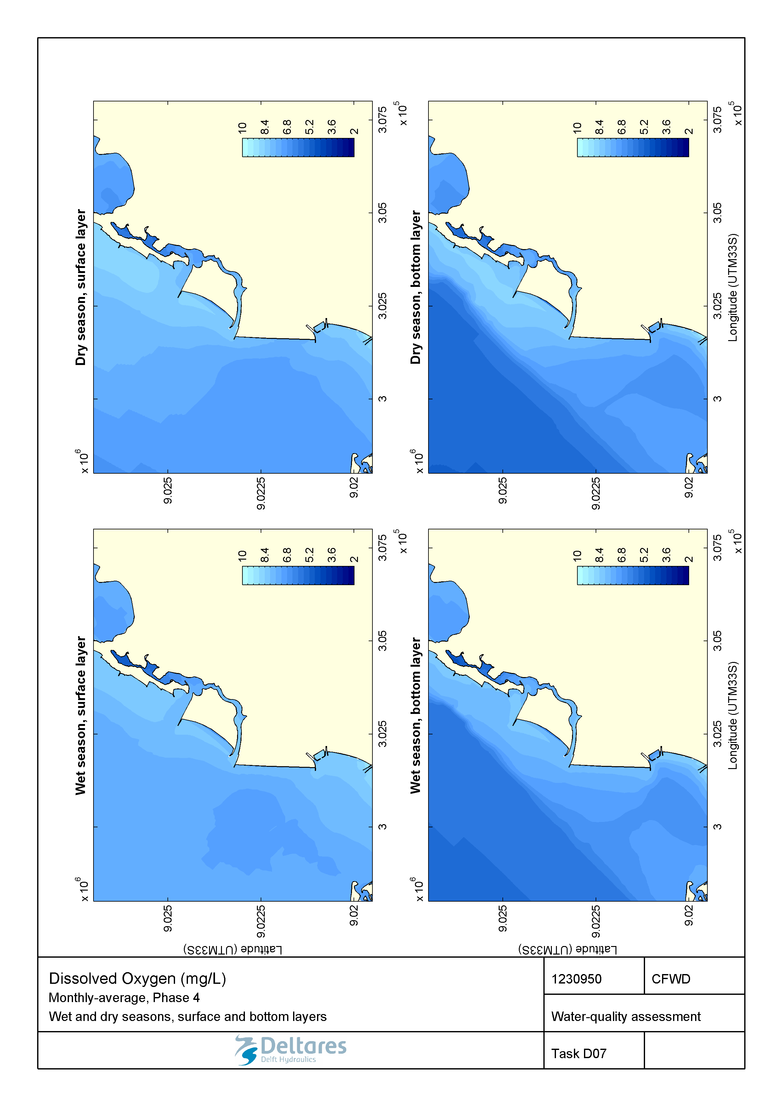

Figure 2.29 Monthly-averaged dissolved oxygen (mg/L) during wet and dry seasons in the surface and bottom layers for the Marginal Phase4 developments.

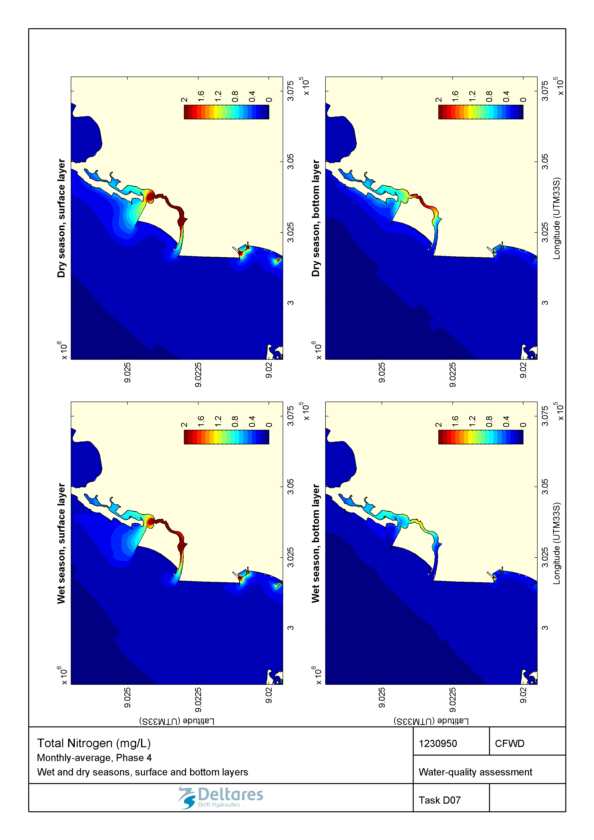

Figure 2.30 Monthly-averaged total nitrogen (mg/L) during wet and dry seasons in the surface and bottom layers for the Marginal Phase4 developments.

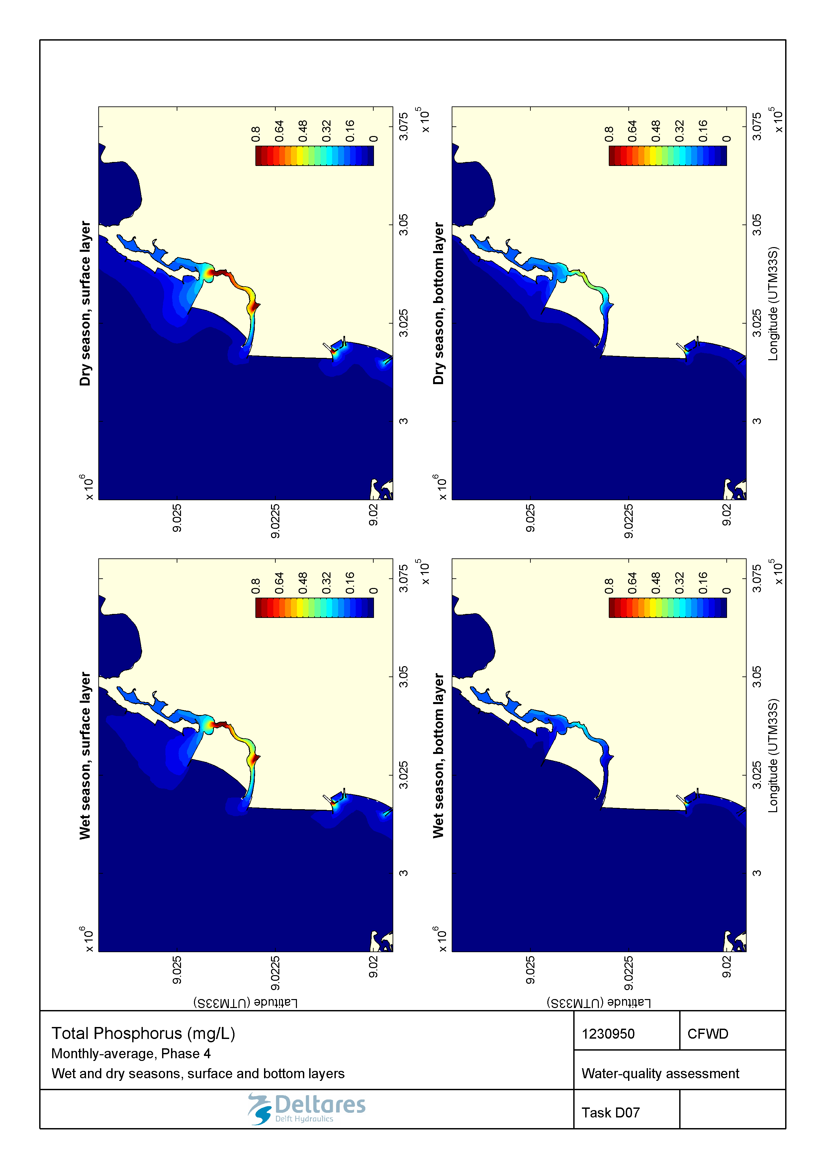

Figure 2.31 Monthly-averaged total phosphorous (mg/L) during wet and dry seasons in the surface and bottom layers for the Marginal Phase4 developments.

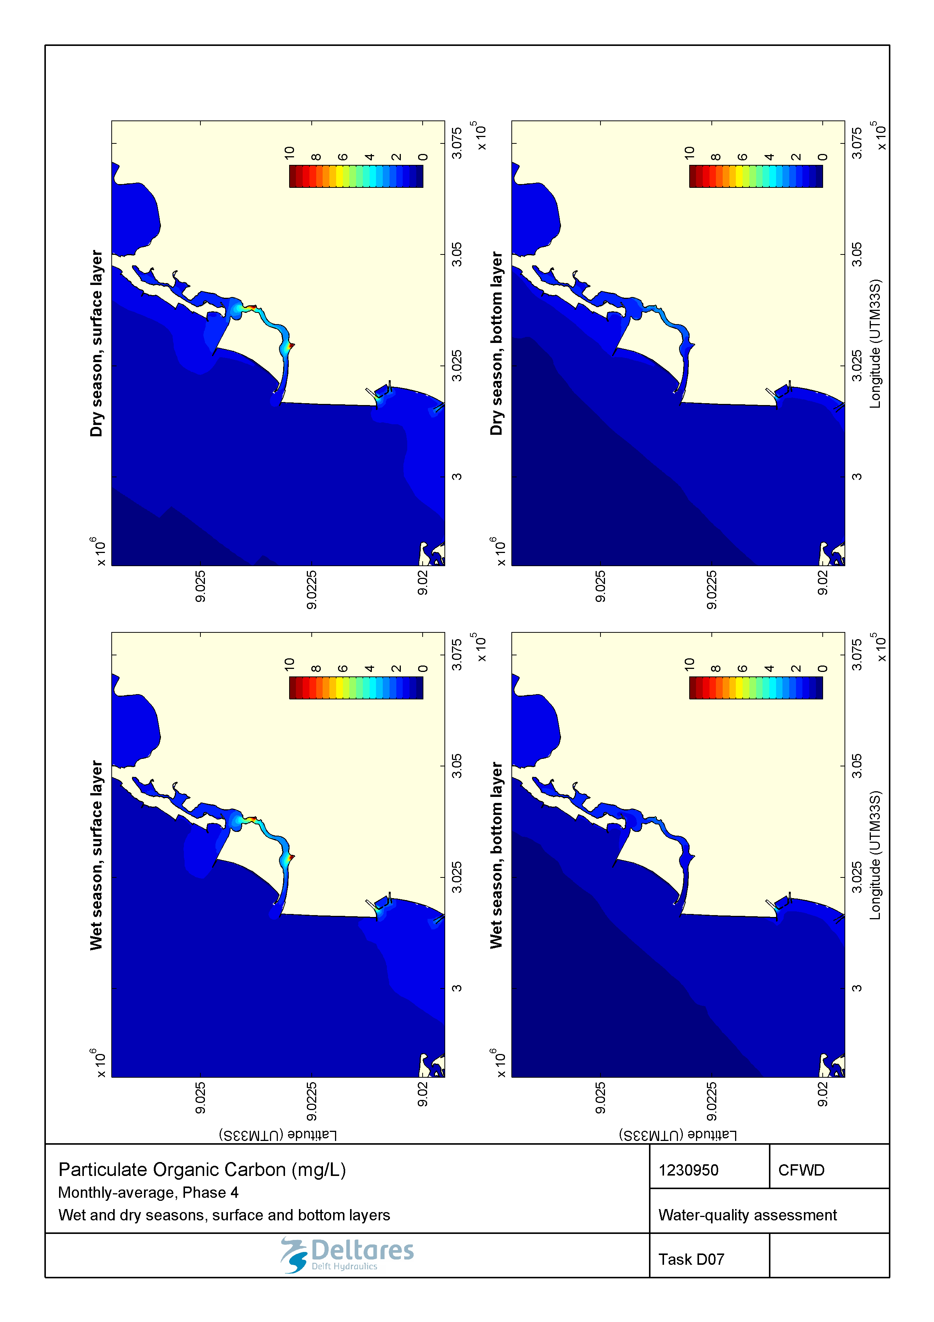

Figure 2.32 Monthly-averaged particulate organic carbon (mg/L) during wet and dry seasons in the surface and bottom layers for the Marginal Phase4 developments.

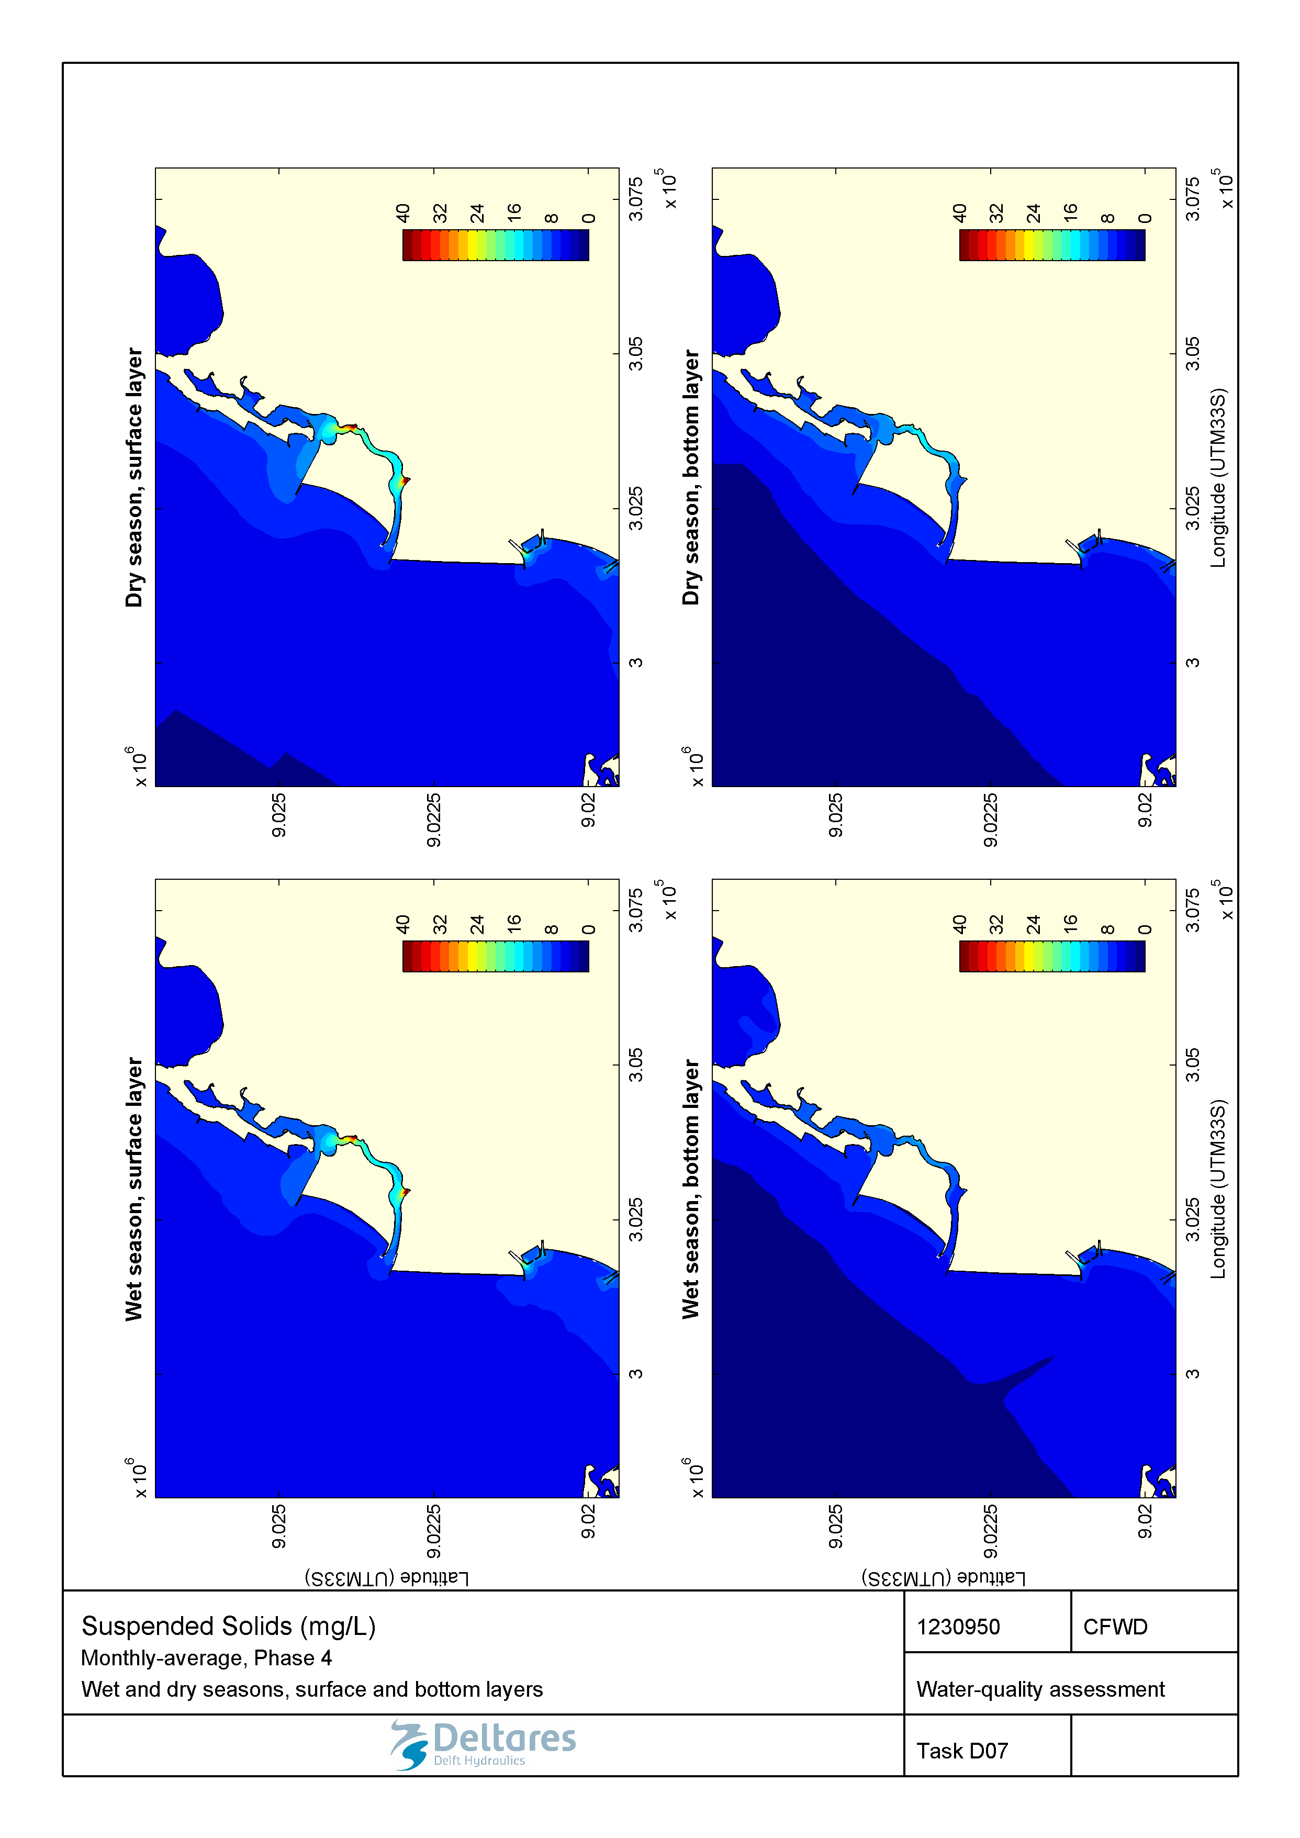

Figure 2.33 Monthly-averaged total suspended solids (mg/L) during wet and dry seasons in the surface and bottom layers for the Marginal Phase4 developments.

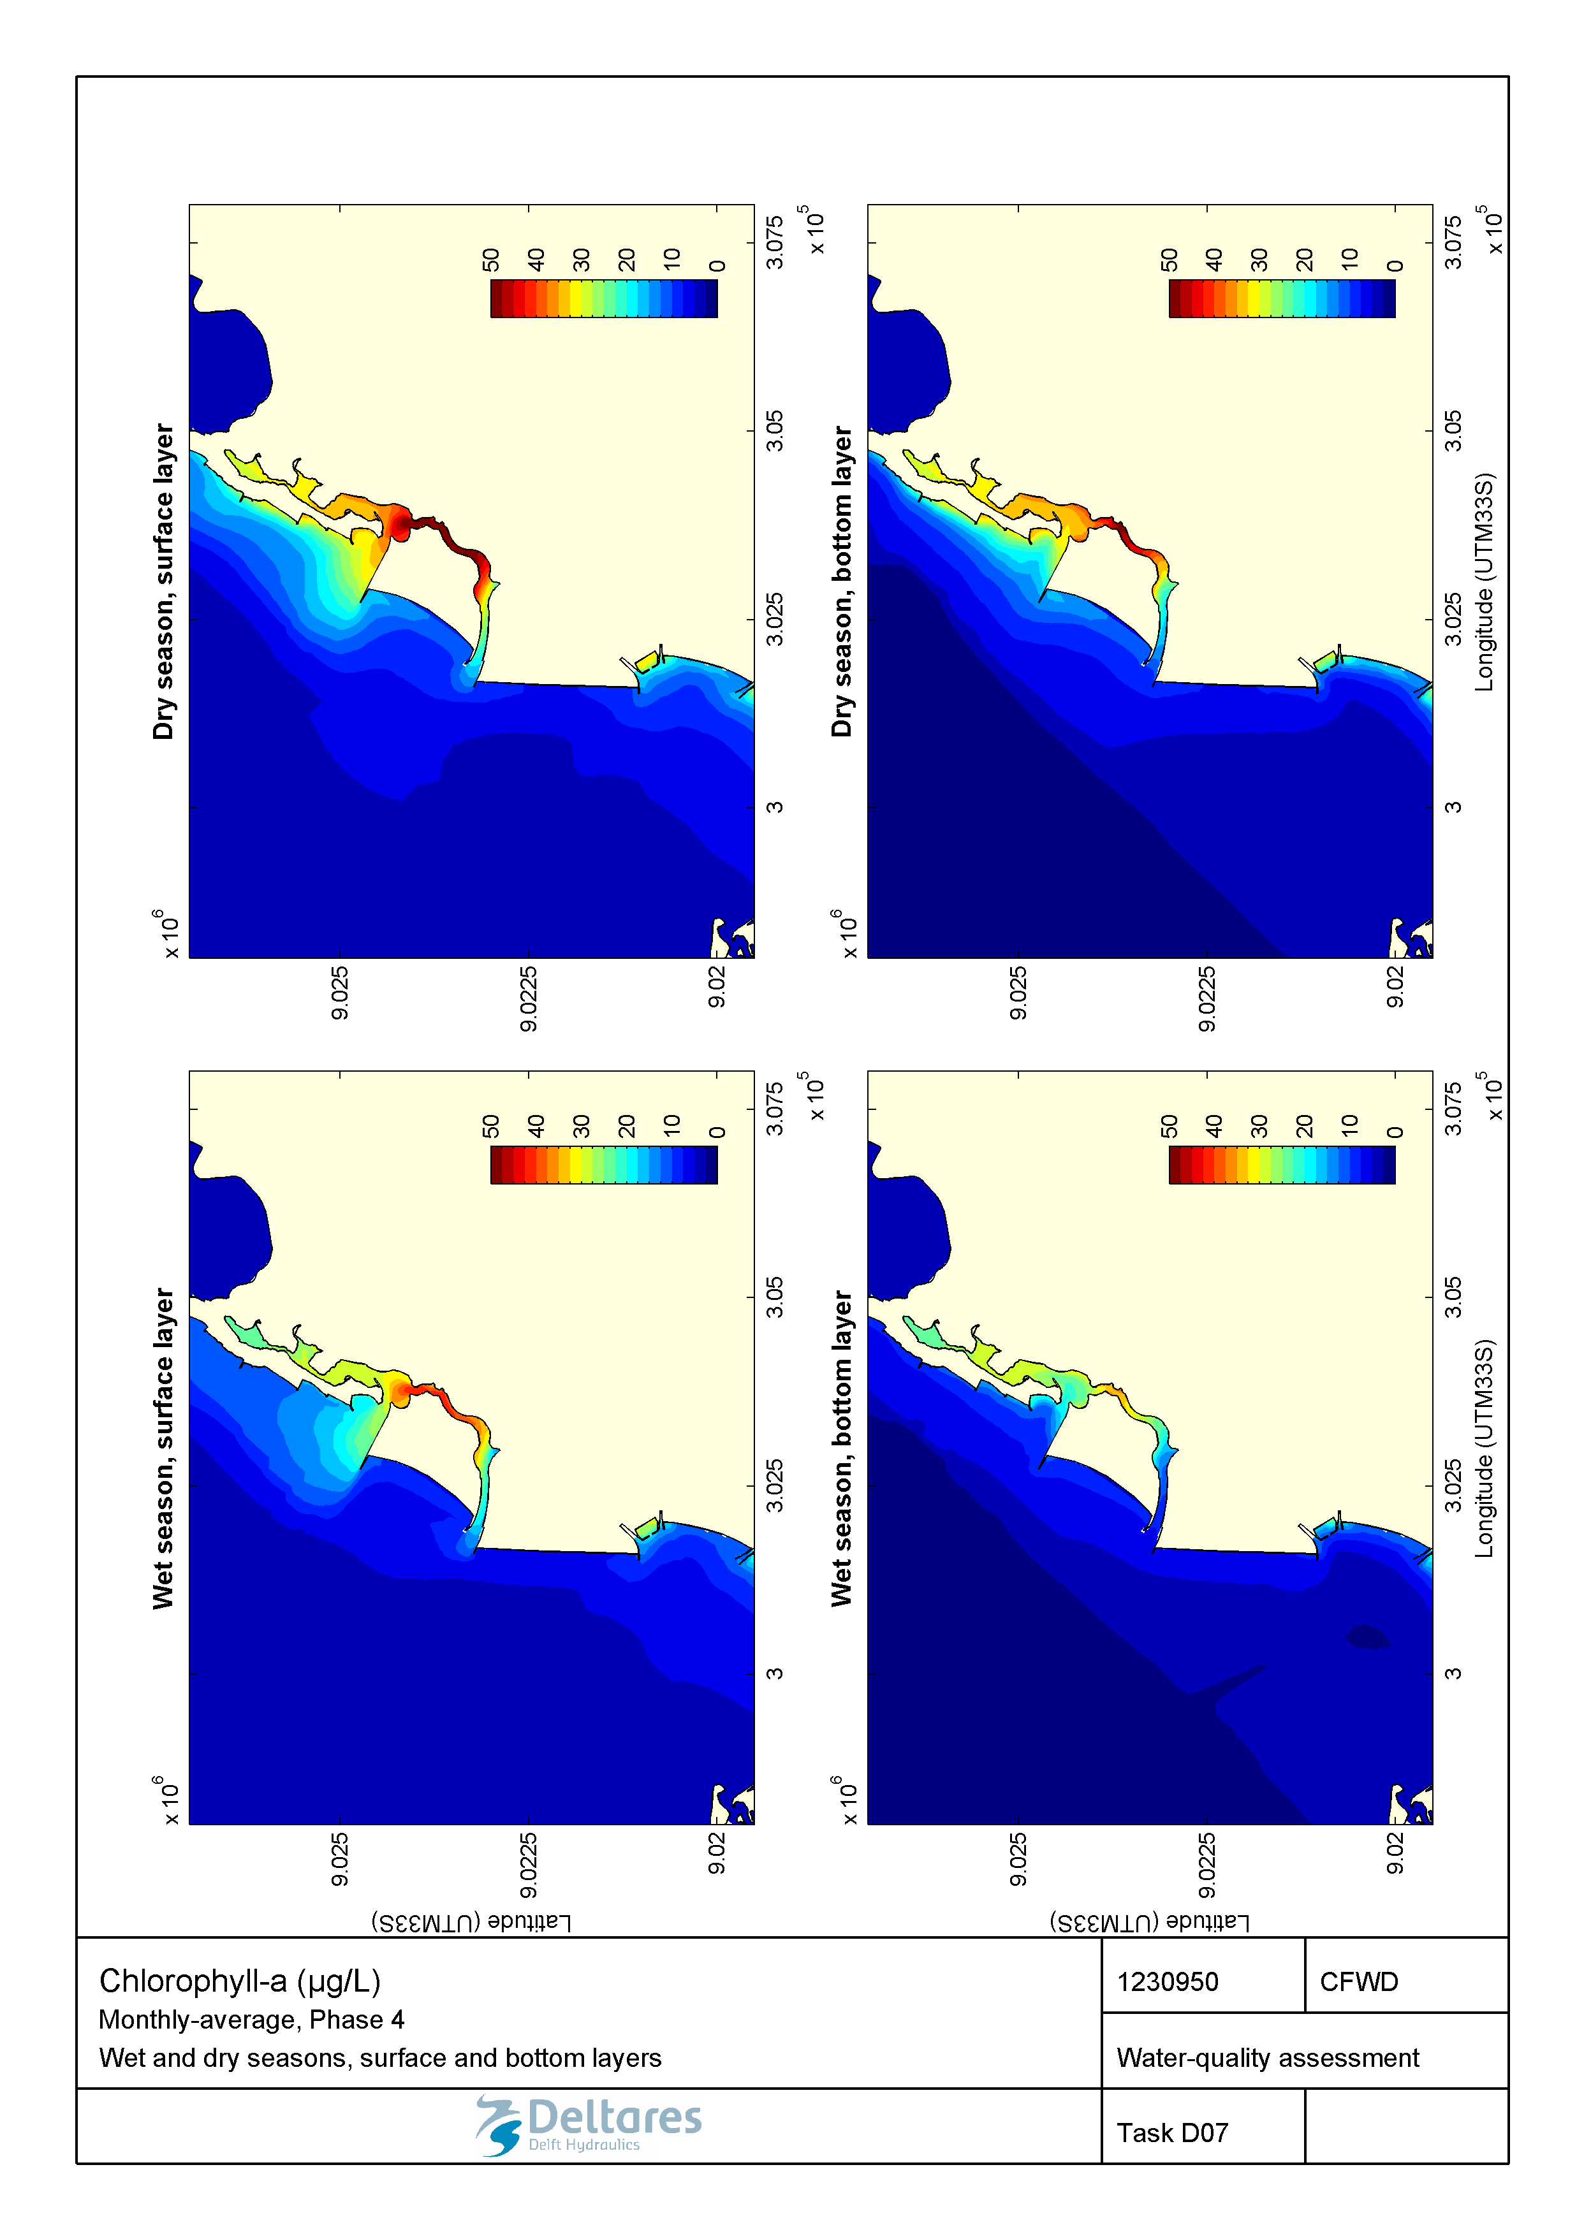

Figure 2.34 Monthly-averaged chlorophyll-a (µg/L) during wet and dry seasons in the surface and bottom layers for the Marginal Phase4 developments.

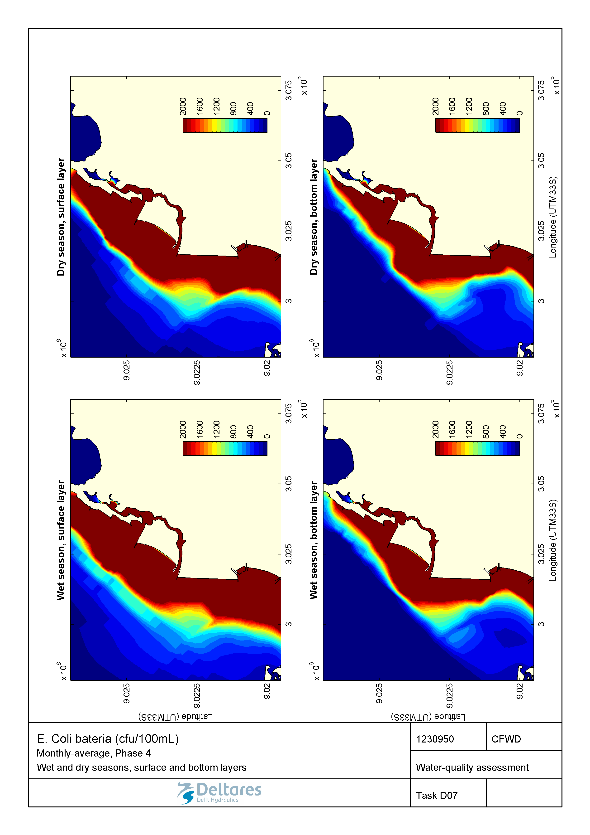

Figure 2.35 Monthly-averaged E. Coli bacteria (CFU/100mL) during wet and dry seasons in the surface and bottom layers for the Marginal Phase4 developments.

#### Wastewater treatment applied

Consequently, compared to the baseline conditions and the change in coastline conditions alone, the average overall water-quality is greatly improved in the Marginal de Corimba development configuration when wastewater treatment is applied (Figure 2.36 to Figure 2.43). Conversely to what was observed in the baseline and the Phase 4 scheme without wastewater treatment, better water quality is achieved in the dry season than in the wet season for the Marginal de Corimba development. This is explained by our assumption that wastewater loads are not collected and treated during rainfall events, whereas they undergo 100% treatment during the dry season.

Therefore, in the wet season, some impacts from pollution loadings can be still observed within the Corimba channel, especially next to the valas outfalls where there is stagnant water. Nonetheless, concentrations drop quickly as water exits the channels and is mixed with nearby open sea water. Based on these results, we expect a limited reduction of the water transparency within the Corimba channel in the wet season only (as compared to the undisturbed conditions).

This situation is much more favourable as compared to the baseline. The simulated concentrations of dissolved oxygen all remain well above 4 mg/L, which implies that we expect no negative effects on marine life. Additionally, since the wastewater is collected for the Marginal de Corimba development, the surface area where the *E. coli* concentration exceeds the suitability criterion for swimming water is strongly reduced in the wet season (compared to the baseline) and nil in the dry season. However, under the present assumptions we expect that Corimba Canal is not suitable for swimming in the wet season.

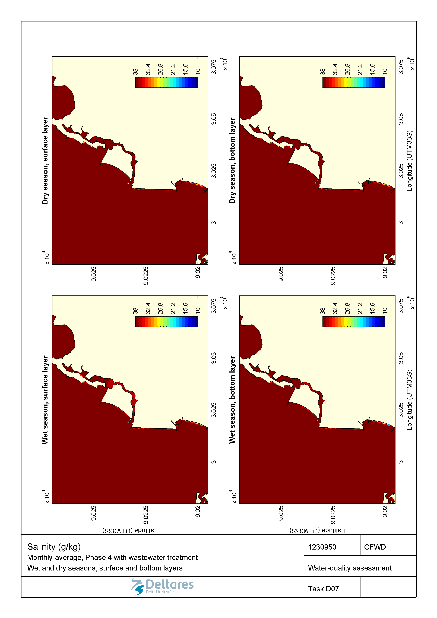

Figure 2.36 Monthly-averaged salinity (g/kg) during wet and dry seasons in the surface and bottom layers for the Marginal Phase4 developments with wastewater treatment.

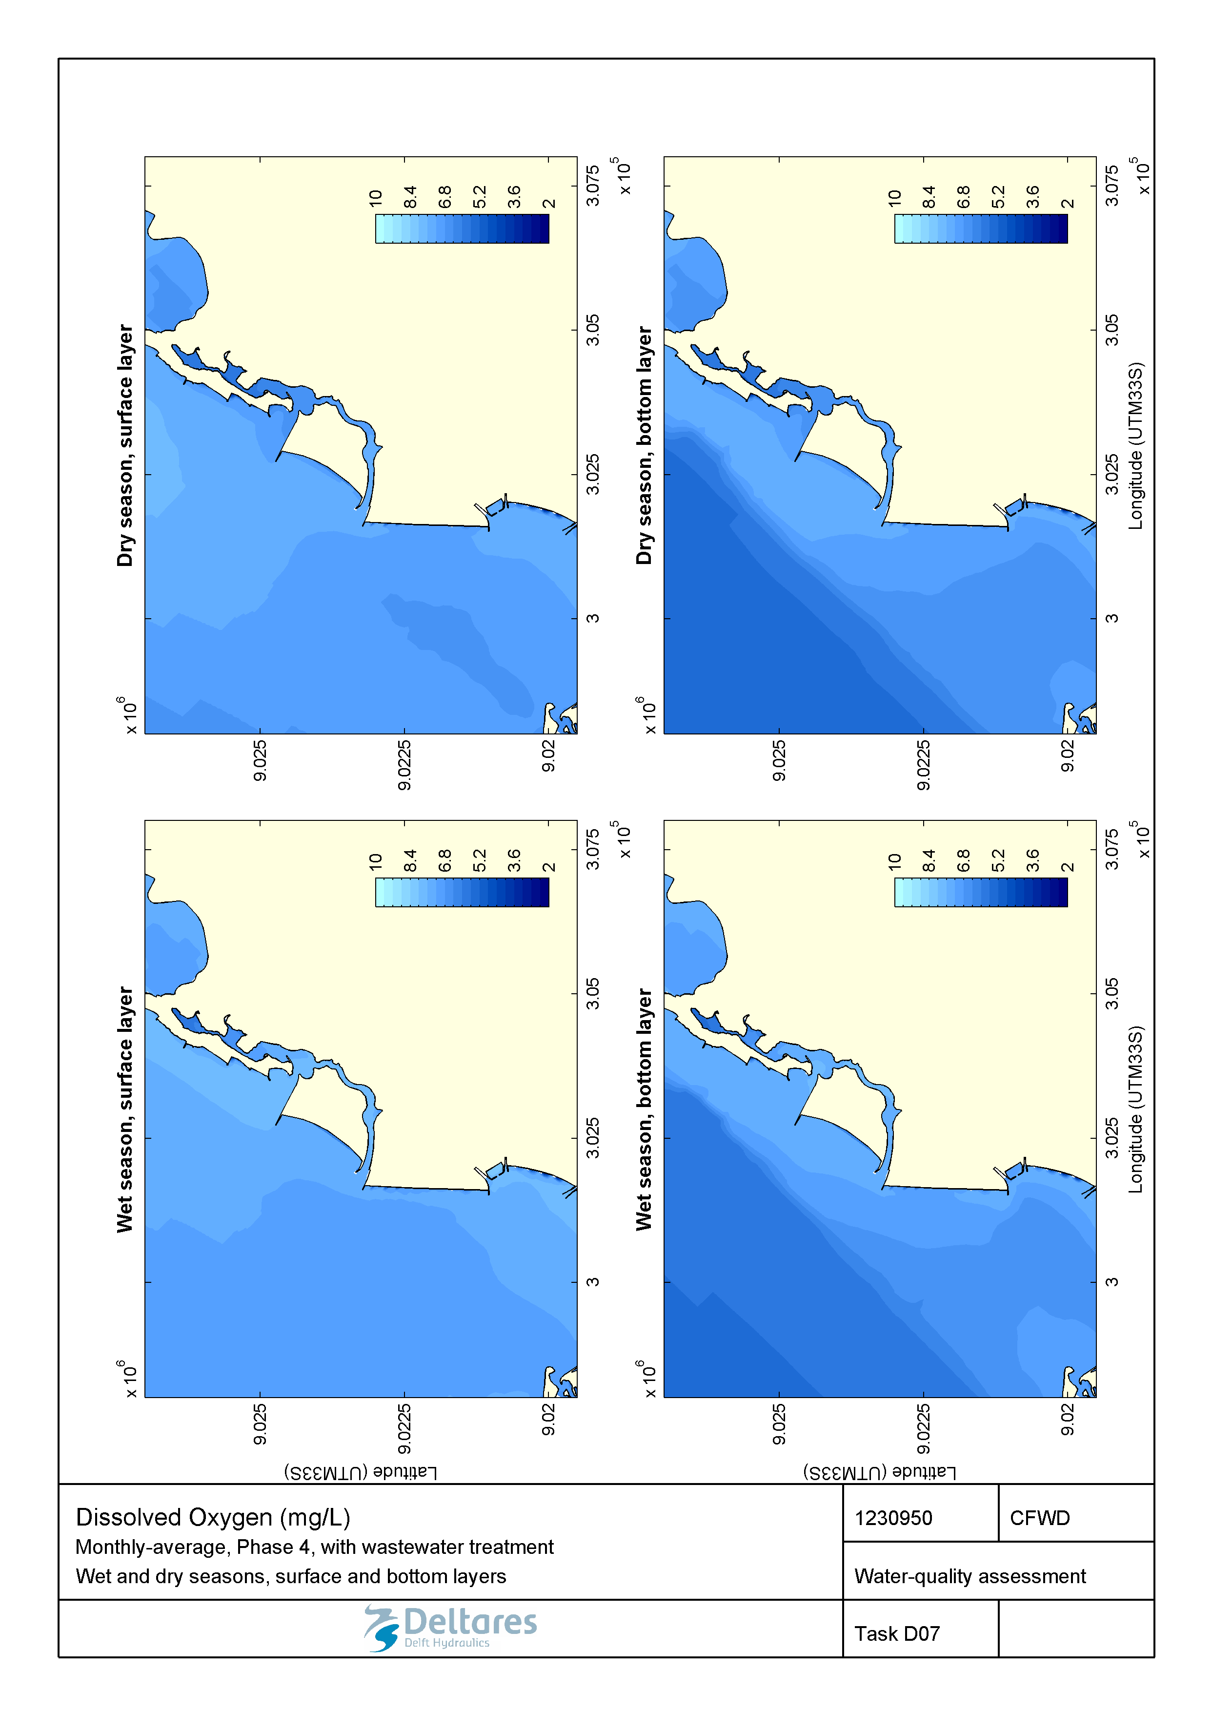

Figure 2.37 Monthly-averaged concentration of dissolved oxygen (mg/L) during wet and dry seasons in the surface and bottom layers for the Marginal Phase4 developments with wastewater treatment.

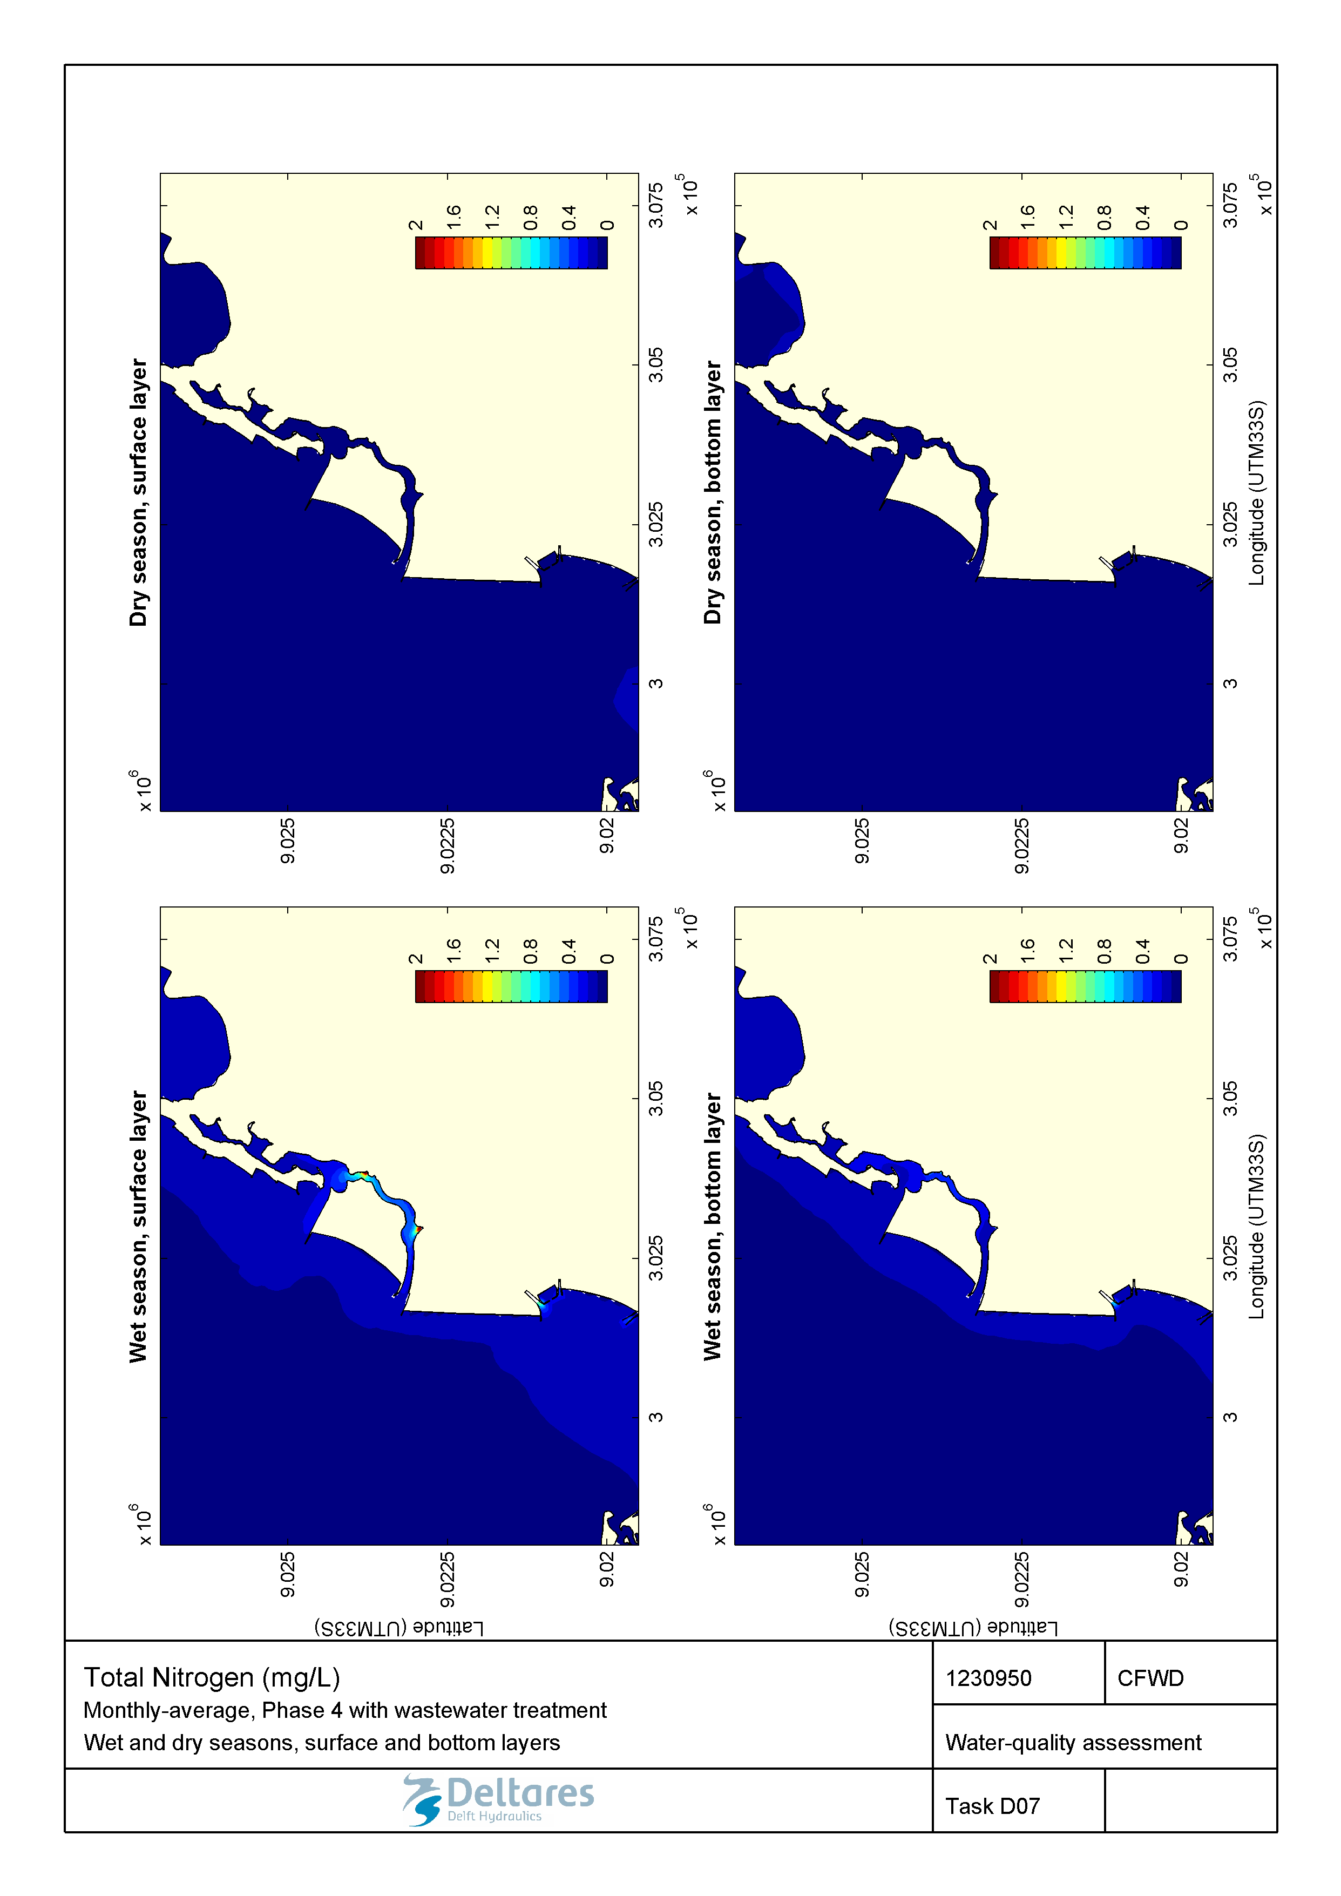

Figure 2.38 Monthly-averaged concentration of total nitrogen (mg/L) during wet and dry seasons in the surface and bottom layers for the Marginal Phase4 developments with wastewater treatment.

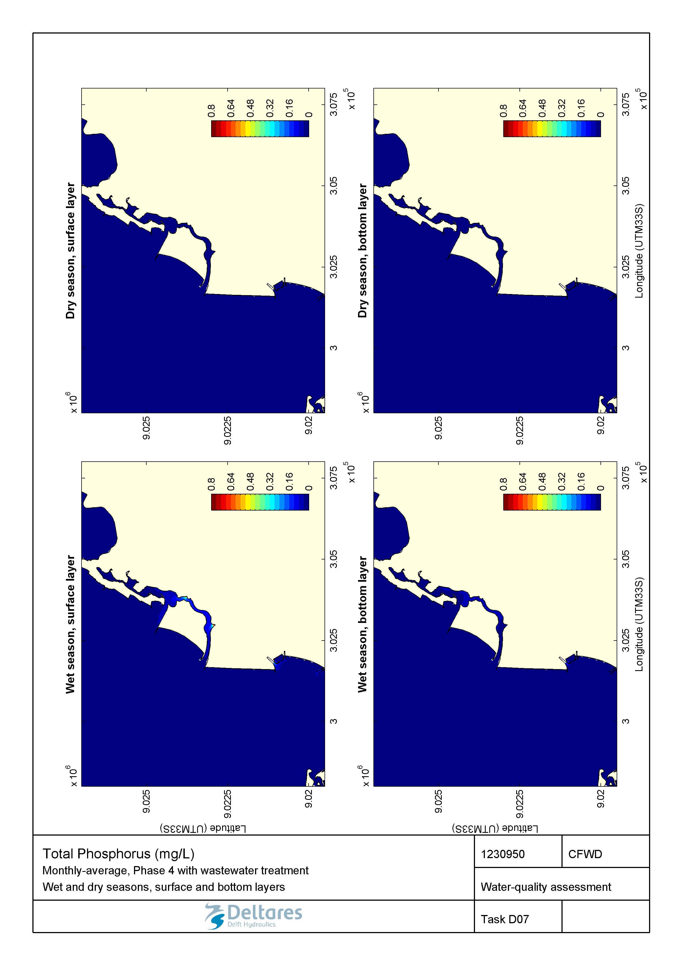

Figure 2.39 Monthly-averaged concentration of total phosphorus (mg/L) during wet and dry seasons in the surface and bottom layers for the Marginal Phase4 developments with wastewater treatment.

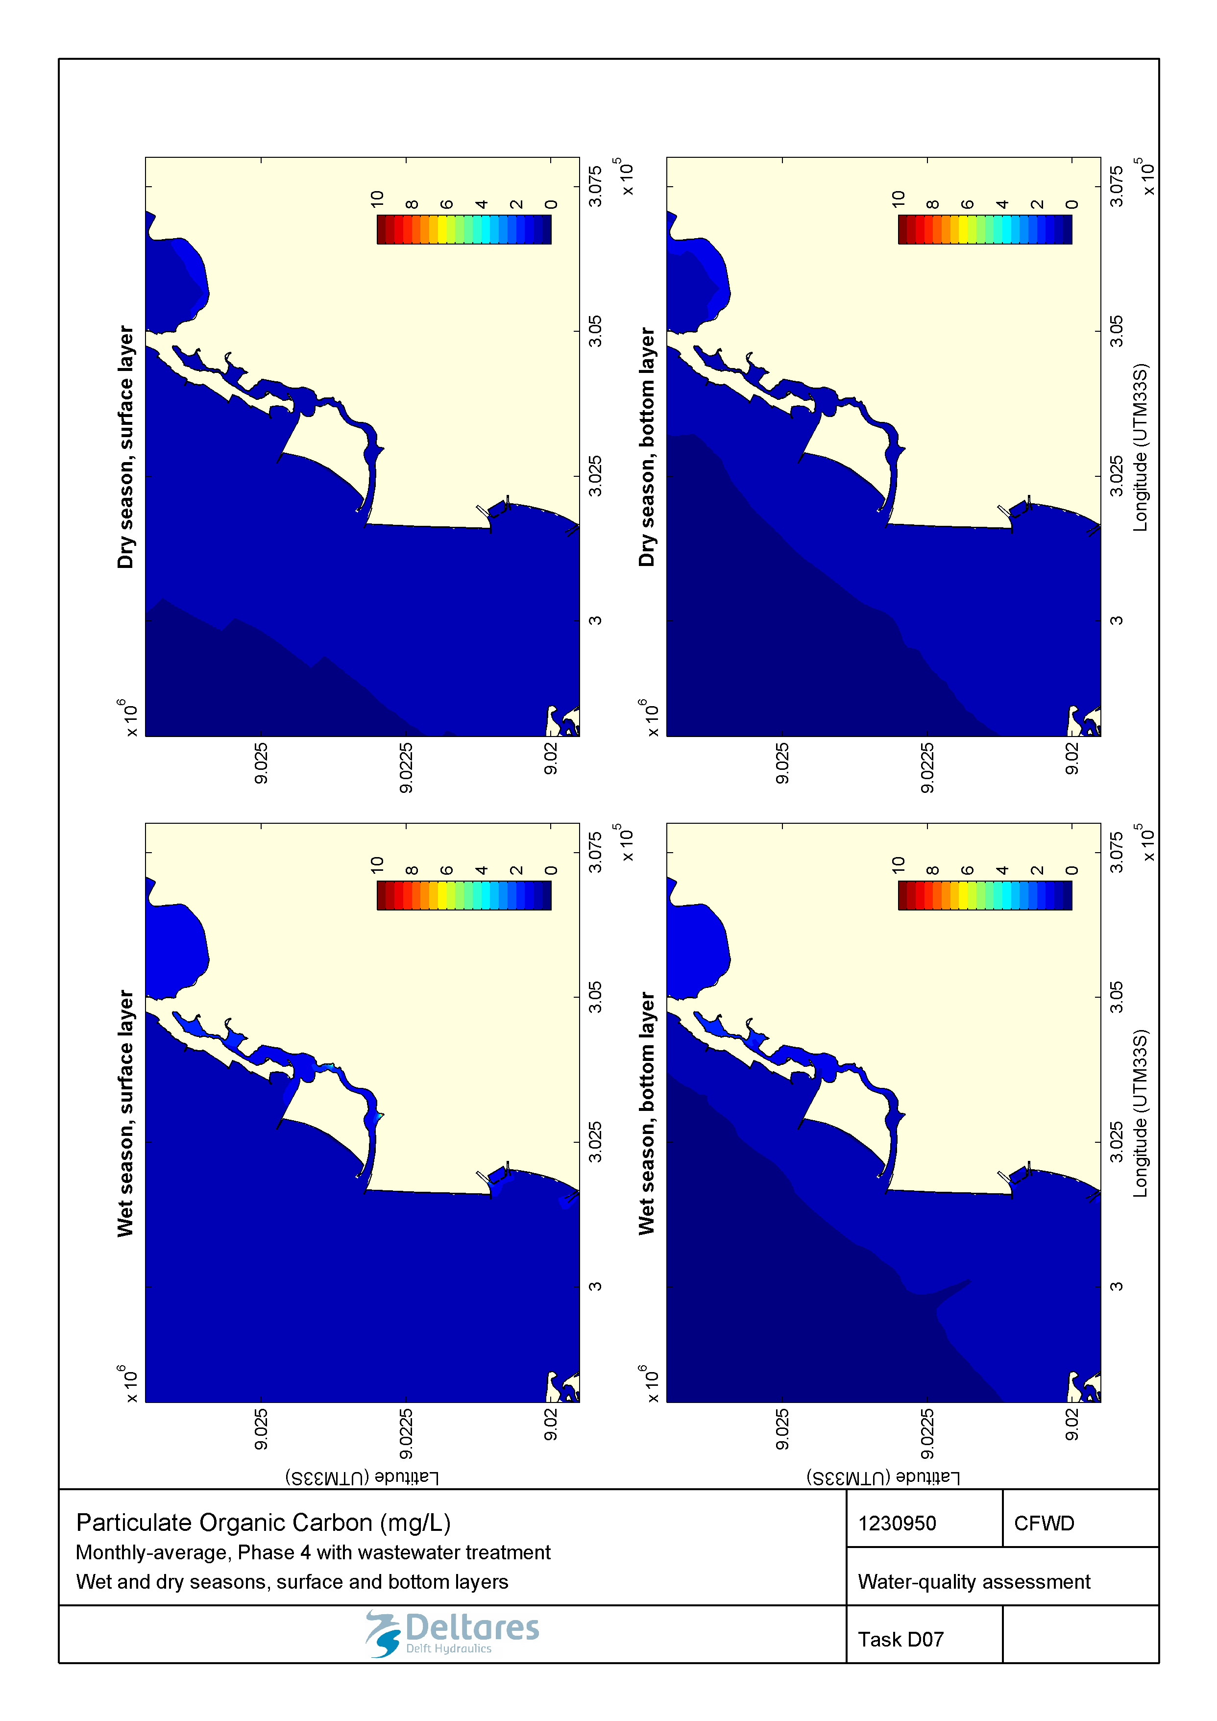

Figure 2.40 Monthly-averaged concentration of particulate organic carbon (mg/L) during wet and dry seasons in the surface and bottom layers for the Marginal Phase4 developments with wastewater treatment.

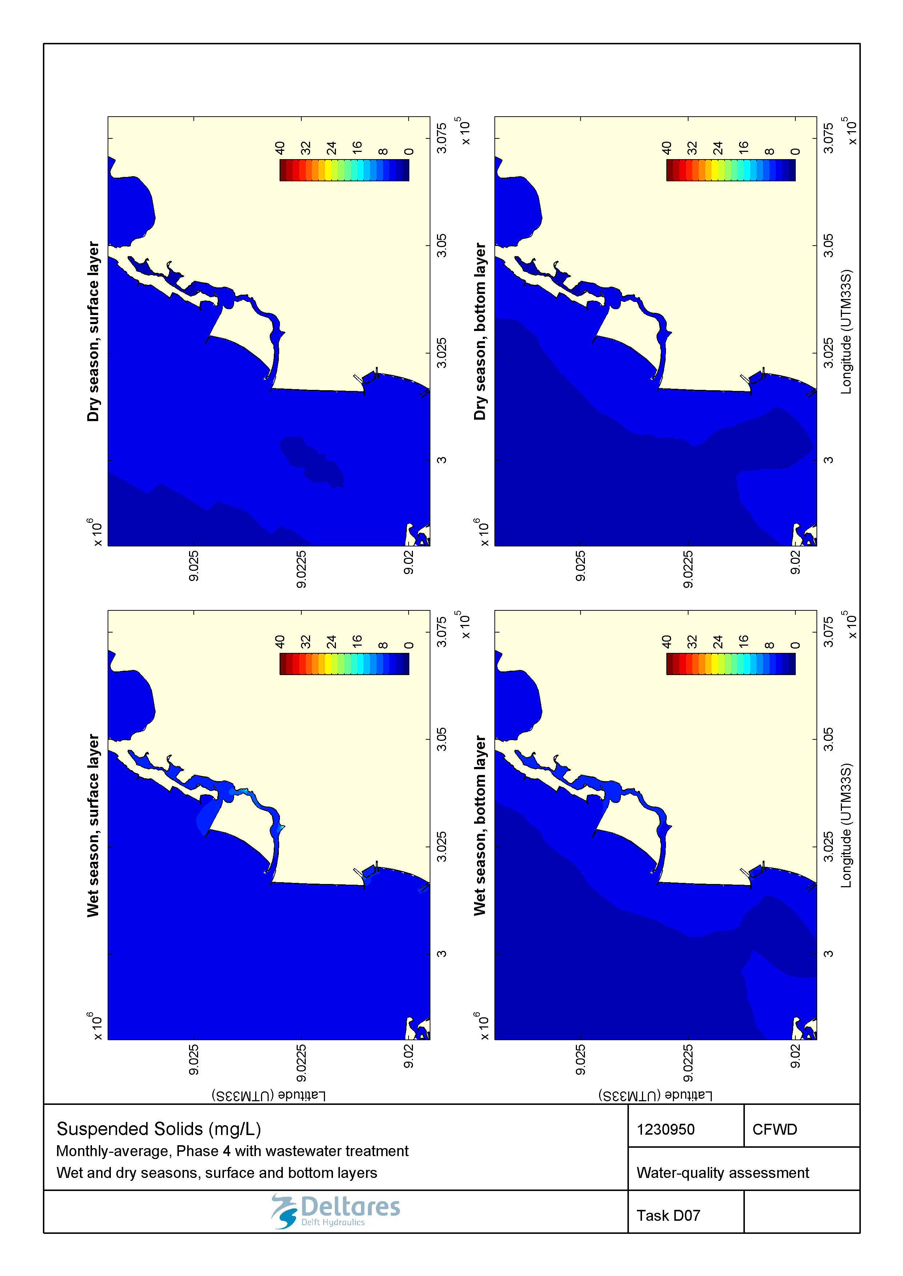

Figure 2.41 Monthly-averaged concentration of suspended solids (mg/L) during wet and dry seasons in the surface and bottom layers for the Marginal Phase4 developments with wastewater treatment.

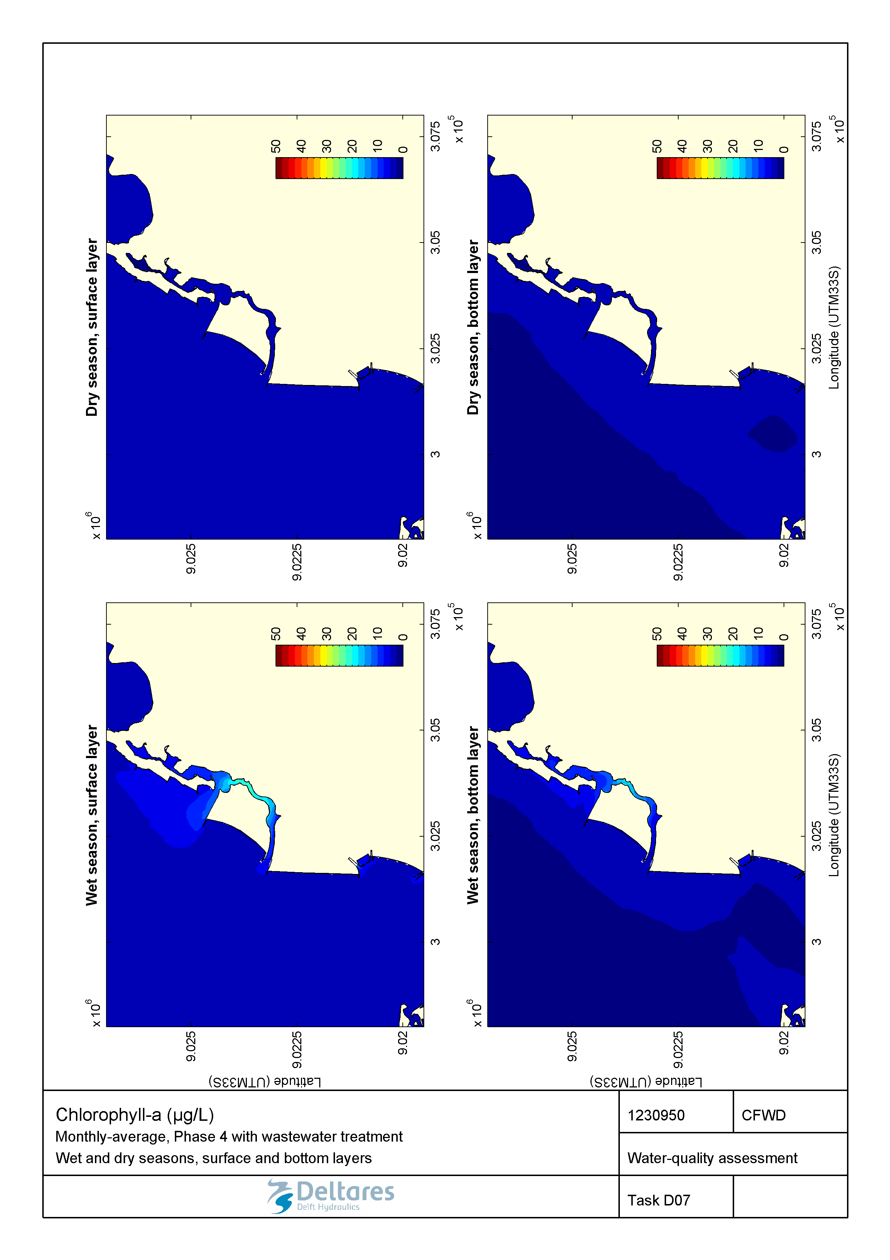

Figure 2.42 Monthly-averaged concentration of Chlorophyll a (µg/L) during wet and dry seasons in the surface and bottom layers for the Marginal Phase4 developments with wastewater treatment.

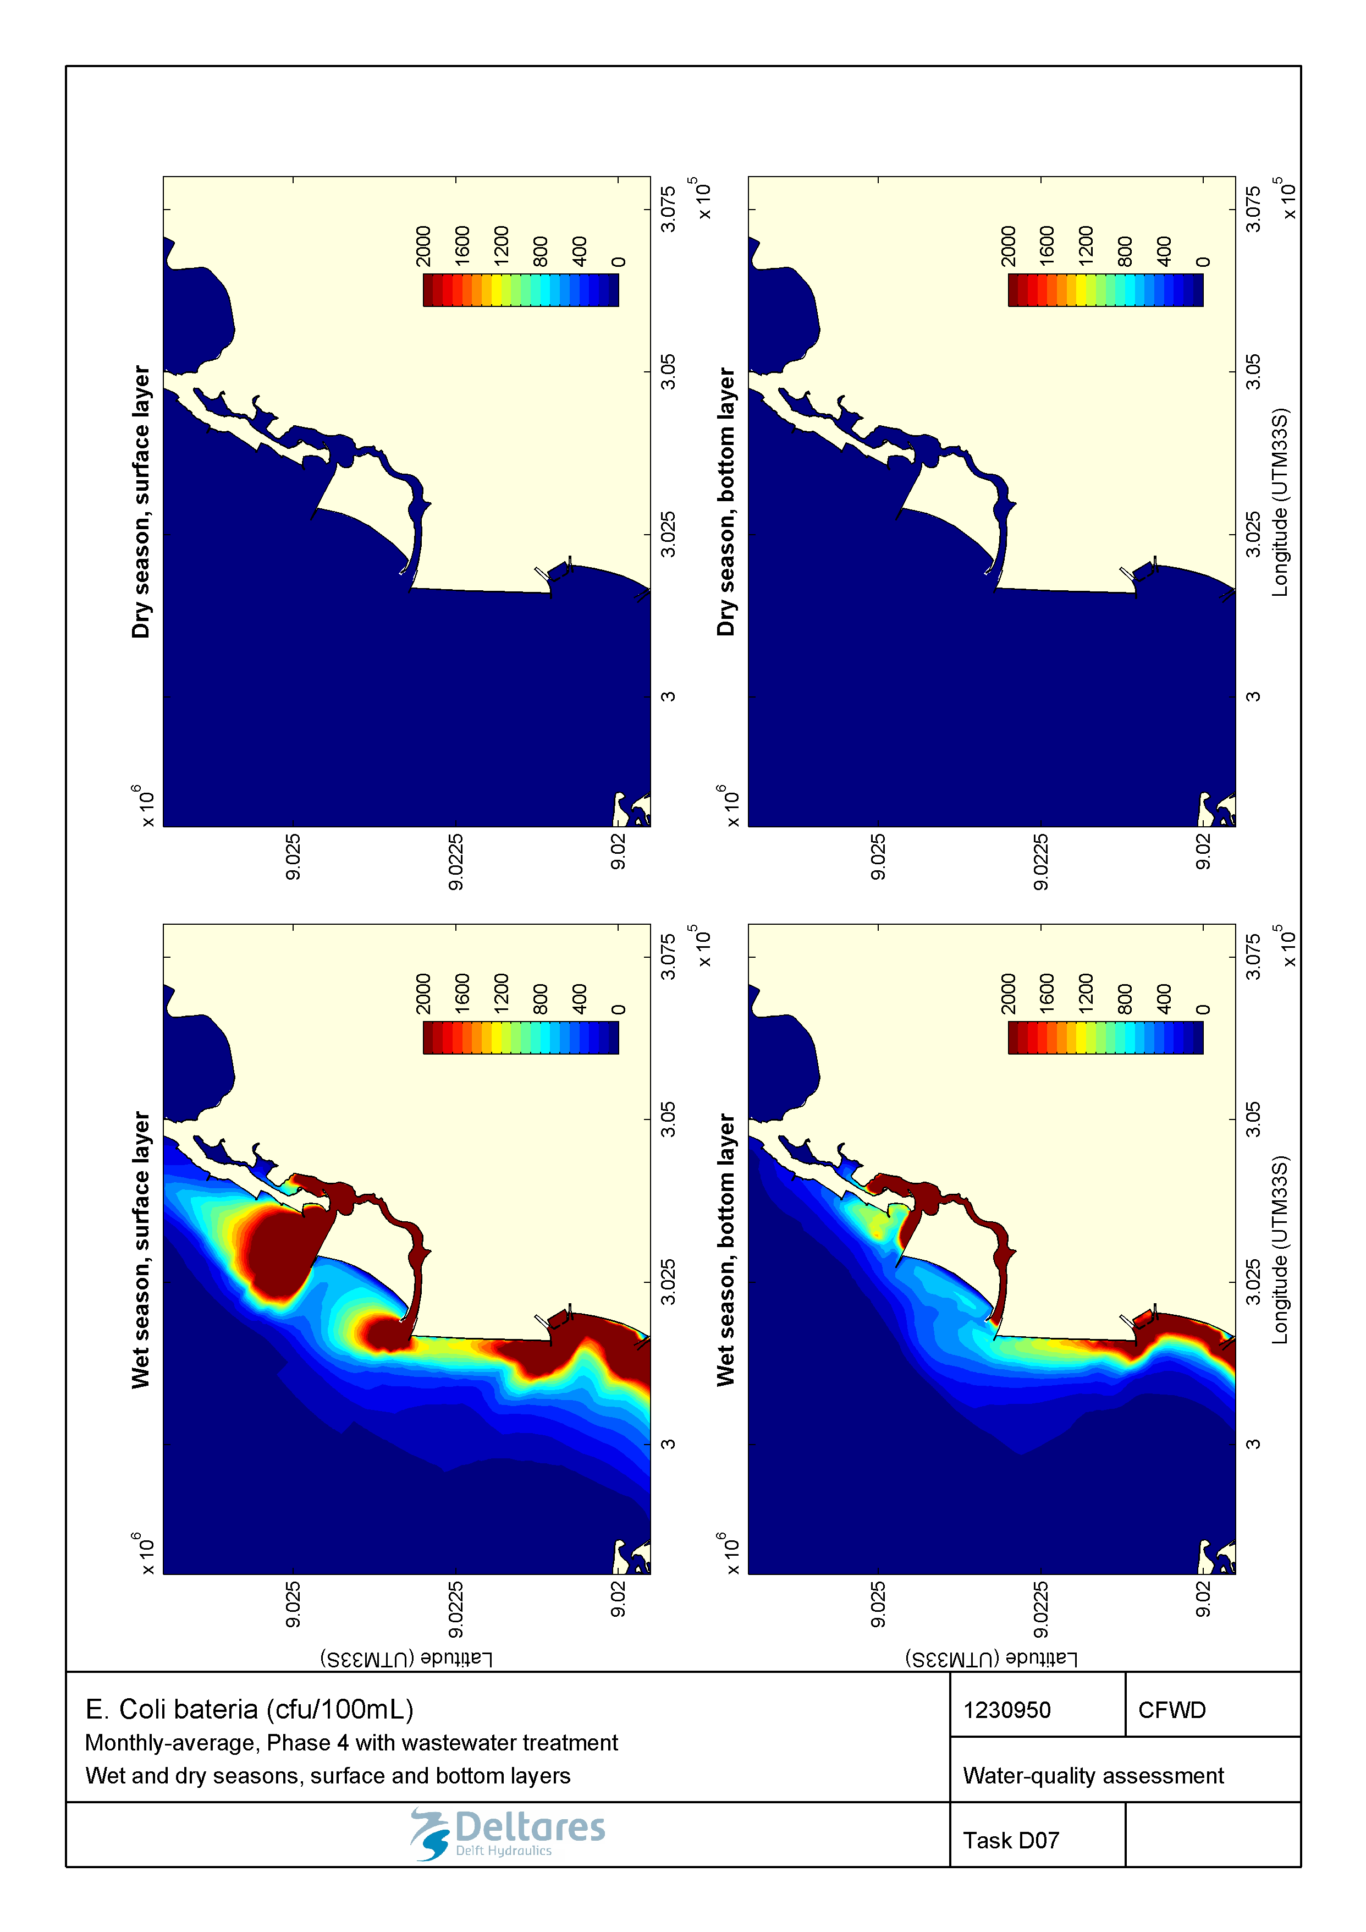

Figure 2.43 Monthly-averaged concentration of E. coli (cfu/100mL) during wet and dry seasons in the surface and bottom layers for the Marginal Phase4 developments with wastewater treatment.

### Marginal de Corimba development scenario – 1-in-100-year storm event

#### No wastewater treatment applied

Compared to the baseline storm event, the new coastline configuration causes small changes to water quality during a 1-in-100 year storm event. The extent of the salinity plume along the coast under these conditions is comparable with that of the baseline storm event (Figure 2.44), but greater stratification is seen in the straight through which the Corimba Channel empties into the Atlantic Ocean than in the straight through which the Samba Lagoon empties into the Atlantic Ocean in the baseline. As a result, dissolved oxygen in the top layer remains approximately the same but slightly lower in the phase 4 configuration (Figure 2.45), but due to the greater stratification, is higher in the lower layer of the Corimba Channel compared to the Samba Lagoon in the baseline.

The maximum concentrations of total nitrogen and phosphorous are comparable between the phase 4 and baseline storm event (Figure 2.46 and Figure 2.47) However, as a result of the stratification within the channel, the concentrations of nutrients in the lower layer of the channel are reduced relative to concentrations in the old Samba Lagoon. The stratification causes the nutrient plume in the top layer to extend just beyond the coast adjacent to the two straights through which the Corimba Channel exits, but the overall spread northward along the coast is comparable to that of the baseline situation.

As a result of the stratification, we see that suspended solids concentrations in the lower layer of the Corimba Channel are lower than those seen in the Samba Lagoon (Figure 2.49). In the Phase 4 configuration the suspended solids concentrations in the upper layer remain comparable but slightly higher in both layers of the Sodimo lagoon compared to the baseline scenario. This can partly be explained by the small increase in Chlorophyll-a concentrations seen in the phase 4 development (Figure 2.50). This increase in Chlorophyll-a may be caused by slightly higher nutrient concentrations present in the Sodimo Lagoon under the phase 4 configuration and also different flushing periods of the Sodimo in phase 4 relative to the baseline (Figure 2.9 to Figure 2.11). These slightly higher concentrations within the Lagoon do not cause a substantial difference to the concentrations observed off the coasts to the north and south of the development area, although the new configuration shows slight increases to chlorophyll-a concentrations near valas 6 and 7 presumably due to higher and more spatially concentrated loading due to the combination of valas 3 and 5 and valas 6 and 7.

Unchanged in the new phase 4 development scenario is the fact that the simulated concentrations of *E. coli* values still exceed the suitability criterion for swimming water (in the order of several hundreds of cfu/100ml) by several orders of magnitude over large areas (Figure 2.51).

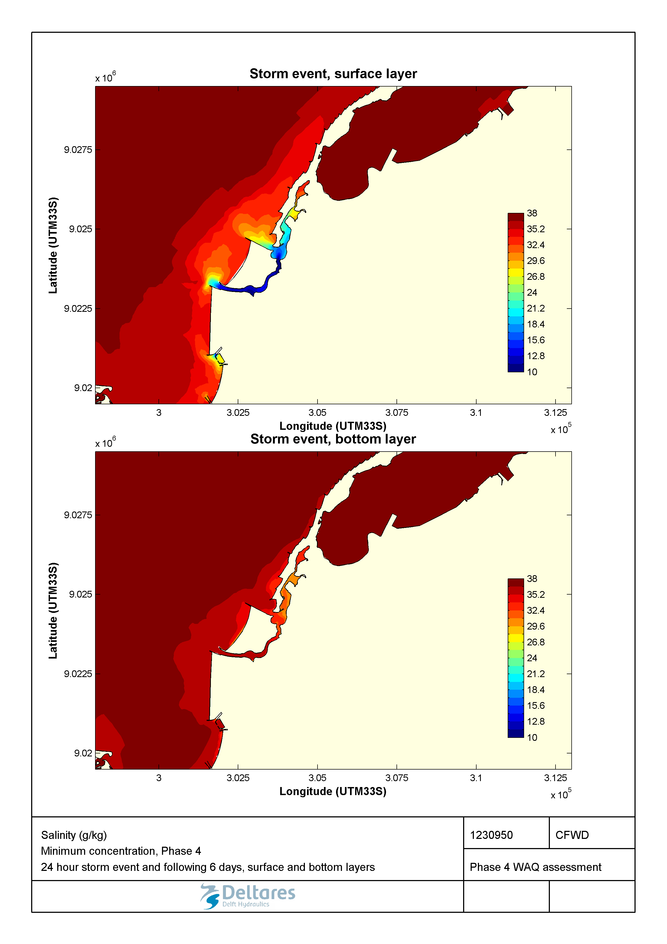

Figure 2.44 Minimum salinity (g/kg) during a 1-in-100-year storm event in the surface and bottom layers for the Marginal Phase4 developments.

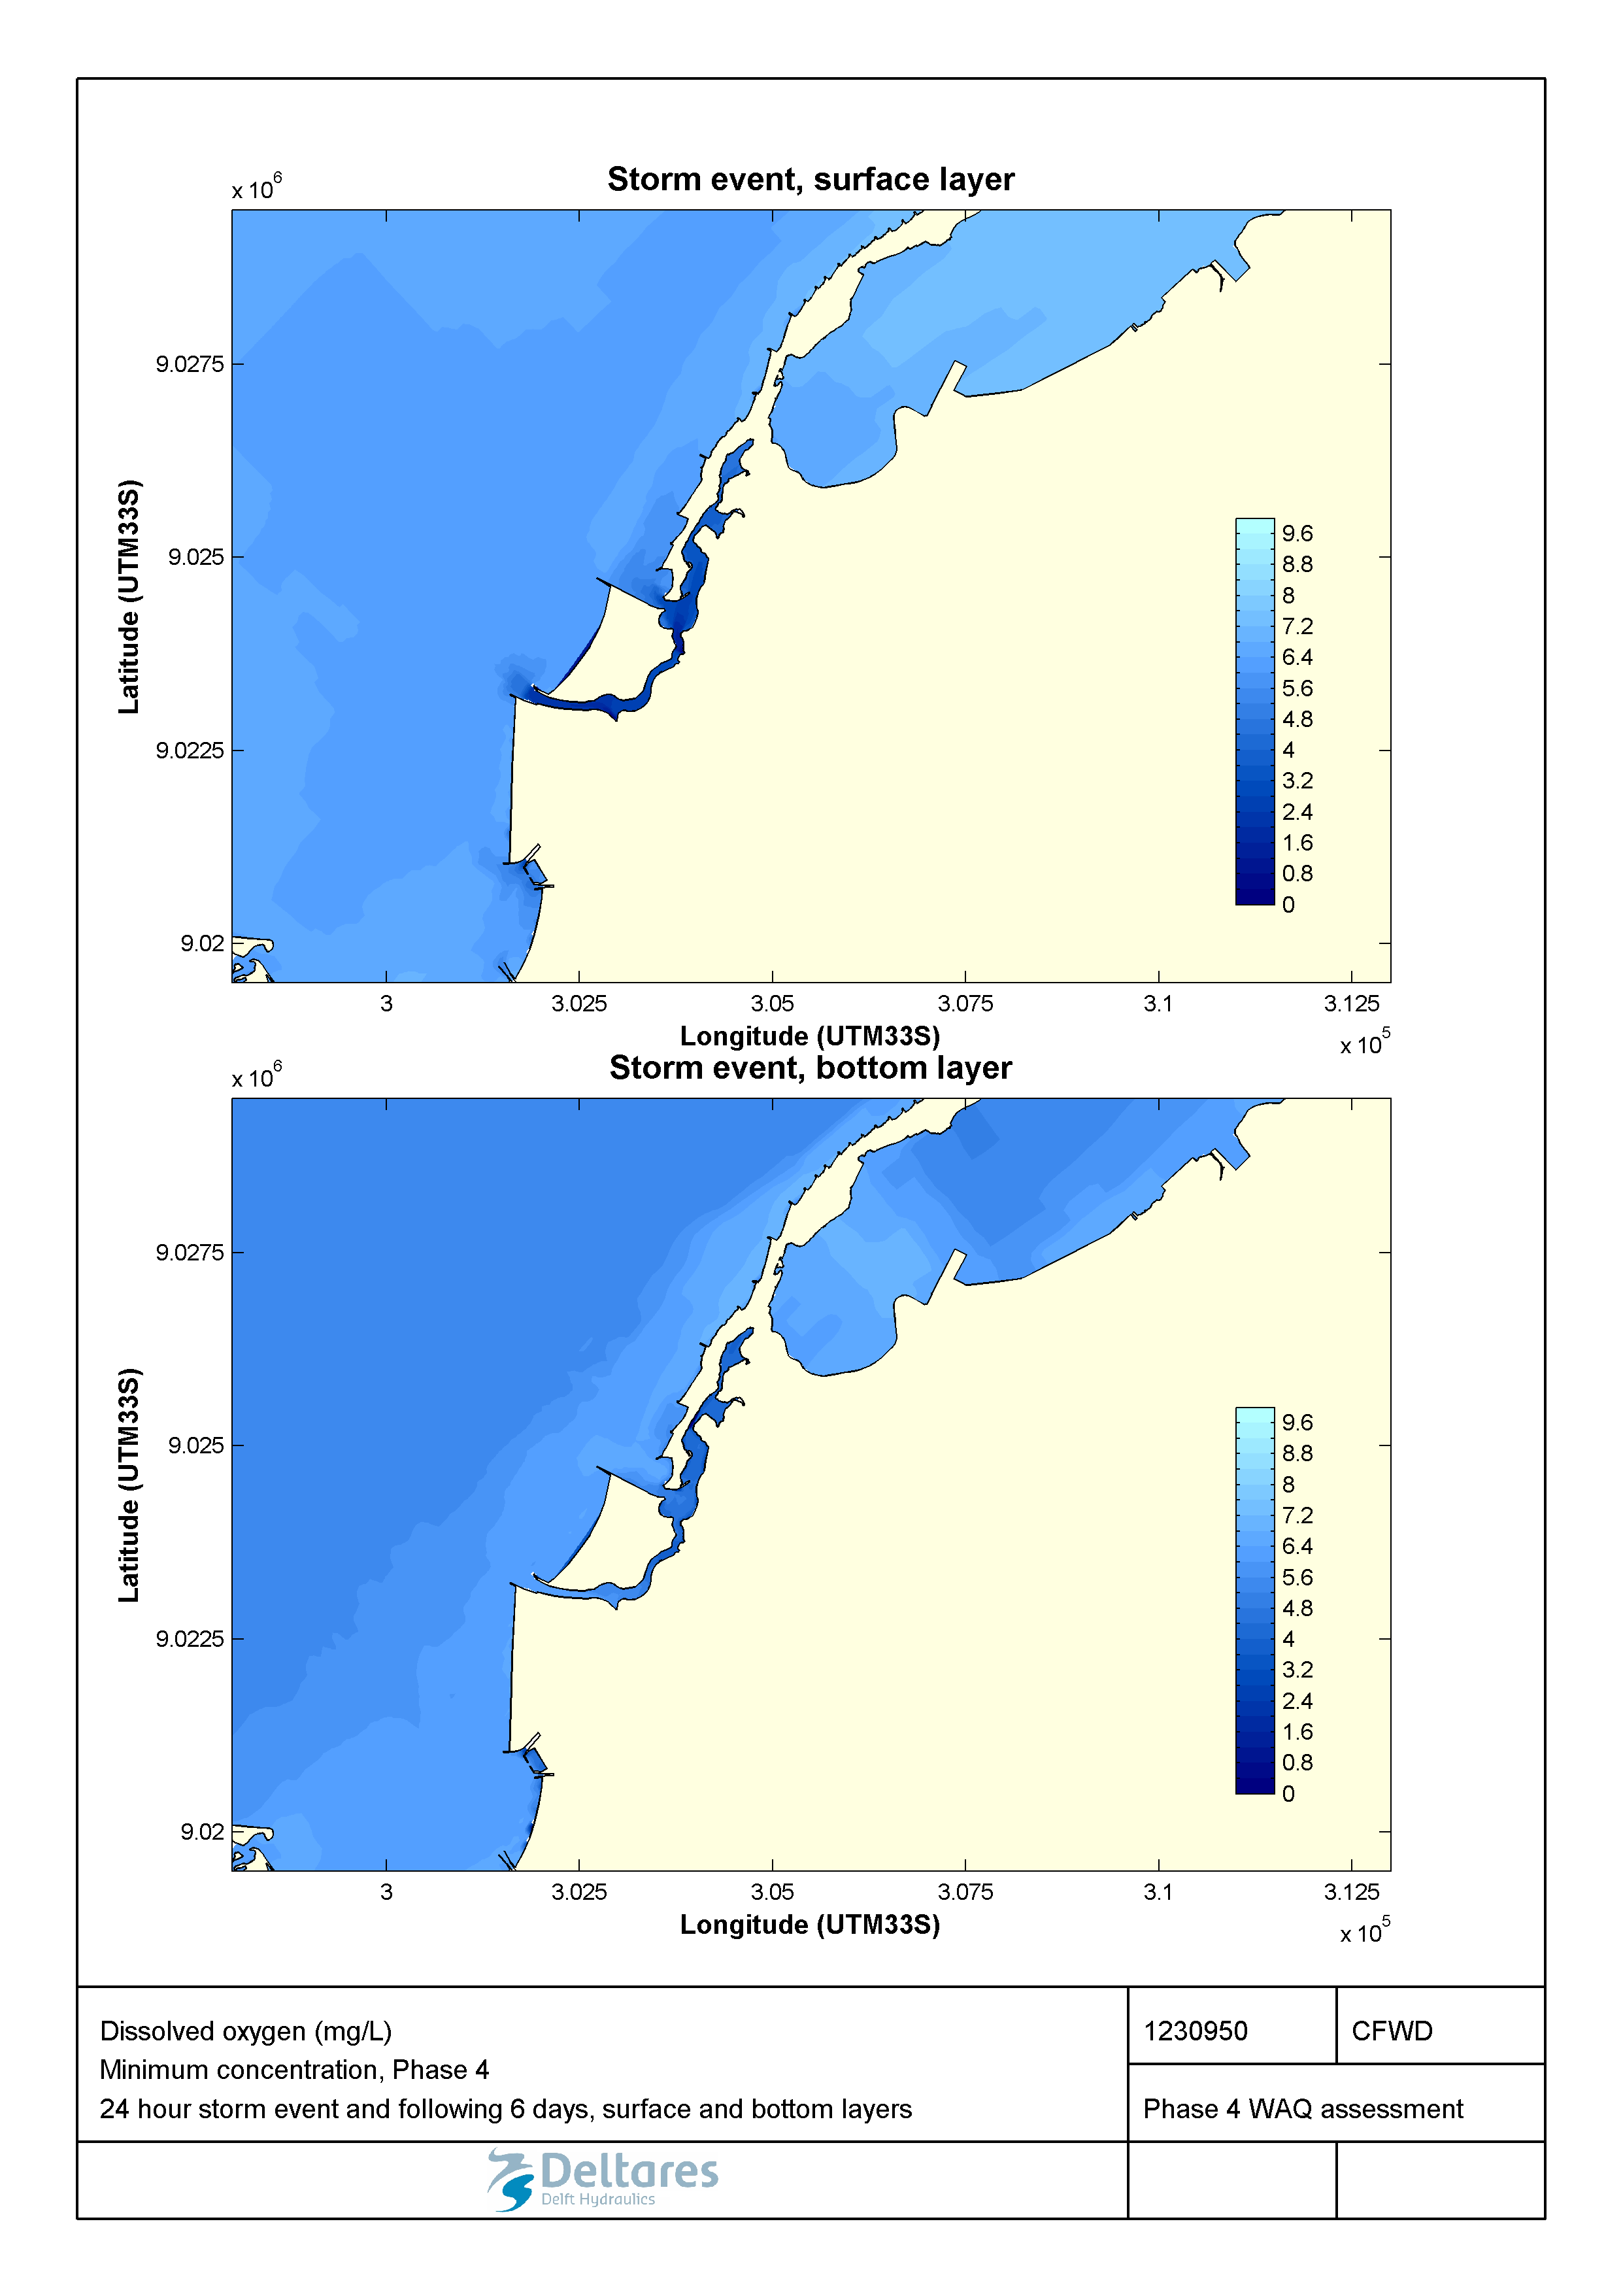

Figure 2.45 Minimum dissolved oxygen (mg/L) during a 1-in-100-year storm event in the surface and bottom layers for the Marginal Phase4 developments.

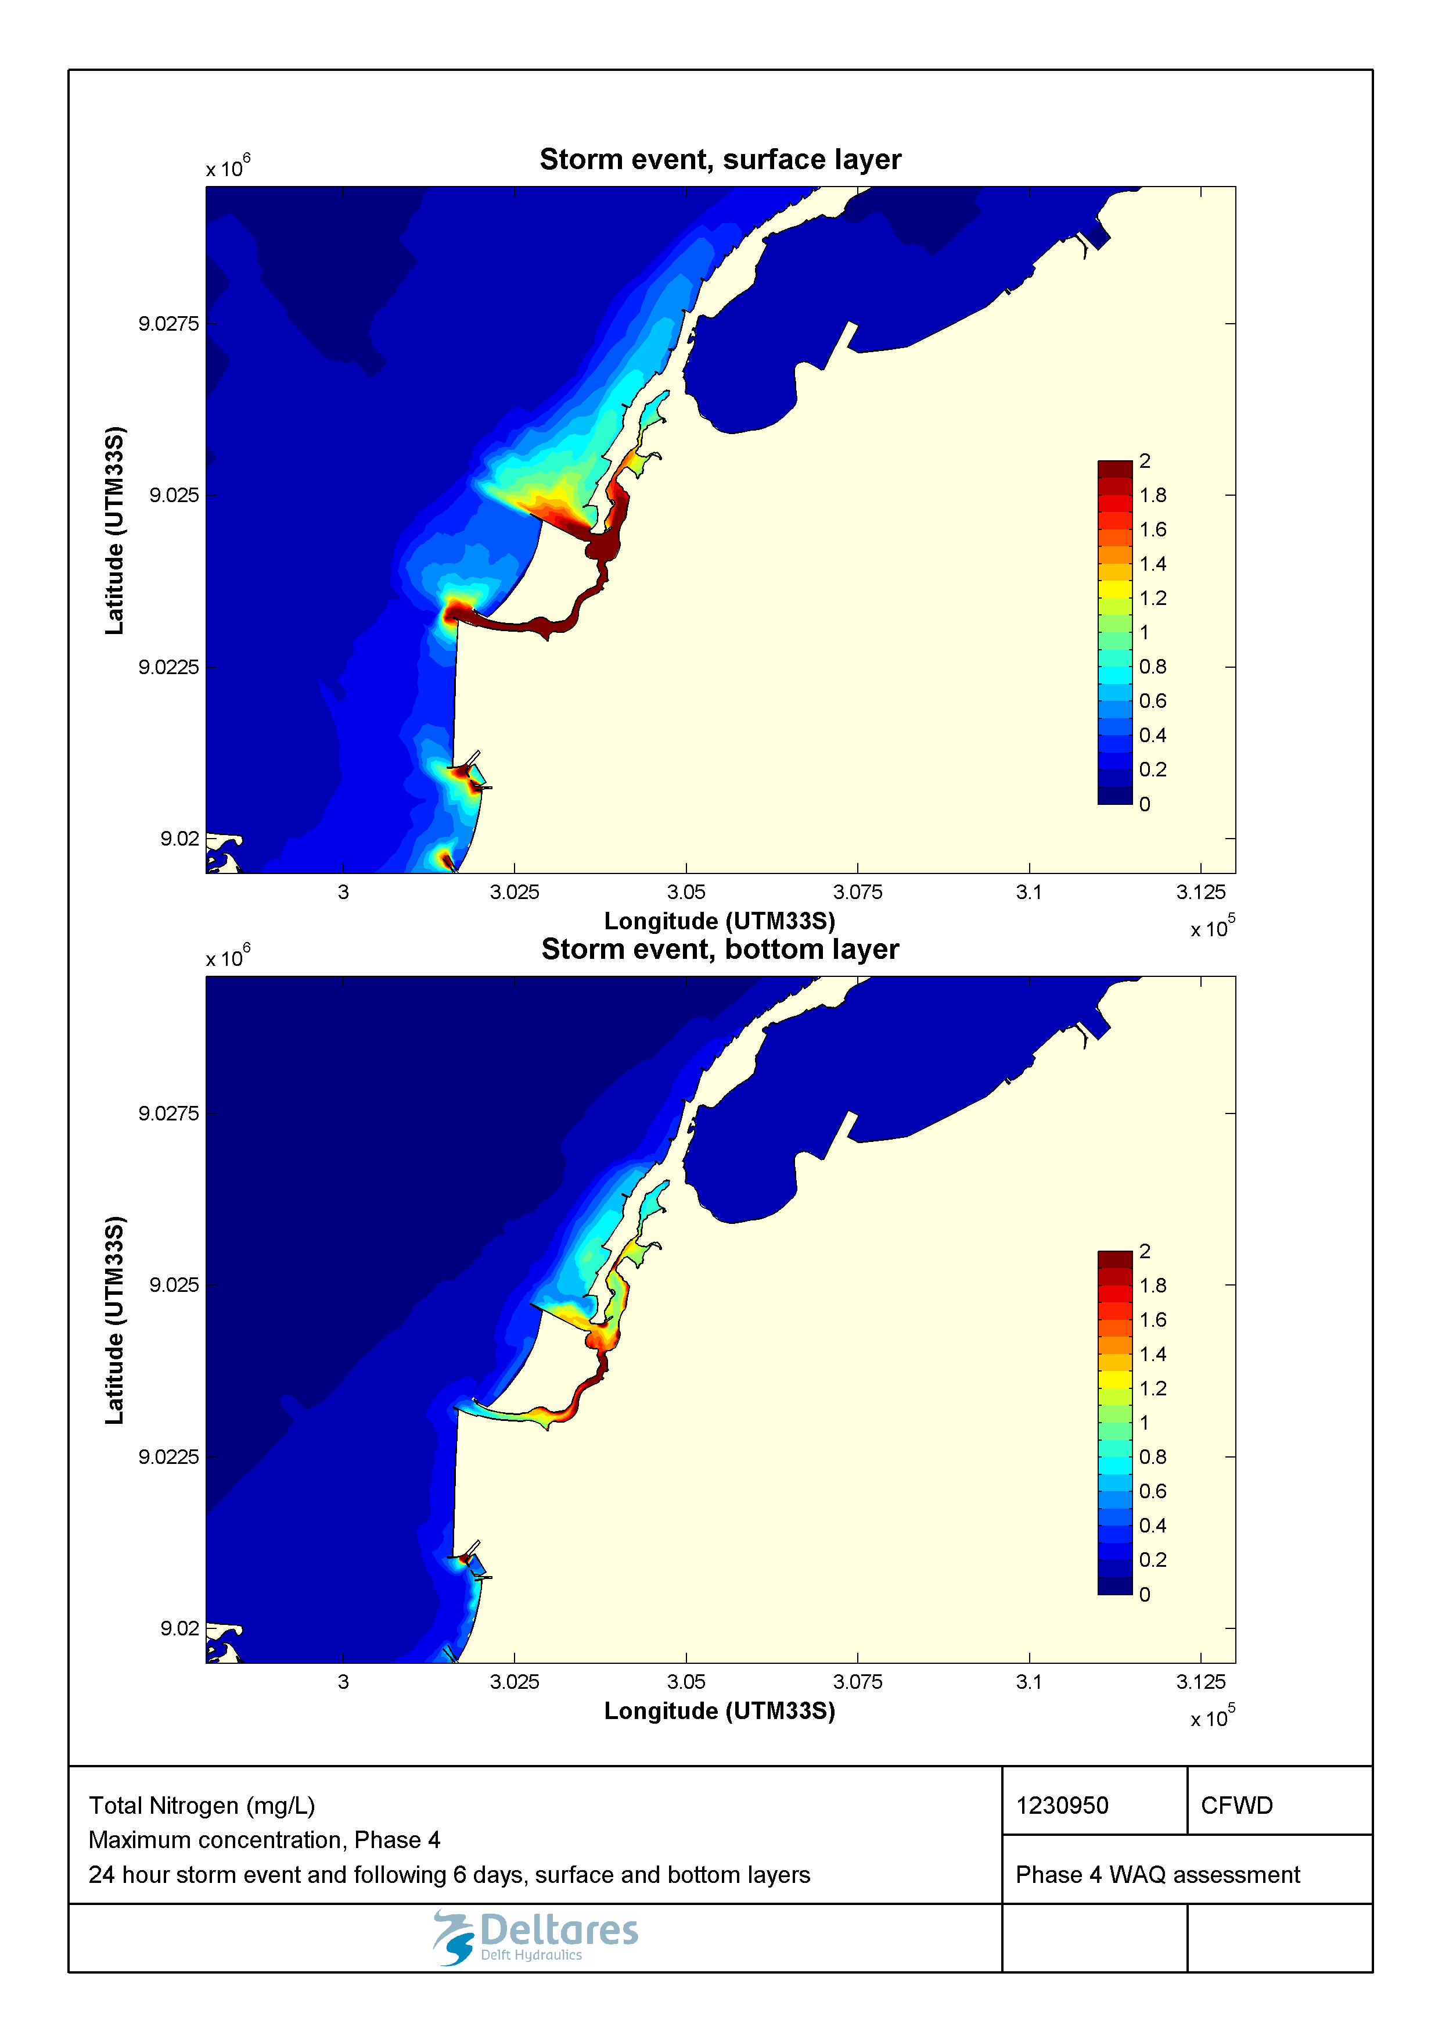

Figure 2.46 Maximum total nitrogen (mg/L) during a 1-in-100-year storm event in the surface and bottom layers for the Marginal Phase4 developments.

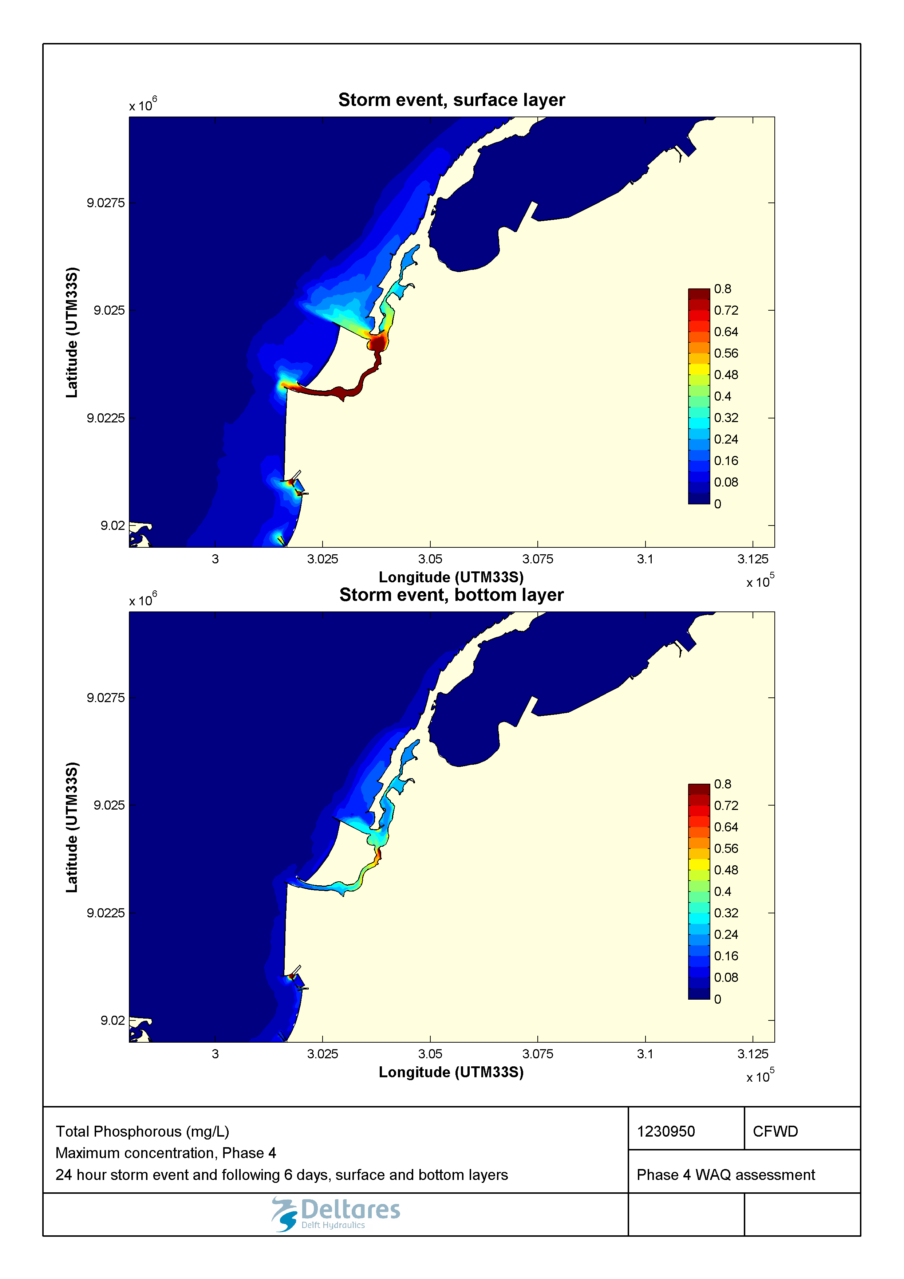

Figure 2.47 Maximum total phosphorous (mg/L) during a 1-in-100-year storm event in the surface and bottom layers for the Marginal Phase4 developments.

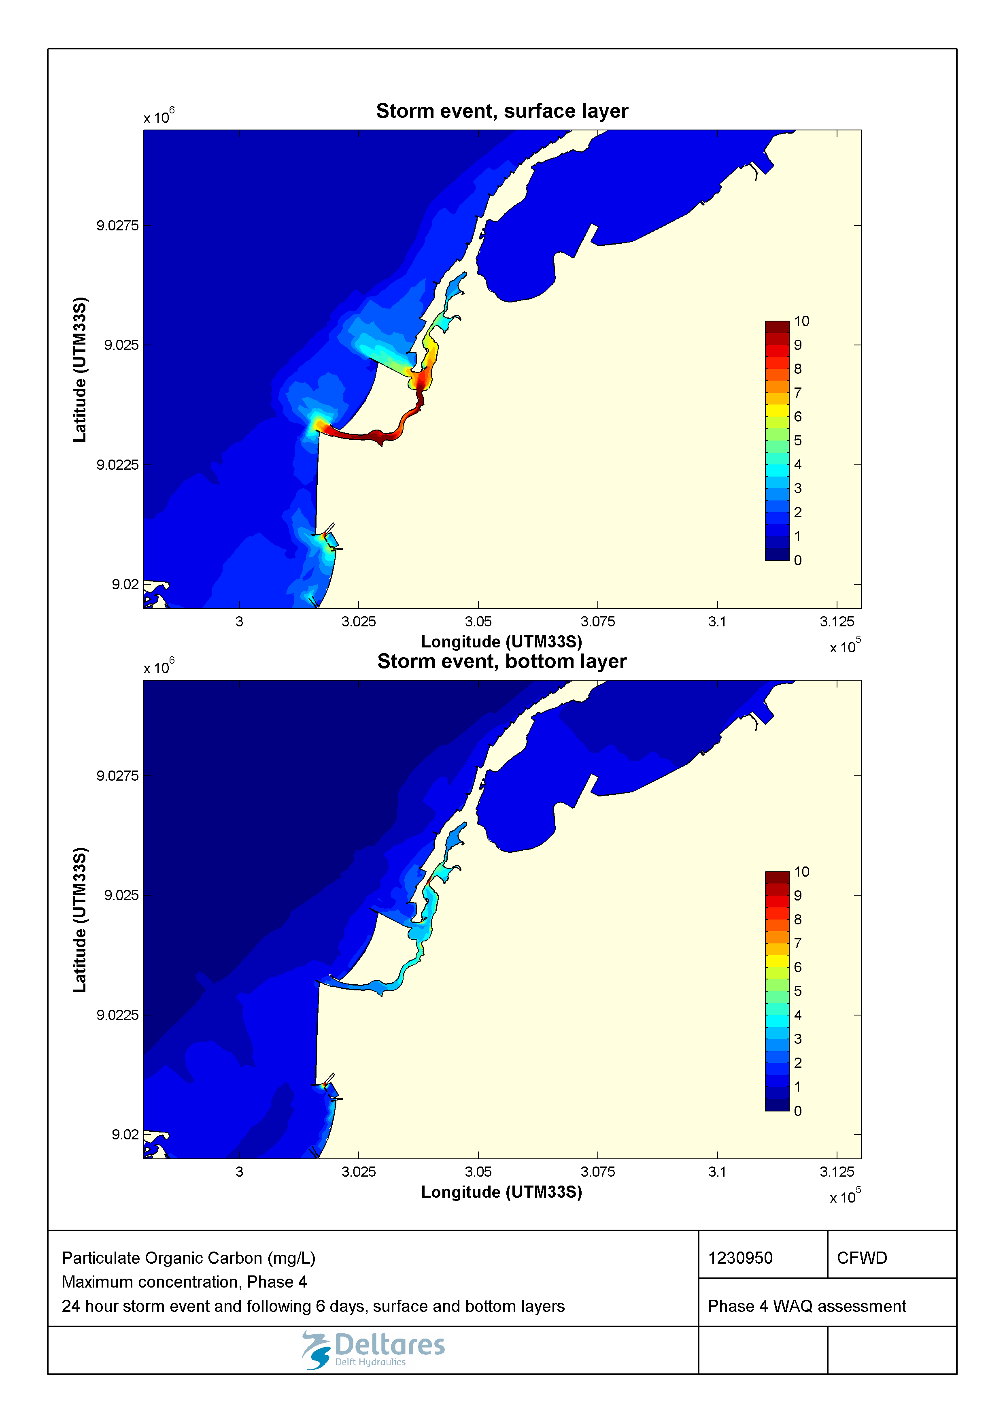

Figure 2.48 Maximum particulate organic carbon (mg/L) during a 1-in-100-year storm event in the surface and bottom layers for the Marginal Phase4 developments.

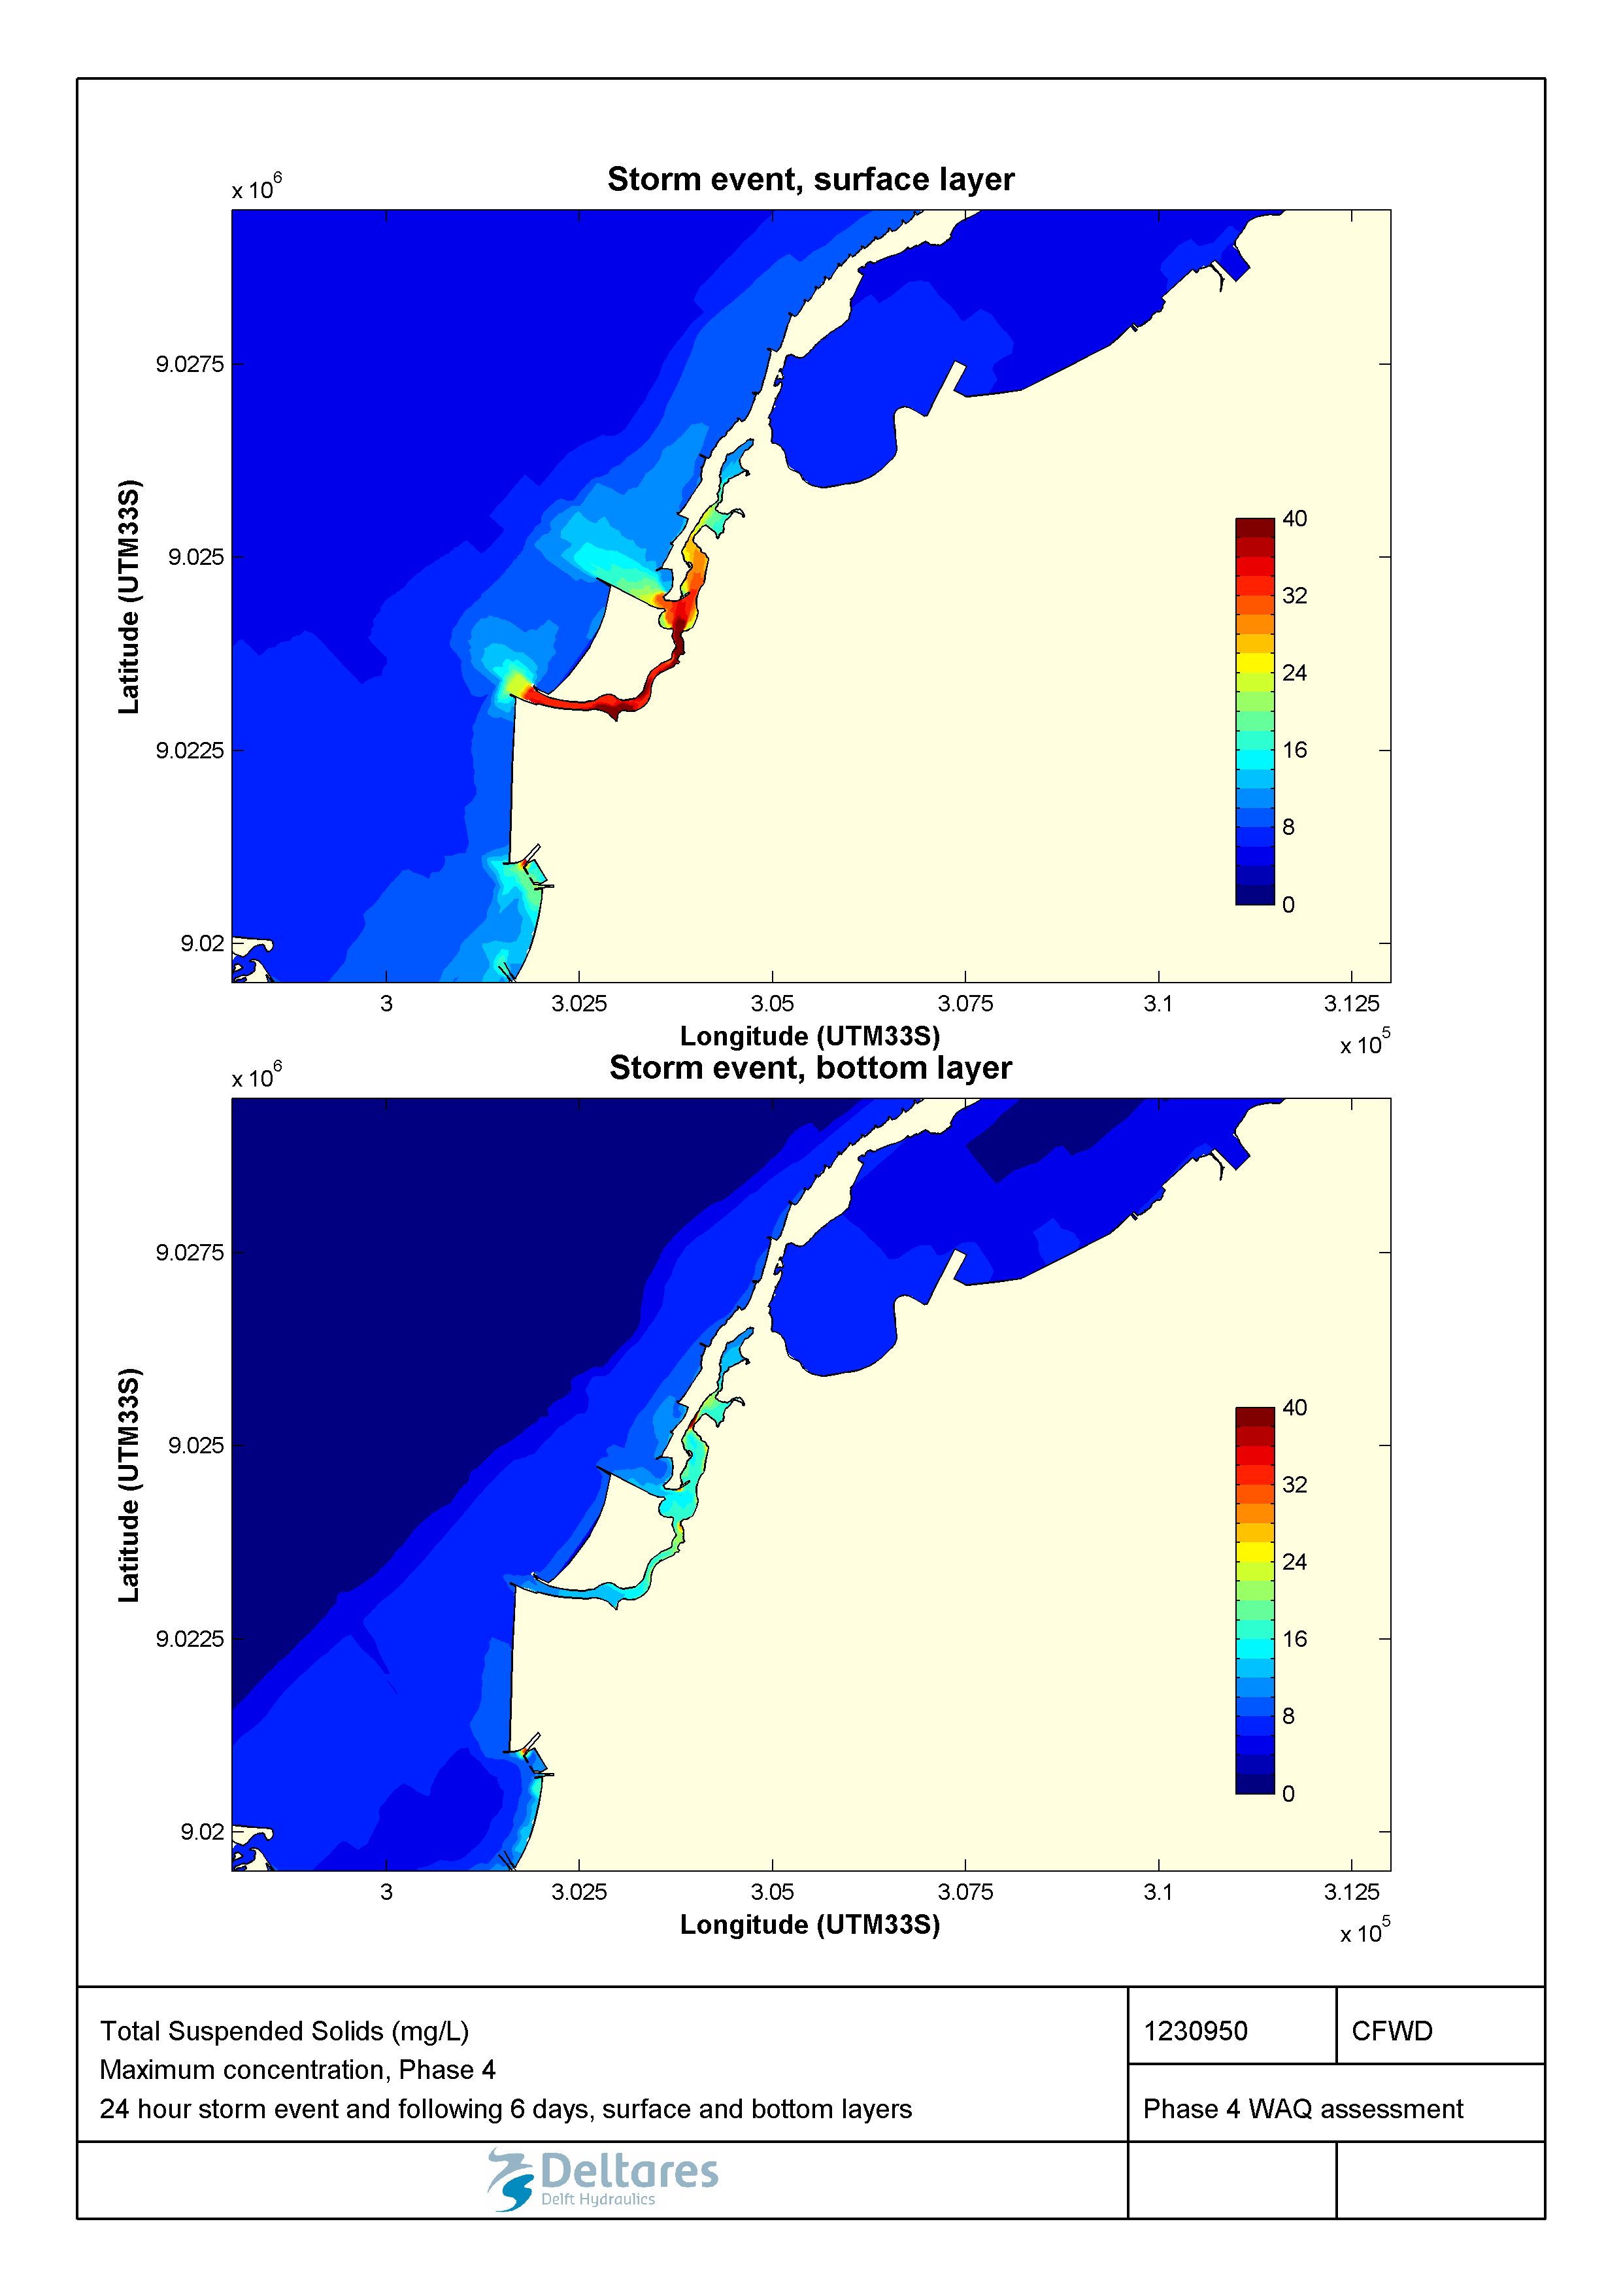

Figure 2.49 Maximum total suspended solids (mg/L) during a 1-in-100-year storm event in the surface and bottom layers for the Marginal Phase4 developments.

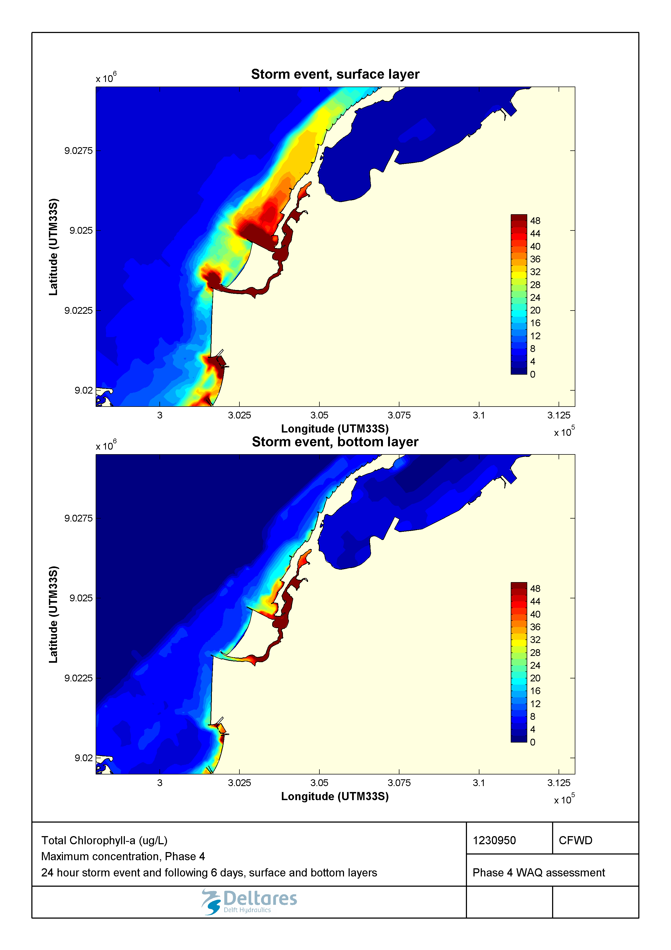

Figure 2.50 Maximum Chlorophyll-a (µg/L) during a 1-in-100-year storm event in the surface and bottom layers for the Marginal Phase4 developments.

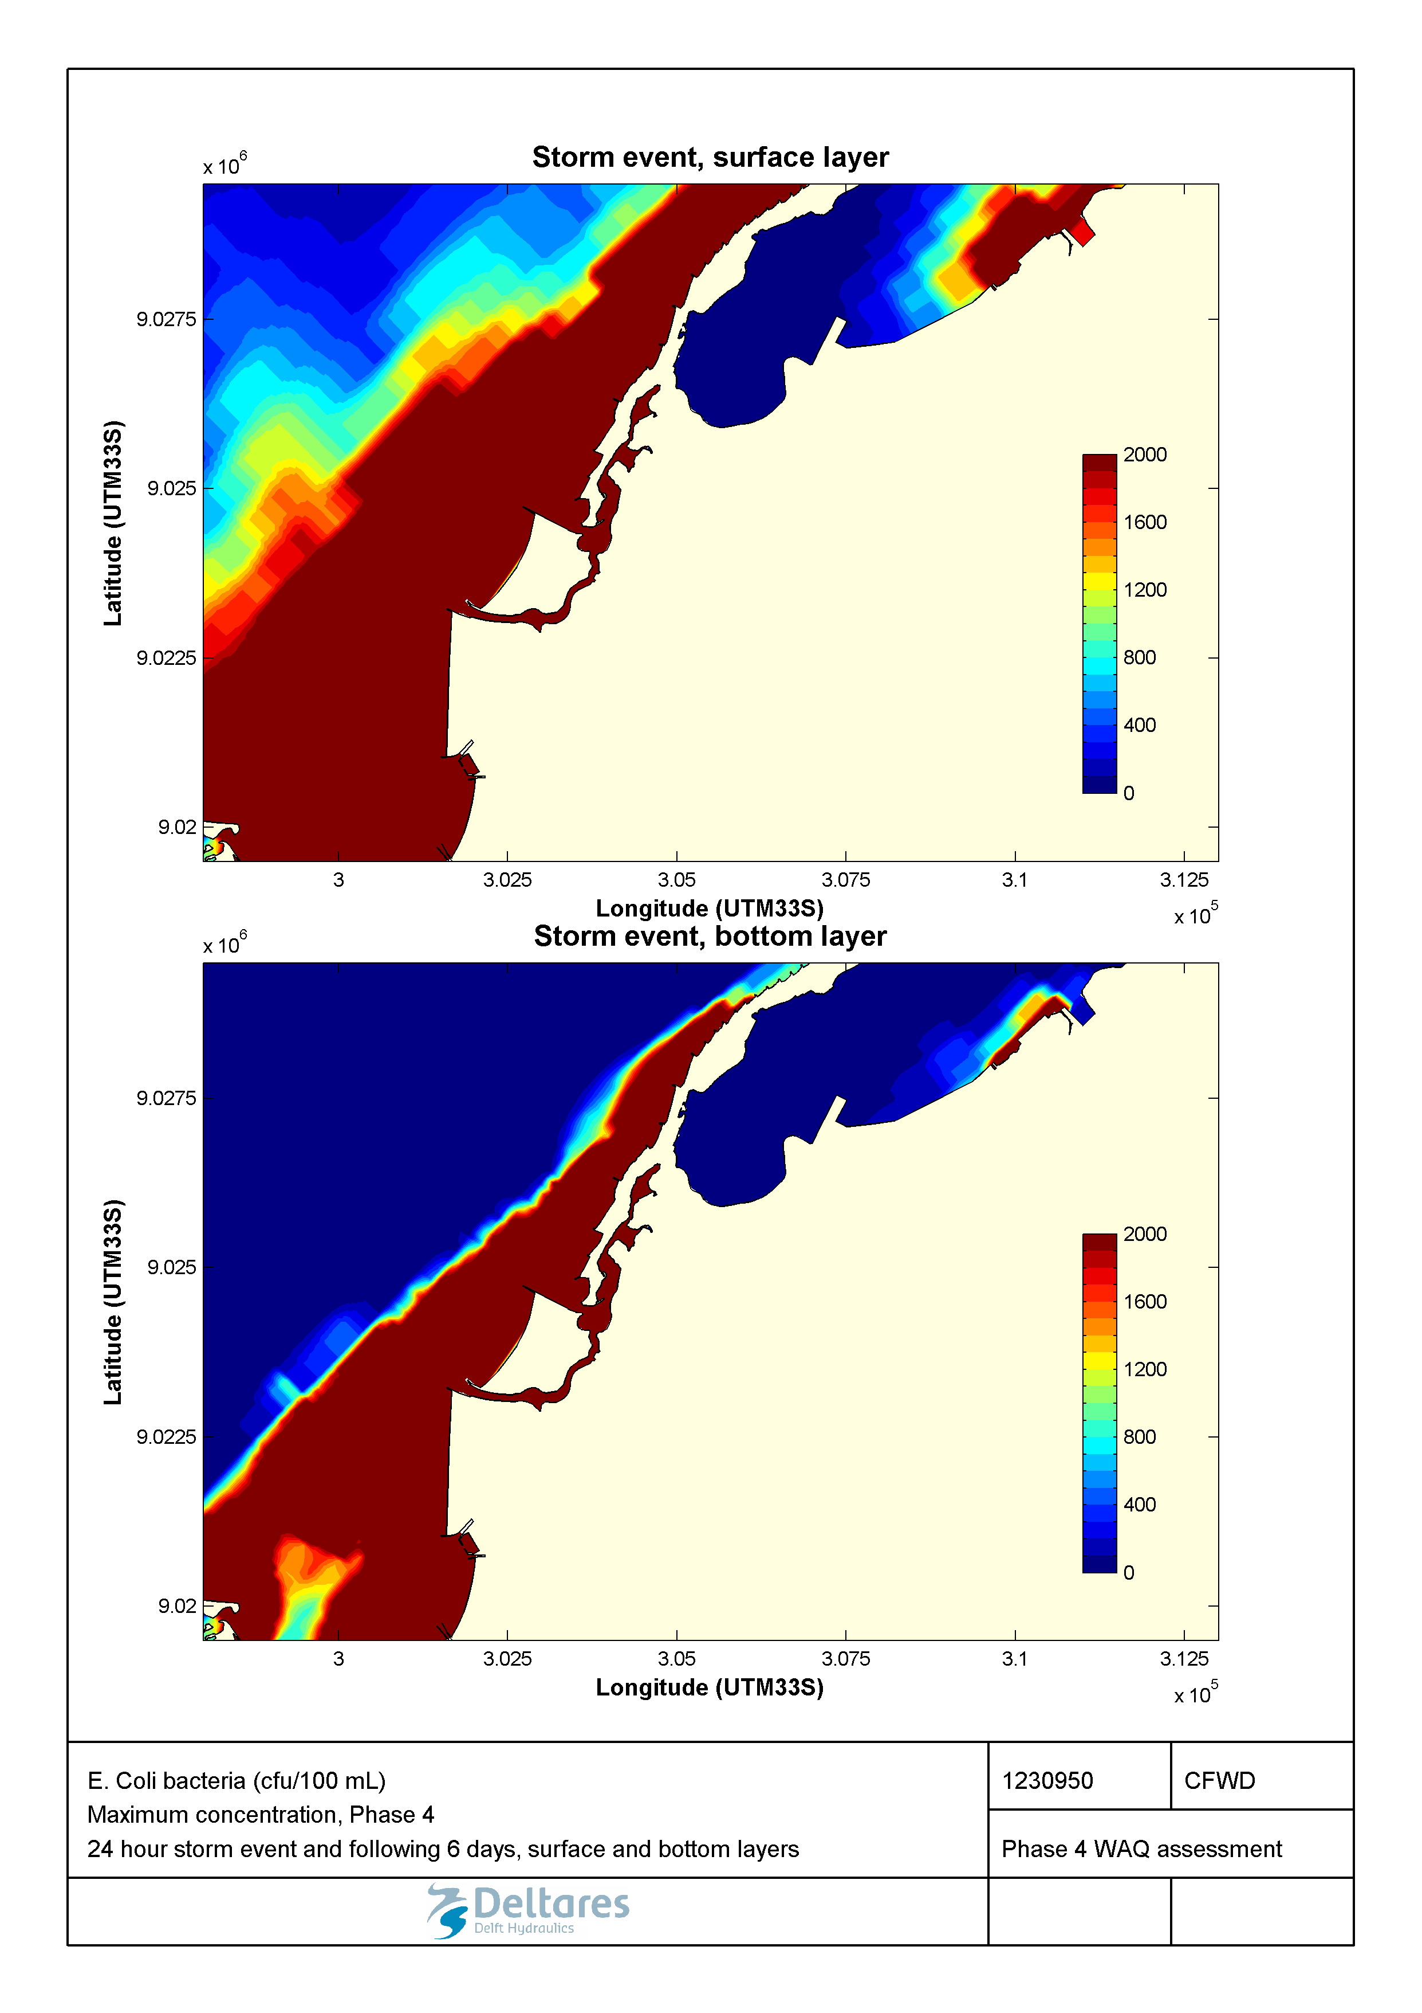

Figure 2.51 Maximum E. Coli bacterial (CFU/mL)) during a 1-in-100-year storm event in the surface and bottom layers for the Marginal Phase4 developments.

#### Wastewater treatment applied

Compared to the baseline conditions, the water-quality is also improved in the Marginal de Corimba development configuration during a 1-in-100-year storm event (Figure 2.52 to Figure 2.59). Similar to the seasonal results, these improvements are caused by the interception of wastewater discharges in the Corimba channel during the days following the storm event.

Nonetheless, low levels of dissolved oxygen are still observed in the Corimba channel, especially in its southern end where most of the valas are discharged. Values below 2 mg/L occur for a few hours only and also not in the bottom layer. Similarly, total nitrogen, total phosphorus, suspended solids and particulate organic carbon reach high concentrations in the top layer of the same area in Corimba Channel, which is caused by the poor flushing relative to the high loading rate. Chlorophyll-a concentrations are therefore still high within the Corimba channel.

Note that although residence times are larger in the northern part of the Sodimo lagoon, the absence of vala discharges there leads to better water-quality than in the southern part of the Corimba channel. The simulated concentrations of *E. coli* values still exceed the suitability criterion for swimming water (in the order of several hundreds of cfu/100ml) by several orders of magnitude over large areas.

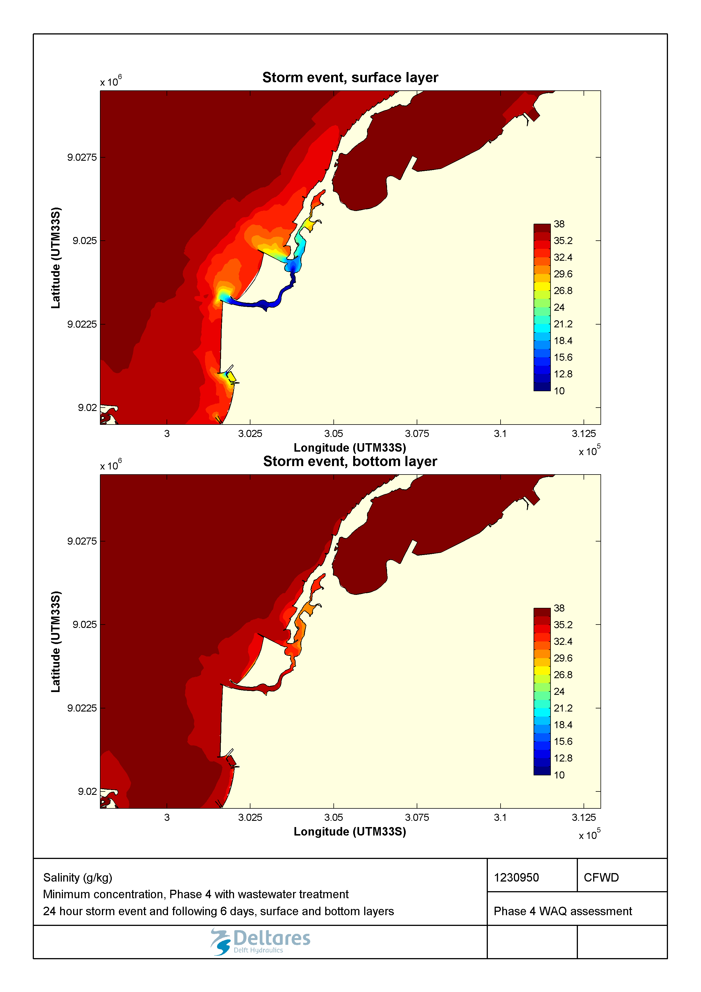

Figure 2.52 Minimum salinity (g/kg) during a 1-in-100-year storm event in the surface and bottom layers for the Marginal Phase4 developments with wastewater treatment.

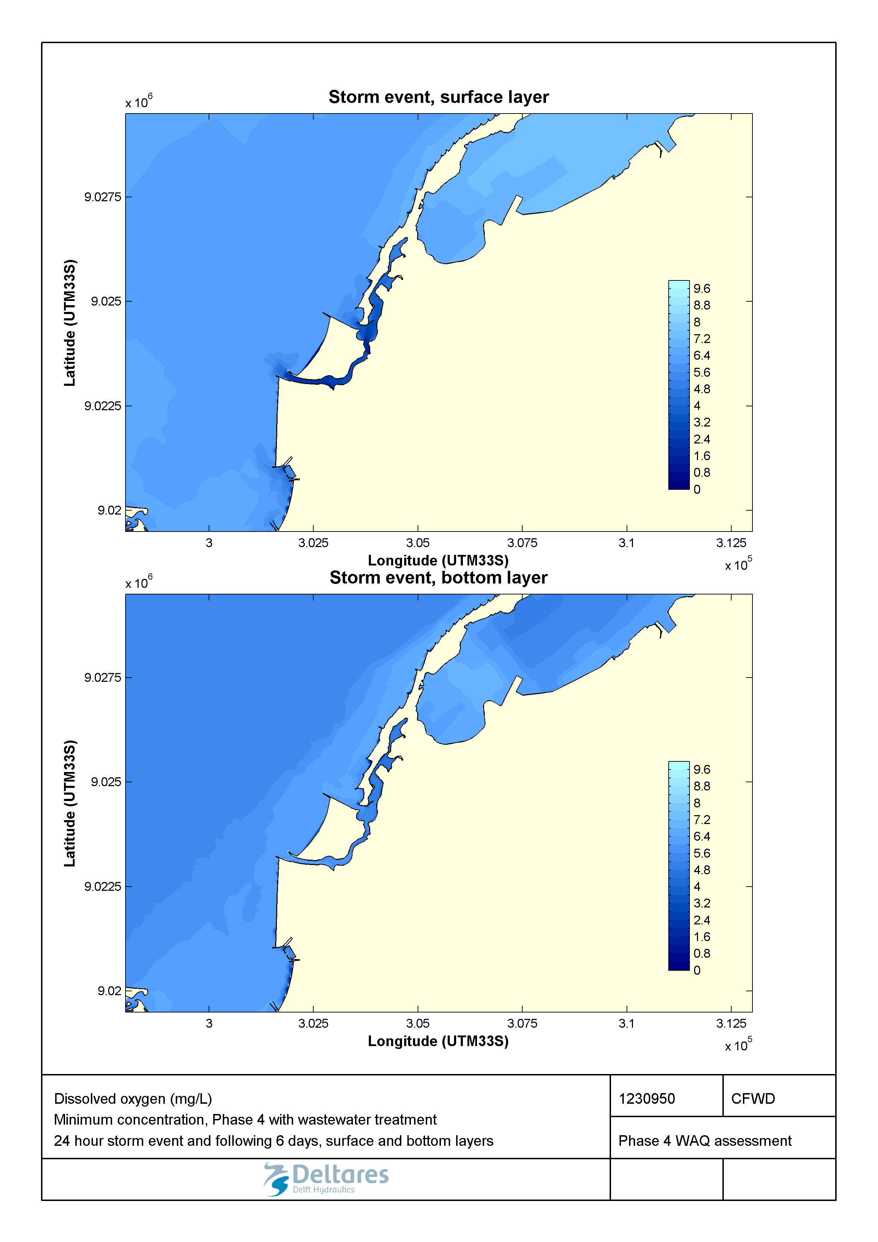

Figure 2.53 Minimum concentration of dissolved oxygen (mg/L) during a 1-in-100-year storm event in the surface and bottom layers for the Marginal Phase4 developments with wastewater treatment.

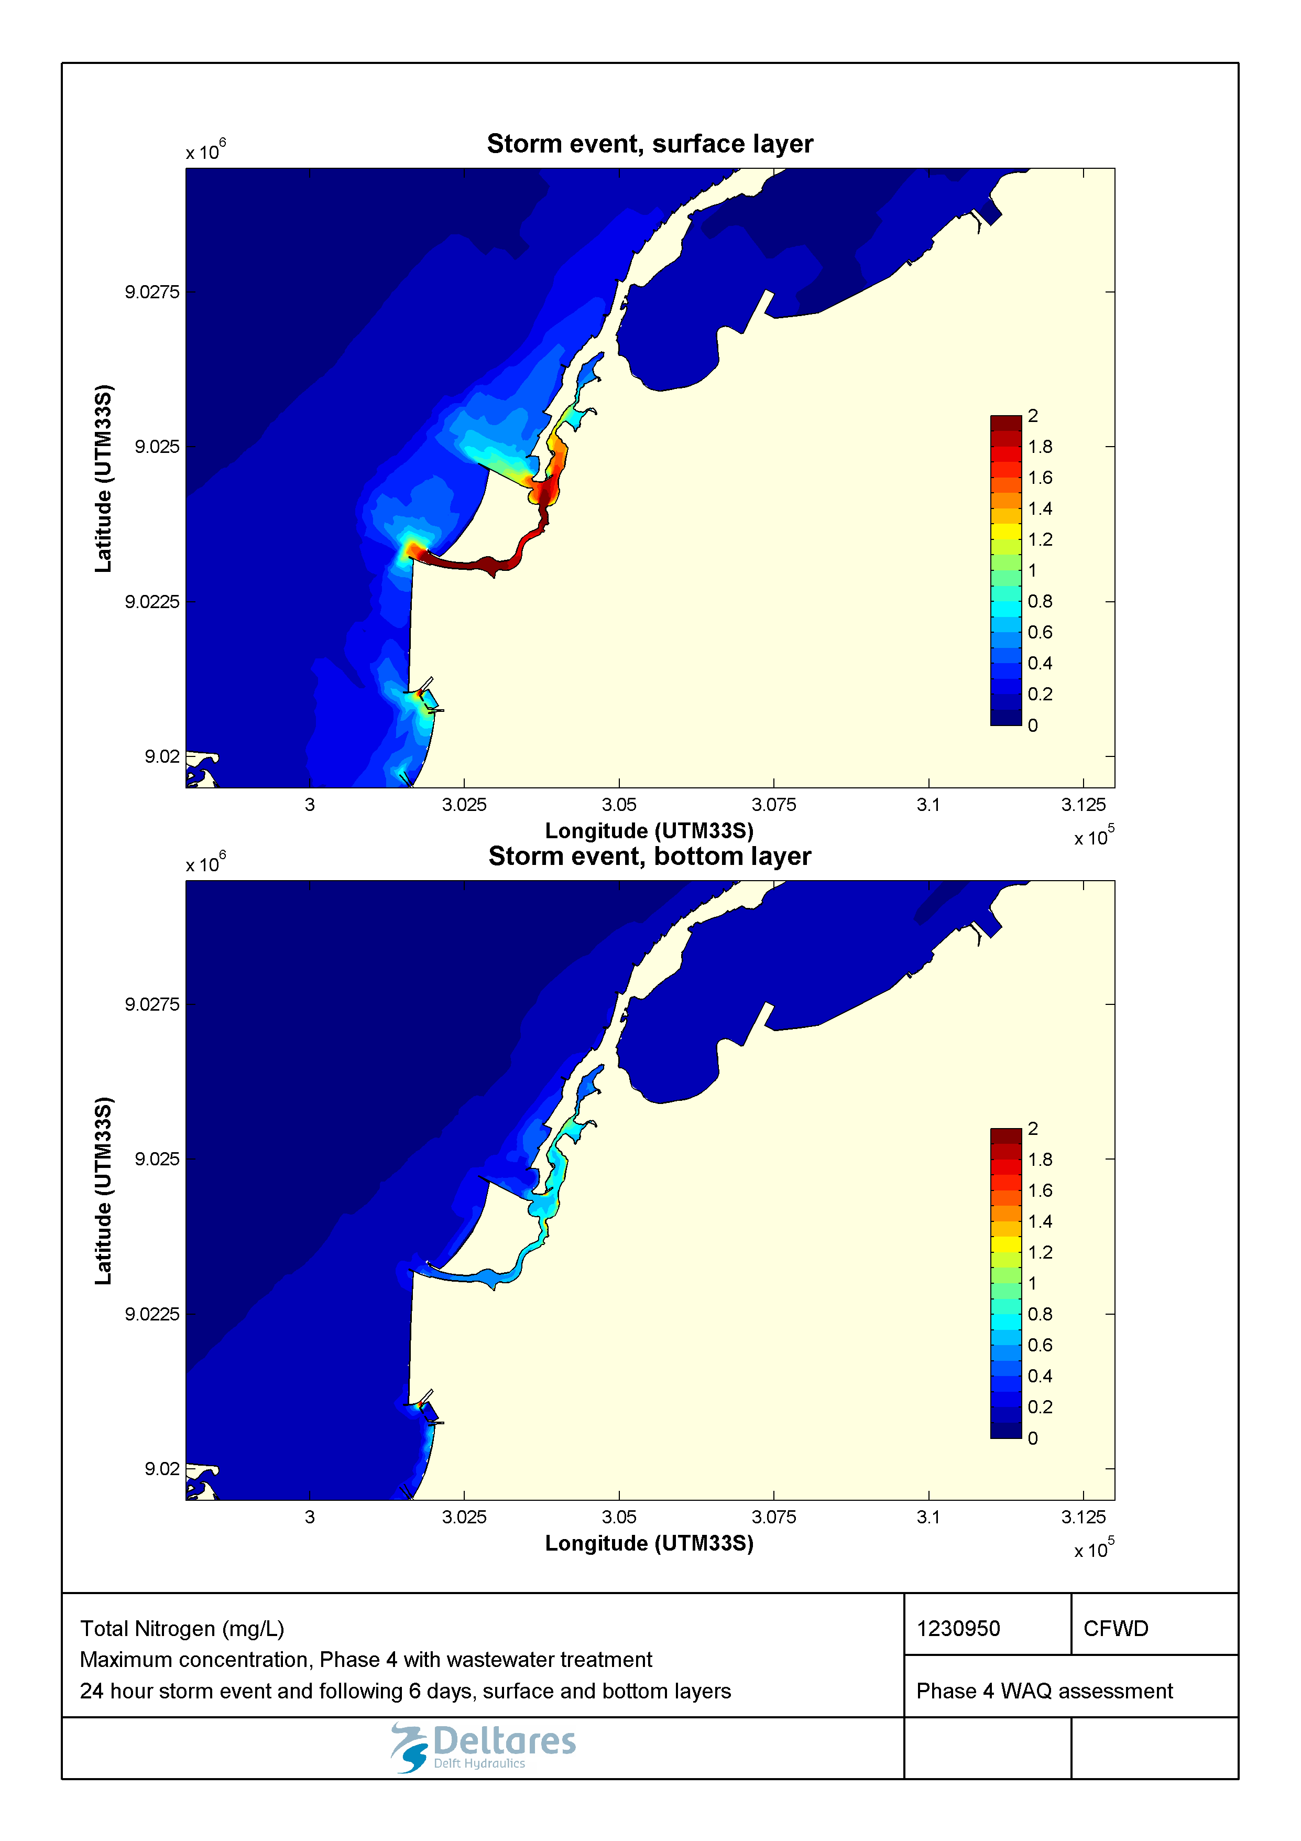

Figure 2.54 Maximum concentration of total nitrogen (mg/L) during a 1-in-100-year storm event in the surface and bottom layers for the Marginal Phase4 developments with wastewater treatment.

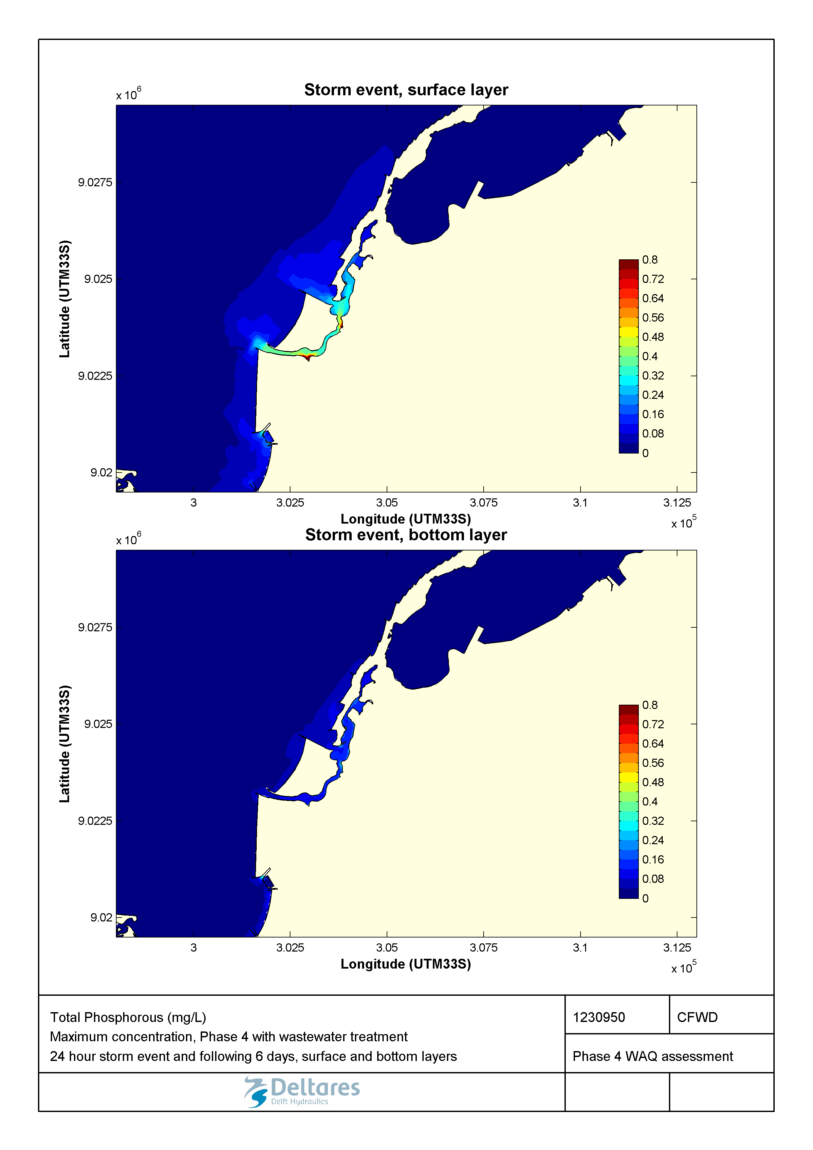

Figure 2.55 Maximum concentration of total phosphorus (mg/L) during a 1-in-100-year storm event in the surface and bottom layers for the Marginal Phase4 developments with wastewater treatment.

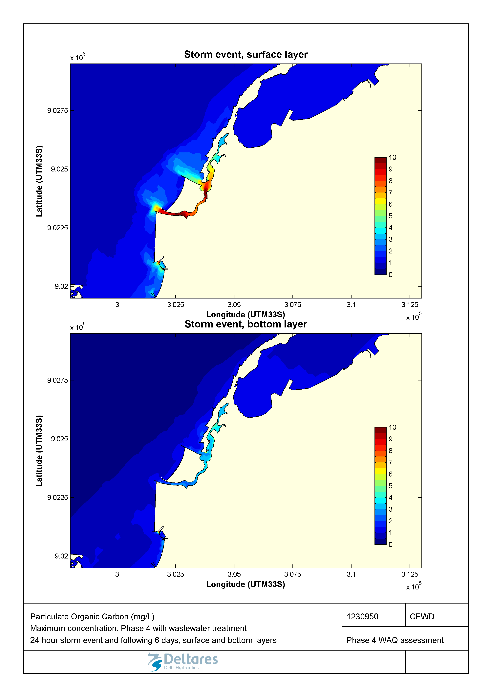

Figure 2.56 Maximum concentration of particulate organic carbon (mg/L) during a 1-in-100-year storm event in the surface and bottom layers for the Marginal Phase4 developments with wastewater treatment.

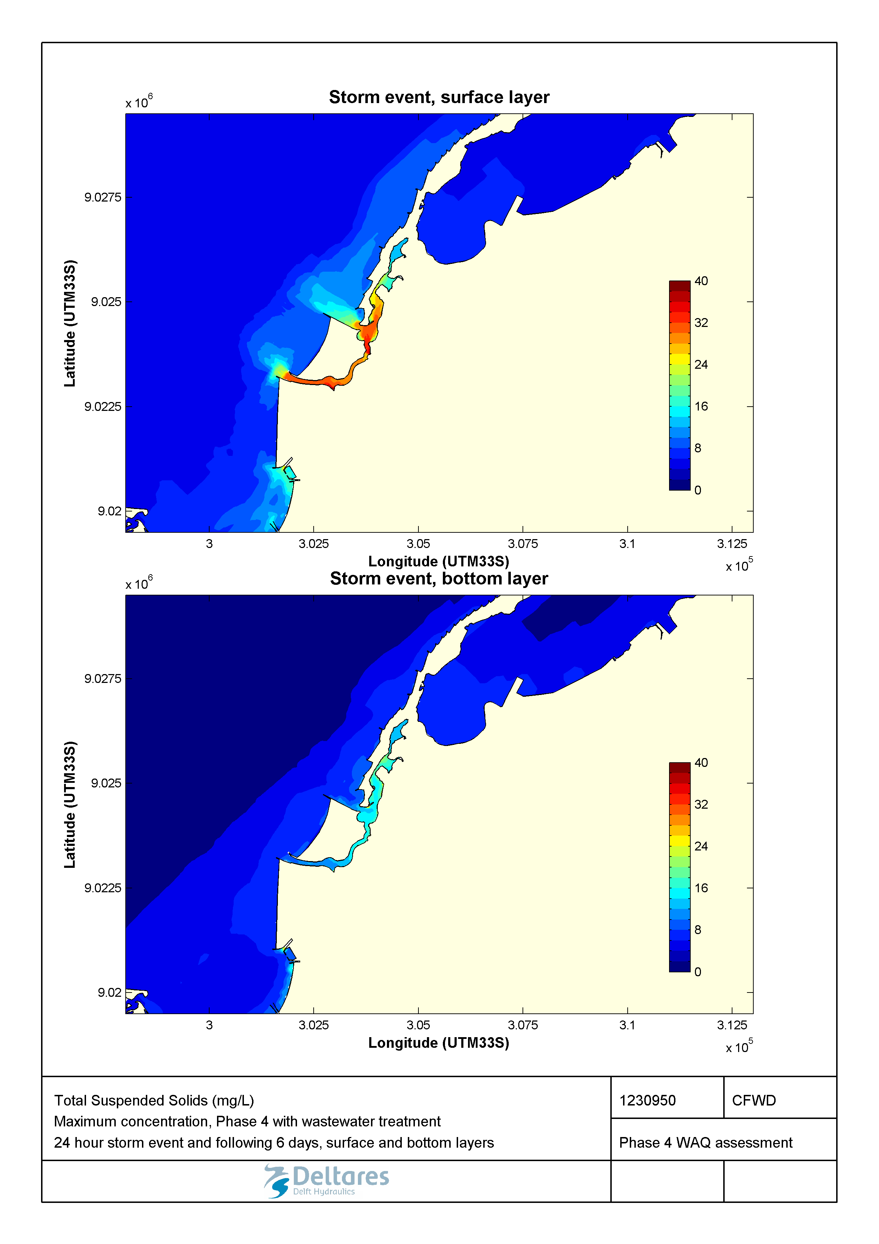

Figure 2.57 Maximum concentration of suspended solids (mg/ L) during a 1-in-100-year storm event in the surface and bottom layers for the Marginal Phase4 developments with wastewater treatment.

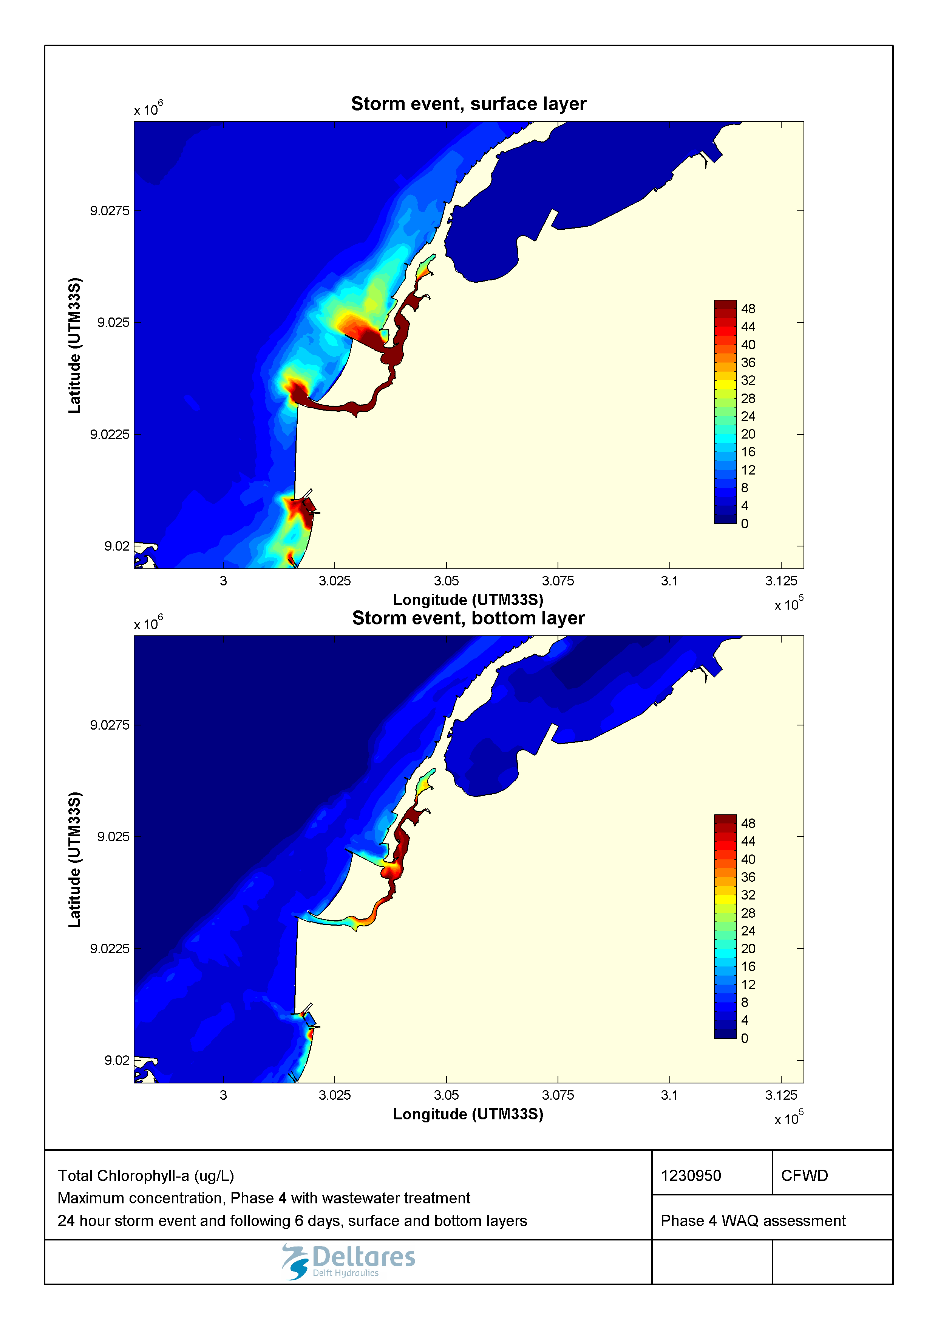

Figure 2.58 Maximum concentration of Chlorophyll a (µg/L) during a 1-in-100-year storm event in the surface and bottom layers for the Marginal Phase4 developments with wastewater treatment.

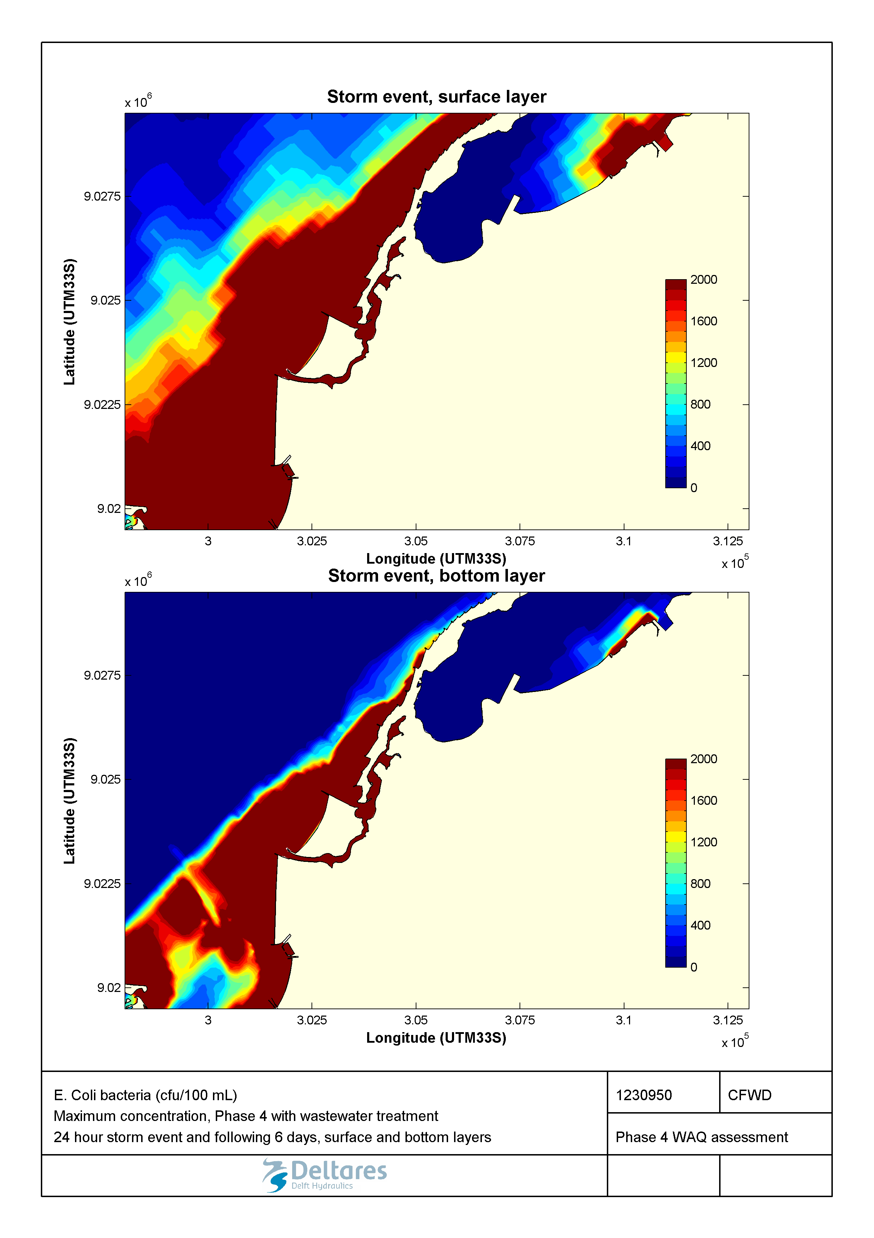

Figure 2.59 Maximum concentration of E. coli (cfu/100mL) during a 1-in-100-year storm event in the surface and bottom layers for the Marginal Phase4 developments with wastewater treatment.

## Sumarizing conclusions

The water quality in the Marginal de Corimba development is expected to be significantly better than in the baseline. This improvement is caused by the planned strategies for interception and treatment of the wastewater discharges from the valas (as described in Section 4.2.5). Without wastewater treatment, there is expected to be little noticeable change to overall water quality.

Under average conditions, the improvements offered by introducing wastewater treatment are expected to be substantial. The only remaining impacts from pollution loadings are a limited reduction of the water transparency (as compared to undisturbed background conditions) within the Corimba channel in the wet season, as a result of the presumed overflows of the wastewater collection and treatment systems in the valas during rain events. Exceedance of *E. coli*'s suitability criterion for swimming water could still be expected, but over much smaller areas than in the baseline.

During rain events there will be an improvement, but as a result of the presumed overflows of the wastewater collection and treatment systems we still expect short term water quality problems. In particular we expect very low concentrations of dissolved oxygen and very high concentrations of *E. coli*.

The remediation of these problems in the selected Marginal de Corimba layout would require an improvement of the wastewater collection and treatment systems in the valas, either by increasing the capacity, or by separating the wastewater from the storm water.

# References

Deltares, 2014a

Chicala Futungu Waterfront Project, Large-scale numerical modelling

Reference 1208570-000-HYE-0010, March 2014

Deltares, 2014b

Chicala Futungu Waterfront Project, Detailed modelling for New Marginal Phase 4

Reference 1208570-000-HYE-0017, October 2014

Deltares, 2017a

Marginal da Corimba Detail Design - Task D12 Scour of the Seabed

Reference 1230950-000-HYE-0008, March 2017

Deltares, 2017b

Marginal da Corimba Detail Design - Task D05 Detailed extreme conditions

Reference 1230950-000-HYE-0009, April 2017

Urbinveste/Van Oord, 2017

Memo bathymetry Mussulo Bay after construction

Reference 30.3888-VODMC-ENG-TN-001, 20 January 2017